## What is Angular?

Angular is a component-based framework for building structured, scalable and single page web applications for client side.

Angular is an open-source, JavaScript framework wholly written in [TypeScript.](https://www.simplilearn.com/tutorials/programming-tutorial/advanced-typescript) It uses HTML's syntax to express your application's components clearly.

It now comes with every feature you need to build a complex and sophisticated web or mobile application. It comes with features like component, Directives, Forms, Pipes, HTTP Services, Dependency Injection, etc

### **What are Single Page Applications (SPA)?**

Single-page applications are web applications that load once with new features just being mere additions to the user interface. It does not load new HTML pages to display the new page's content, instead generated dynamically. This is made possible through JavaScript's ability to manipulate the DOM elements on the existing page itself. A SPA approach is faster, thus providing a seamless user experience.

### What are Angular advantages?

1. It is Relatively simple to build Single Page Applications (by using Components)

2. Flexible and structured client applications (by using OOPS concepts)

3. Angular is cross platform and open source(Free to use)

4. Writing Reusable Code is easy (by using Services)

5. Testing is easy (by using spec.ts)

### How to build a scalable Angular application

Often we start building Angular application without any architectural consideration. Angular is a complete framework and provides features to build a large application. However, if we are not following architectural considerations. It often becomes bulky and less maintainable.

**Project structure- Organize Codebase**

Project structure is very important for the scalability of the Angular application. There is the standard structure of the Angular application. We should group folders in feature modules. We will discuss feature modules in more detail later part of the story. ***Bottom line is group folders based on features***. Angular application folder should be grouped by logical units. i.e. Group users folder for all users. Product for product folder.

Root App Module  
 └── Product Module — feature Module└── Other feature modules based on app functionality...├── Shared Module — feature Module└── environments — Logical Separation of concern

**Use Feature modules — More structural code**

When application grows feature modules provide less coupled modules. Feature modules provide clear boundaries between the components. You can group code based on functionality.

Modules can also be grouped based on technical responsibility. Route related modules can be grouped into router modules. Route authentication guard can be included in router modules. Similarly, service that does messaging of request and response can be moved to service modules.

***Group modules based on application functionality and based on the technical responsibility of modules.***

Following are the architectural benefits of feature modules:

* Using feature modules will deliver a cohesive set of functionality.
* Feature module with Lazy Loading enables faster application. ***Initial application render time increases. Modules are provided on demand***. Many can argue that this will make more server calls and use of bandwidth. However, it’s worth using it.
* Also depends on user behavior, Some modules are used by specific users. i.e. in one of my application user roles are accessible by Administrator users. So loading user’s role modules for all the users is not a good idea.

**Use Feature components -Small Components**

Well similar to feature module feature component enforce small components. Keeping all features in one component makes it difficult to maintain. If we have a product list and add, update the product list. Divide into two components. The first component will be the product list and the second component will be added and update products.

**Small components do one thing and do it very well.**

Most often we forgot to create feature component and component grows even more than 500 lines of code. The bottom line is when you see a component growing try to refactor it in the smaller components. Do brainstorming on how to split the component. It can be anything, a separate button, a special control, or any feature.

**Use Lazy loading — Optimize application initial Load time**

By default, Angular application support eager loading. Which download all pages when application first-time loads. As the application starts growing eager loading make initial load time sluggish. There are tons of widgets, feature modules that are loading at one go. Better to make feature modules lazy loaded modules. This will make a faster initial load time of the application. Use below code snippet to load modules as children. When the route is invoked the module will be loaded from the server.

const routes: Routes = [{path: ‘products’,loadChildren: () => import(‘../products/products.module’).then(mod => mod.ProductModule)}];

Many can argue that this will make more server calls and use of bandwidth. However, it’s worth using it. Also depends on user behavior, Some modules are used by specific users. i.e. in one of my application user roles are accessible by Administrator users. So loading user’s role modules for all the users is not a good idea.

**UI Component library- Build fast or Build slow**

Often time we use UI component libraries to build applications faster. There are very useful libraries PrimeNG, Angular material, and Bootstrap. All these UI component libraries are useful to reuse the controls. Also, it comes with the cost of customization. So while developing scalable applications better to create your components. Creating own components gives the flexibility to change or mold the functionality based on the user need.

Consuming UI component libraries will lead to faster development of applications. However, the UI components come with standard customization. UI components are best suited when we have less customization of controls.

Also, avoid using multiple UI components in different modules. For instance, using Angular material in one feature module and using PrimeNG for the other feature modules. This will make the application look and feel different.

**CSS Encapsulation and Styling**

Styling in Angular application should be done with utmost priority. Build a proper strategy of CSS encapsulation and styling.

* If there is branding of application in a later stage of the development. Try to move out of the commonly used CSS in root style.css. This will make branding easy in later stage.
* If using UI component libraries. You might be consuming these libraries controls as viewChild. Better to pass CSS and styling in HTML to the child component. Do not use to override. ::ng-deep .
* Use ViewEncapsulation strategy very carefully. If there is no native shadowing DOM use None. If style is emulated use emulated and for native rendering of styles use native.

**Managing state — Use store or not**

Managing state in the Angular application is very important. Creating a feature module will always lead to the complexity of communication between the feature components and feature modules.

* For small applications, we can use @input, @Output, and EventEmitter for the component communication.
* For small to mid-level of application use RxJS shared services for the feature module communication. Use RxJS BehaviourSubject and ReplaySubject to hold the data and share the data between components and modules.
* For large and complex applications that need to maintain state. It is good to build a store. Redux or NGRX provide store for the Angular applications.
* Creating a store is expensive. Especially setting up store infrastructure. Creating Reducer, Action, and store configuration required lots of coding work. However, the best part is once the store is ready it is very simple to use.

**Using reactive programming RxJS- Inheritance vs Functional programming**

RxJS operators provide managing streams, combining the stream into a single stream. It also helps in calling APIs (set of observable) sequential and parallel. But the main problem is there are so many operators. Combining operators is always a challenge. RxJs provides a set of the wizard on their website for combining these operators. If the wrong operator is combined it will lead to race conditions. Also, all the subscriptions need to unsubscribe when components are out of scope, failing this will lead to memory leaks. Memory leaks are terrifying especially when the application is running in production environments. Below is the brief sketch of the uses of RxJS in Angular.

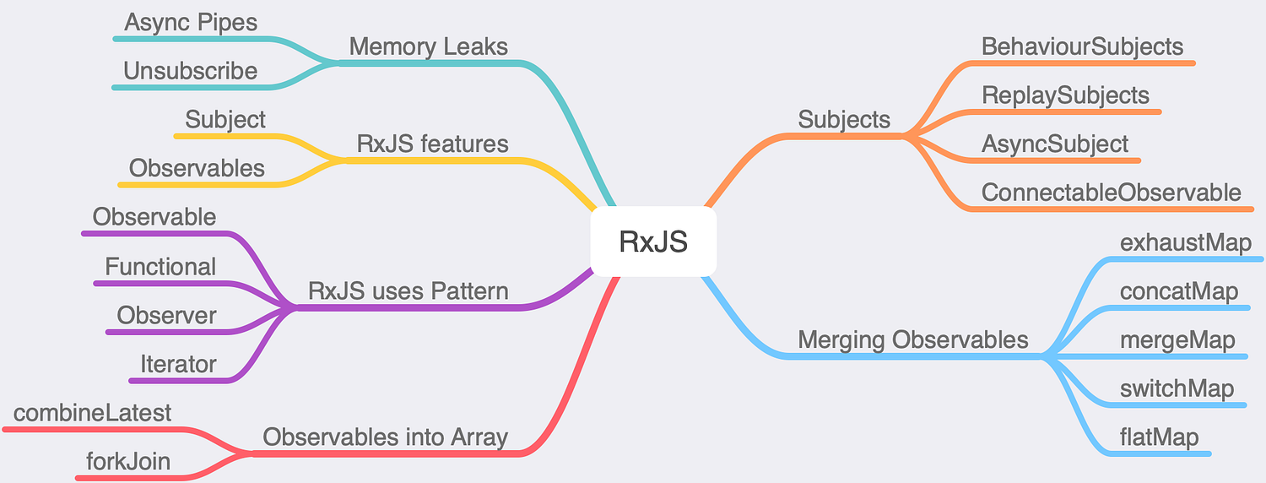

**Designing Data Model with Typescript Type- Strong Type**s

Design the page data model with typescript interfaces. For example, if we are creating the product component then create interfaces product features and pass them to the Product interface. The product interface takes product features like an array. Below is the data model.

export interface productFeatures{featureName:string,featureAddedDate:string,featureDescription?:string}export interface Product<productFeatures> {pid: number | null;productName: string;productCode: string;description?: string;productFeatures?: productFeatures[];}

**Create Base class for Get/Post/Put/Delete**

Create a single file for all CRUD related operations. A base class for the Get, Post, Put, and delete methods. Extend base class in all other classes. Benefits of using single base class is below:

* Create a single base class for standard errors.
* Single place to handle all custom error including 401, 404 and 402.
* Single place to data messaging in all requests and responses.

**Unit Testing- Test-Driven Development**

Unit testing plays an important role to find out the remaining 20% scenario that can not be either reproduce by QA testers. Unit testing also benefits in refactoring code. Angular provide Jasmine/Karma for unit testing. Jasmine/Karma runs on browser and when unit test increases it perform very slow. On the other hand, Jest provides a faster unit test environment than Jasmine/Karma.

**Summary**

So the above points are the guidelines that you must follow to build a scalable Angular application. If we implement the above steps, Our Angular application will be scalable manifolds. Creating a feature module and feature component is the start point of creating a scalable Angular application. Once the feature module is done, it is very easy to create a Lazy loading in the application. I am suggesting to start the Feature module and Lazy loading as soon as possible. Once the application is developed stage it is very hard to refactor it for Lazy loading and feature modules.

<https://medium.com/coding-in-depth/10-steps-to-create-a-scalable-angular-application-3263f7e347a1>

**What are SOLID principles in Angular**

<https://indepth.dev/posts/1414/angular-and-solid-principles>

SOLID is a mnemonic acronym for five design principles intended to make software designs more understandable, flexible, and maintainable. The principles are a subset of many principles promoted by American software engineer and instructor Robert C. Martin (Uncle Bob) - **Wikipedia**

The primary benefits of a SOLID architecture are that you will write code:

* that is testable
* that is easy to understand
* that can be adjusted and extended quickly without producing bugs
* that separates the policy (rules) from the details (implementation)
* that allows for implementations to be swapped out
* where business logic is where it is expected to be
* where classes do what they are intended to do

S: Single Responsibility Principle - A class or function should only have one reason to change

O: Open-Closed Principle - A software artifact should be open for extension but closed for modification

L: Liskov-Substitution Principle - Introduced by Barbara Liskov in the 1980s. This principle defines that objects of a superclass shall be replaceable with objects of its subclasses without breaking the application. That requires the objects of the subclasses to behave in the same way as the objects of the superclass.

I: Interface Segregation Principle - Prevent classes from relying on things that they don’t need

D: Dependency Inversion Principle - Abstractions should not depend on details. Details should depend on abstractions

### What is benefit of Single page application in Angular.

<https://www.pluralsight.com/guides/why-do-we-need-a-single-page-application>

**Advantages of Single-page Apps**

An important feature of single-page applications is performance. They get a performance boost by loading HTML, CSS, and JavaScript resources as soon as the website is loaded.

The reason is that when users come to an application, they need the shortest possible wait time so that they can do their work and leave. The performance reflects the demand for the application.

If the application does not provide the necessary performance, users may leave that app and choose another platform. That's one of the primary reasons developers choose single-page apps nowadays.

There are other advantages as well:

* Battery reusability
* Optimization
* Client-side rendering
* User experience
* Easy debugging
* Performance
* Less complex implementation
* Better caching
* Better SEO optimization

### How to clear Browser Cache on Angular app.

The caching options of the CLI can be customized through the configuration settings in the  **angular.json**  file. Among the various options available is  **cache** , which enables users to turn off the caching feature.

{

"$schema": "./node_modules/@angular/cli/lib/config/schema.json",

"version": 1,

"cli": {

"cache": {

"enabled": false

}

},

"projects": {}

}

This command can also be used to turn off the feature.



**ng config cli.cache.enabled false**

* To remove stored data on Unix-based operating systems, specifically the cache.

**rm -rf .angular/cache**

* To clear the cache on Windows:

**rmdir /s /q .angular/cache**

[https://copyprogramming.com/howto/clear-angular-cache-in-angular-folder](https://copyprogramming.com/howto/clear-angular-cache-in-angular-folder#google_vignette)

### Where to store static files in Angular project?

Store static files in assets folder of the Angular project.

### What is the role of Angular.json file in Angular?

The angular.json file is the primary configuration file for an Angular project

### What is the difference between JIT and AOT in Angular?

Both JIT and AOT are used to compile Angular Typescript components to JavaScript, because browser understands JavaScript not Typescript.

|  |  |
| --- | --- |
| ANGULAR COMPILE | DETAILS |
| Just-in-Time (JIT) | Compiles your application in the browser at runtime.  This was the default until Angular 8. |
| Ahead-of-Time (AOT) | Compiles your application and libraries at build time.  This is the default starting in Angular 9. |

All the latest Angular versions use AOT to compile Typescript to JavaScript.

**Advantage of AOT** - Loading in AOT is much quicker than the JIT, because it already has compiled your code at build time.

### **Key features of Angular:**

Angular is a popular open-source front-end web application framework maintained by Google. It provides developers with a set of powerful tools and features to build dynamic, responsive, and scalable web applications. Some of the key features of Angular include:

1. **Component-Based Architecture**: Angular follows a component-based architecture, where applications are built using reusable and independent components. Each component encapsulates its own HTML, CSS, and behaviour, making it easier to develop and maintain large applications.
2. **Two-Way Data Binding**: Angular offers two-way data binding, which means changes to the model (data) are automatically reflected in the view (UI), and vice versa. This simplifies the handling of data synchronization between the model and the view.
3. **Directives**: Angular provides built-in and custom directives that allow developers to extend the functionality of HTML elements. Directives enable the creation of dynamic, interactive, and reusable components within templates.
4. **Dependency Injection**: Angular has a powerful dependency injection system that facilitates the management of components and their dependencies. It allows for better code organization, testability, and maintainability.
5. **Templates and Views**: Angular templates use HTML enhanced with Angular-specific syntax to define the UI components and views. Templates allow developers to create dynamic views and interact with data.
6. **Routing**: Angular provides a powerful router module that enables developers to implement client-side routing. It allows for navigation between different views and pages without the need to reload the entire page.
7. **Forms and Validation**: Angular provides robust support for building forms with two-way data binding, form validation, and form submission handling. It simplifies the process of managing form data and user input.
8. **HTTP Client**: Angular’s built-in HTTP client module allows applications to communicate with backend servers and APIs. It supports various HTTP request methods and provides features like error handling, interceptors, and request/response transformations.
9. **RxJS Integration**: Angular incorporates RxJS (Reactive Extensions for JavaScript), which provides powerful reactive programming concepts for handling asynchronous data streams, events, and more.
10. **Internationalization (i18n)**: Angular supports internationalization and localization of applications, making it easier to develop applications that can be adapted for users from different regions and languages.
11. **Testing Support**: Angular is designed with testability in mind, and it comes with built-in testing utilities. It supports unit testing, integration testing, and end-to-end testing, making it easier to maintain code quality and catch bugs early.
12. **Mobile Support**: Angular offers tools like Angular Material, a UI component library, and Angular Universal, for server-side rendering, which helps in building responsive and mobile-friendly applications.

These features, among others, make Angular a robust and developer-friendly framework for building modern web applications with a rich user interface and smooth user experience.

### Architecture of an Angular

Architecture of an Angular application follows a component-based design pattern, where the application is divided into reusable and independent building blocks called components. These components work together to create a dynamic and interactive user interface. The overall architecture of an Angular application can be described as follows:

1. **Modules**:
   * An Angular application is organized into modules, and at least one root module is required to bootstrap the application. Modules are used to group related components, services, and other features.
   * Modules help to organize the application into smaller, manageable parts, making it more maintainable and scalable.
2. **Components**:
   * Components are the building blocks of an Angular application. Each component represents a specific part of the user interface and encapsulates its own logic, template, and styles.
   * Components are responsible for rendering data and responding to user interactions.
   * Components can have parent-child relationships, forming a tree-like structure, where the root component represents the entire application.
3. **Templates**:
   * Templates define the HTML markup of a component's view. They use Angular-specific syntax that allows for data binding and integration of component logic into the UI.
   * Templates are responsible for displaying data from the component's class and reacting to user actions.
4. **Directives**:
   * Directives are special instructions in the template that allow developers to extend HTML with custom behaviors or manipulate the DOM.
   * Angular provides built-in directives like ngFor, ngIf, and ngSwitch, and developers can create their own custom directives.
5. **Services**:
   * Services are used to share data, perform business logic, and interact with external APIs or data sources across different components.
   * Services are singleton objects, which means they have a single instance throughout the application's lifetime.
   * Components can depend on services through dependency injection, allowing for better separation of concerns and easier testing.
6. **Dependency Injection (DI)**:
   * Angular uses dependency injection to manage the relationships between components and services.
   * DI provides a way to request dependencies from a component's parent module or the application root injector and makes it easier to create, maintain, and test components.
7. **Routing**:
   * Angular's router module provides client-side routing, enabling navigation between different views and components without the need for a full page reload.
   * Routes are defined in the application's configuration and map URLs to specific components.
8. **Data Binding**:
   * Angular supports two-way data binding, allowing for automatic synchronization of data between the component and the template.
   * Data binding helps to keep the UI in sync with the application's data state.
9. **RxJS Integration**:
   * Angular leverages RxJS (Reactive Extensions for JavaScript) to handle asynchronous operations, such as HTTP requests and event handling.
   * RxJS provides a powerful way to work with streams of data and events in a reactive and declarative manner.

By following this component-based architecture, Angular applications can be organized, modular, and maintainable, enabling developers to build complex and feature-rich web applications with ease.

### Angular CLI

**Angular CLI** (Command Line Interface) is a powerful tool provided by the Angular team to simplify and streamline the process of creating, developing, building, testing, and deploying Angular applications. It is a command-line tool that offers a set of commands and pre-configured templates, making it easier for developers to set up and manage Angular projects efficiently.

Here's how Angular CLI simplifies Angular development:

1. **Project Generation**: Angular CLI provides a simple command (**ng new**) to create a new Angular project from scratch. It sets up the project structure, installs the necessary dependencies, and creates essential configuration files, saving developers from the tedious task of manual project setup.
2. **Code Scaffolding**: Angular CLI offers various commands to generate components, services, directives, modules, and other Angular artifacts. With a single command (**ng generate** or **ng g**), developers can create the boilerplate code for these artifacts, reducing the need for manual coding.
3. **Development Server**: Angular CLI includes a development server (**ng serve**) that allows developers to run the application locally and automatically reload the page when changes are made. It eliminates the need for manual refreshing and speeds up the development process.
4. **Build and Deployment**: Angular CLI simplifies the build process (**ng build**) by generating optimized production-ready bundles of the application. These bundles can then be easily deployed to a web server or a cloud platform.
5. **Testing**: Angular CLI comes with built-in support for running unit tests (**ng test**) and end-to-end tests (**ng e2e**). It sets up testing configurations and provides an environment where developers can execute tests with ease.
6. **Configuration Management**: Angular CLI abstracts away the complex configuration details, making it easier for developers to focus on coding rather than managing project configurations manually.
7. **Updates and Maintenance**: Angular CLI is continuously updated and maintained by the Angular team. When a new version of Angular is released, the CLI provides commands (**ng update**) to help upgrade the project to the latest version, saving developers time and effort in managing updates.
8. **Extensibility**: While Angular CLI provides a set of built-in commands, it is also extensible through schematics. Developers can create custom schematics to generate custom code templates and enhance project workflows further.

Overall, Angular CLI greatly simplifies the Angular development process by automating common tasks, providing a standardized project structure, and offering a smooth development experience. It reduces the initial setup time and enables developers to focus on building high-quality applications with less boilerplate code and more productivity.

### What is CLI tool?

NPM(Node package manager) is an online repository, from where you can get thousands of free libraries which can be used in your angular or node js projects.

The node_modules folder is used to save all downloaded packages from npm in your Angular project.

The Angular CLI(command-line interface) is a tool that you use to initialize and develop Angular applications directly from Terminal.

### Optimizing the performance

**Optimizing the performance** of an Angular application is essential to provide a smooth and responsive user experience. Here are some key strategies to optimize the performance of your Angular application:

1. **Lazy Loading Modules**: Implement lazy loading for modules to load them only when needed, rather than loading the entire application upfront. This reduces the initial load time and improves the application's perceived performance.
2. **AOT Compilation**: Use Ahead-of-Time (AOT) compilation instead of Just-in-Time (JIT) compilation. AOT compiles templates during the build process, reducing the parsing and compilation time during runtime.
3. **Minification and Bundling**: Minify and bundle your application's code and assets to reduce the number of HTTP requests and overall file size. This can significantly improve loading times.
4. **Tree Shaking**: Enable tree shaking in your build configuration. Tree shaking removes unused code during the production build, resulting in smaller bundle sizes.
5. **Optimize Images**: Compress and optimize images to reduce their file size. Consider using responsive images or lazy loading images to load images as needed.
6. **Angular Universal (Server-Side Rendering)**: Implement server-side rendering (SSR) using Angular Universal to improve the initial rendering speed, SEO, and perceived performance.
7. **Change Detection Strategy**: Use the **OnPush** change detection strategy for components where possible. This reduces unnecessary change detection cycles and improves performance.
8. **TrackBy Function**: When using **ngFor** to render lists, provide a **trackBy** function to improve rendering performance by reusing DOM elements instead of recreating them.
9. **Avoid Unnecessary Pipes**: Be cautious with using complex or costly pipes. Use pure pipes where possible and avoid excessive or unnecessary data transformations.
10. **Optimize CSS**: Optimize your CSS by removing unused styles and using efficient selectors. Consider using CSS minification and compression techniques.
11. **Service Workers and Progressive Web Apps (PWAs)**: Implement service workers to cache assets and enable offline access. PWAs can improve performance, especially on mobile devices.
12. **Caching and Memoization**: Implement caching and memoization for expensive computations and API calls to avoid redundant processing.
13. **Reducing HTTP Requests**: Minimize the number of HTTP requests by combining files, using HTTP compression, and leveraging browser caching.
14. **Performance Profiling**: Use Angular's built-in tools or browser developer tools to profile and identify performance bottlenecks in your application.
15. **Optimize Third-Party Libraries**: Be mindful of using third-party libraries, and choose ones that are lightweight and performant. Avoid libraries that may negatively impact your application's performance.
16. **Use NgZone Sensibly**: Use **NgZone** only when necessary and avoid wrapping entire components in the **NgZone** zone, as it can impact performance.
17. **Use Proper TrackBy Strategy for Large Lists**: For large lists, consider virtual scrolling or implementing a custom trackBy strategy to improve rendering performance.

Optimizing the performance of an Angular application requires a combination of techniques and constant monitoring. Regularly measure the application's performance, analyse the results, and apply appropriate optimizations to ensure that your application remains fast and efficient as it grows and evolves.

### Server-side rendering in Angular (SSR)

<https://interviewprep.org/angular-server-side-rendering-interview-questions/>

### Standalone Components

In Angular, a standalone component refers to a self-contained and reusable unit of code that encapsulates logic, data, and UI elements. Unlike regular components, standalone components are not dependent on Angular's NgModule system for their configuration and dependencies. By using standalone components, developers have more flexibility and control over their codebase. They can create small, focused components that are easier to understand, test, and maintain. Standalone components also promote better organisation of code, as they can be grouped based on their functionality or purpose.

<https://blogs.halodoc.io/angular-standalone-components-unleashed-exploring-the-magic-of-a-world-without-ngmodule/#:~:text=In%20Angular%2C%20a%20standalone%20component,for%20their%20configuration%20and%20dependencies>.

### Angular Change Detection Questions

<https://climbtheladder.com/angular-change-detection-interview-questions/>

### ForwardRef

**ForwardRef: works as closure but reference to class**

<https://stackoverflow.com/questions/50894571/what-does-do-forwardref-in-angular>

<https://angular.io/api/core/forwardRef>

### What is a service worker in Angular?

At its simplest, a service worker is **a script that runs in the web browser and manages caching for an application**. Service workers function as a network proxy. ... Unlike the other scripts that make up an application, such as the Angular application bundle, the service worker is preserved after the user closes the tab.

**Worklets** are hooks into the browser’s rendering pipeline, enabling us to have low-level access to the browser’s rendering processes such as styling and layout.

**Service workers** are a proxy between the browser and the network. By intercepting requests made by the document, service workers can redirect requests to a cache, enabling offline access.

**Web workers** are general-purpose scripts that enable us to offload processor-intensive work from the main thread.

<https://bitsofco.de/web-workers-vs-service-workers-vs-worklets/#:~:text=Service%20workers%20are%20a%20proxy,work%20from%20the%20main%20thread>.

**Bundles:**

Bundling is the process of joining multiple files into a single file. In our case, we'll be bundling all of our application's code into app.**bundle**.js . Third party libraries like **Angular** and other dependencies will be **bundled** into vendor.**bundle**.js.

**Webpack:**

Create **Angular** applications with a **Webpack** based tooling. **Webpack** is a popular module bundler, a tool for bundling application source code in convenient chunks and for loading that code from a server into a browser. It's an excellent alternative to the SystemJS approach **used** elsewhere in the documentation

**Polyfills:**

**Polyfills in angular** are few lines of code which make your application compatible for different browsers. The code we write is mostly in ES6(New Features: Overview and Comparison) and is not compatible with IE or firefox and needs some environment setups before being able to be viewed or used in these browsers.

The **polyfill** provides a functionality expected to be natively available. An **Angular application** created with the **angular**-cli contain the file src/**polyfills**.**ts** . The file highlight the different modules that might be needed for a specific browser in order to work properly.

/** Evergreen browsers require these. **/

import 'core-js/es6/reflect';

import 'core-js/es7/reflect';

import 'zone.js/dist/zone'; // Included with Angular CLI.

Ex: import “***@angular/localize/init***”

### What is Zone.js?

<https://medium.com/better-programming/zone-js-for-angular-devs-573d89bbb890>

Angular localization:  
 <https://blog.ninja-squad.com/2019/12/10/angular-localize/>

<https://angular.io/guide/i18n-common-add-package>

### Angular application gets loaded as:

main.ts  **>>**   app.Module.ts  **>>**  app.component.ts  **>>**  index.html  **>>**  app.component.html

From <<https://www.javatpoint.com/how-an-angular-app-get-loaded-and-started>>

### Frequently used Angular cmds :

npm install

ng serve

ng build –prod

ng g c component-name

Latest angular features in angular :

<https://www.syncfusion.com/blogs/post/angular-16-top-7-features.aspx>

### What is the use of tsconfig.json ?

tsconfig.json file specifies the base TypeScript and Angular compiler options that all projects in the workspace inherit.

From <<https://angular.io/guide/typescript-configuration#tsconfig>>

### ng build

command **compiles an angular application/library into an output directory named dist at given path**.

Ng build --prod for production

How do we install dependencies in angular

npm i --save {package name}

npm install {package name} --save-dev

npm install

### What happens after running build command in angular

ng build

Compiles an Angular app into an output directory named dist/ at the given output path. Must be executed from within a workspace directory.

From <<https://angular.io/cli/build>>

### inside dist folder which all files are there in angular

**dist/ Folder**

The dist folder is the build folder which contains all the files and folders which can be hosted in the server.

The dist folder contains the compiled code of your angular application in the format of JavaScript and also the required HTML and CSS files.

**Inside dist/ folder**

|  |  |
| --- | --- |
| Folder/File | Description |
| assets | The folder contains resources copied from the Angular CLI assets configuration. |
| index.html | index.html file is the entrypoint for the application. |
| main.[hash].js | The file contain bundled application. |
| polyfill.[hash].bundle.js | It contains polyfill dependencies |
| runtime-[es-version].[hash].bundle.js | It contains webpack loader |
| style.[hash].bundle.css | It contains the style definitions |

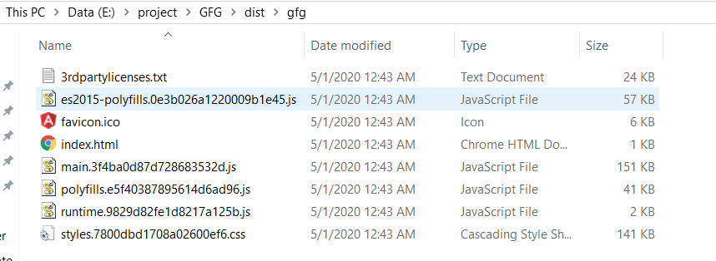

From <<https://www.geeksforgeeks.org/how-to-bundle-an-angular-app-for-production/>>

### command to update angular cli to latest version

ng update @angular/cli @angular/core

From <<https://angular.io/cli/update>>

### [**What is the difference between the "environment.TS" and "environment.prod.TS" files in Angular?**](https://www.quora.com/What-is-the-difference-between-the-environment-TS-and-environment-prod-TS-files-in-Angular)

“environment.ts” file is used when you run your project or try to make a build of your angular project in the development environment, this will be used for global configuration variables.

“environment.prod.ts” file is used when you run your project or try to make a build of your angular project in the production environment, this will be used for global configuration variables.

Both files consist the same JSON objects having the same keys but different values

### Can we have multiple index.html in application ?

Yes, micro front end example

### Can I have two components with same name in two diff modules ?

Yes,

Which renders it impossible to import all of the modules with the same name (unless you use the as syntax to "rename" them).

From <<https://stackoverflow.com/questions/44187925/same-names-for-components-with-angular>>

### main differences between the package.json and package.lock.json

|  |  |
| --- | --- |
| package.json | package.lock.json |
| It contains basic information about the project. | It describes the exact tree that was generated to allow subsequent installs to have the identical tree. |
| It is mandatory for every project. | It is automatically generated for those operations where npm modifies either node_modules tree or package.json. |
| It records important metadata about the project. | It allows future devs to install the same dependencies in the project. |
| It contains information such as name, description, author, script, and dependencies. | It contains the name, dependencies, and locked version of the project. |

From <<https://www.geeksforgeeks.org/difference-between-package-json-and-package-lock-json-files/>>

### Is constructor required in Angular ?

If your constructor is empty and has no parameters, you can safely remove it. If it has parameters declared as public or private those parameters are also member variables, in which case you might not be able to remove it - it depends on the rest of the class.

From <<https://stackoverflow.com/questions/63486890/angular-do-we-need-a-constructor-if-it-doesnt-have-any-logic>>

### Comparison between Ahead of Time (AOT) and Just in Time (JIT) –

|  |  |
| --- | --- |
| **JIT** | **AOT** |
| JIT downloads the compiler and compiles code exactly before Displaying in the browser. | AOT has already complied with the code while building your application, so it doesn’t have to compile at runtime. |
| Loading in JIT is slower than the AOT because it needs to compile your application at runtime. | Loading in AOT is much quicker than the JIT because it already has compiled your code at build time. |
| JIT is more suitable for development mode. | AOT is much suitable in the case of Production mode. |
| Bundle size is higher compare to AOT. | Bundle size optimized in AOT, in results AOT bundle size is half the size of JIT bundles. |
| You can run your app in JIT with this command:  ng build OR ng serve | To run your app in AOT you have to provide –aot at the end like:  ng build --aot OR ng serve --aot |
| You can catch template binding error at display time. | You can catch the template error at building your application. |

From <<https://www.geeksforgeeks.org/what-is-aot-and-jit-compiler-in-angular/>>

### Shared Library

<https://indepth.dev/posts/1193/create-your-standalone-angular-library-in-10-minutes>

### What is the use of shared module?

<https://angular.io/guide/sharing-ngmodules>

@[NgModule](https://angular.io/api/core/NgModule) takes a metadata object that describes how to compile a component's template and how to create an injector at runtime. It identifies the module's own components, directives, and pipes, making some of them public, through the exports property, so that external components can use them. @[NgModule](https://angular.io/api/core/NgModule) can also add service providers to the application dependency injectors.

From <<https://angular.io/guide/ngmodules>>

### What is an process of inserting an Embedded view dynamically ?

Embedded views are created from templates using [TemplateRef](https://angular.io/api/core/TemplateRef), while host views are created using a view (component) factory. For example, the main component that is used to bootstrap an application (AppComponent) is represented internally as a host view attached to the component’s host element (<app-comp>).

<https://indepth.dev/posts/1134/working-with-dom-in-angular-unexpected-consequences-and-optimization-techniques>

<https://medium.com/front-end-weekly/dynamically-add-components-to-the-dom-with-angular-71b0cb535286>

How to display list of users using comma delimiter

Methods to Create Comma Separated List from an Array:

* **using**[**Array join()**](https://www.geeksforgeeks.org/javascript-array-join-method/)**method**
* **using** [**Array toString()**](https://www.geeksforgeeks.org/javascript-array-tostring-method/)**method**
* **using Array literal**

<https://www.geeksforgeeks.org/create-a-comma-separated-list-from-an-array-in-javascript/>

### For showing pagination and values what have you used ?

Ng-grid and call to back end and show them in ng-grid table

### Have you written Unit Test cases ?

Yes, in Jasmine……..Jasmine....Experience.... test case sample

### Sort employees in ascending order of names ?

The Grid component provides built-in support for sorting data-bound columns in ascending or descending order. To enable sorting in the grid, set the [allowSorting](https://ej2.syncfusion.com/angular/documentation/api/grid/#allowsorting) property to **true**.

<https://ej2.syncfusion.com/angular/documentation/grid/sorting>

or

<https://www.freecodecamp.org/news/how-to-sort-alphabetically-in-javascript/>

### Throw pop-up if user is idle for sometime ?

Using ng-idle library

<https://www.npmjs.com/package/@ng-idle/core>

Cache....SessionStorage.... Is it a good approach to store LocalStorage ?

Data is stored in localstorage in one tab... Can we access localstorage in same application in another tab ? Yes

Display response for 1 Lakh records.... Logic

<https://blog.angular-university.io/angular-material-data-table/>

How do you create a material tab

<https://material.angular.io/components/tabs/overview>

How do you create a dialog box

Using MatDialog  of angular material

<https://material.angular.io/components/dialog/overview>

What is Steppers

<https://material.angular.io/components/stepper/overview>

How to extract selected results from Json

<https://medium.com/@anooprvarrier/angular-reading-data-from-json-file-using-httpclient-3c46ba1aaf22>

How we can assign unique color to each type of roles

The NgStyle directive lets you set a given DOM elements style properties.

How do we create custom pagination

<https://www.c-sharpcorner.com/article/custom-pagination-component-in-angular-6/>

Can we use one module component to other module components ?

Component can be declared in a single module only. In order to use a component from another module, you need to do two simple tasks:

1. Export the component in the other module
2. Import the other module, into the current module

<https://stackoverflow.com/questions/39601784/use-component-from-another-module>

How do we handle errors? What is mat-error ?

Error messages can be shown under the form field underline by adding mat-error elements inside the form field. Errors are hidden initially and will be displayed on invalid form fields after the user has interacted with the element or the parent form has been submitted. Since the errors occupy the same space as the hints, the hints are hidden when the errors are shown.

We used ng-toaster library to show errors.

How do you handle error status using 400 bad status ?

The basic way to handle errors in Angular is to use Angular's HttpClient service along with RxJS operators throwError and catchError. The HTTP request is made, and it returns the data with a response if anything wrong happens then it returns an error object with an error status code.

How to parse JSON object ?

Using JSON.parse(stringifiedData)

<https://www.c-sharpcorner.com/blogs/how-to-parse-and-stringify-json-data-using-angular>

How do u install material Ui in package.json ?

ng add @angular/material

How to design auto complete ?

In this article, you’ll learn how to implement your own autocomplete component using Angular and RXJS. For the demo, I’ll pass an array to the suggestion options. You can also get the options from an HTTP request through API. You have a choice for the options shown. Just fetch the options and store them into an array.

<https://medium.com/@shilpasyal55/building-autocomplete-search-component-from-scratch-angular-7b012339514>

<https://material.angular.io/components/autocomplete/overview>

Country... State... City... Drop-down.... Each drop-down dependent on one another

<https://blog.bitsrc.io/how-to-create-dependent-dropdown-in-angular-with-mat-select-and-rxjs-aaa14f5488d1>

Dashboard things... Dashboard frameworks.... Pie chart...

<https://www.ag-grid.com/angular-charts/pie-series/>

Language support in Application... Internationalisation... i18n.... Localisation

UI Testing... Karma... steps to execute... TestBed...

Change Theme in Application... using predefined css values and some conditions

How will be handle table when data is loading, when we are making http call.... This.loader= true ? ( loader... A msg )

<https://www.npmjs.com/package/ng-http-loader>

How will u handle error if response fails ?

Where will we keep urls for diff env ?

**src/environments folder…** After creating environment file we need to configure in angular.json file

### Where will we get which env we are ?

<https://www.itsolutionstuff.com/post/how-to-use-environment-variable-in-angularexample.html>

### Which compiler TS to JS code ?

The Angular ahead-of-time (AOT) compiler converts your Angular HTML and TypeScript code into efficient JavaScript code during the build phase before the browser downloads and runs that code.

### Can we reduce file bundle size ?

<https://danielk.tech/home/angular-how-to-improve-bundle-size#reduce-now>

### What is PWA ?

@angular/pwa is a library with Angular service worker support that provides a user experience as if the application were designed to run on your operating system and hardware.

## Modules and Components

**In Angular, modules are a way to organize and bundle related components, directives, pipes, services, and other features of an application.** Modules are an essential concept in Angular, and they play a crucial role in structuring and managing the application's architecture. Each Angular application has at least one root module, which is used to bootstrap the application. Additionally, an Angular application can have multiple feature modules that group related functionality.

### Key characteristics of Angular modules:

1. **Organization**: Modules provide a way to organize an application's components, services, and other features into cohesive and manageable units. This helps to keep the codebase clean and maintainable.
2. **Encapsulation**: Modules encapsulate components and other related artifacts, preventing naming collisions and isolating their functionality from other parts of the application.
3. **Reusability**: Modules can be reused across different parts of the application or even in other Angular projects. This promotes code reuse and modularity.
4. **Dependency Management**: Modules define a boundary for dependency injection in Angular. Components and services declared in a module can be easily injected into other components and services within the same module.
5. **Lazy Loading**: Angular supports lazy loading of feature modules. Lazy loading allows you to load modules only when they are needed, improving the initial loading time of the application.

### How to create an Angular module:

To create an Angular module, you use the **@NgModule** decorator. This decorator allows you to specify the components, directives, pipes, and services that belong to the module. The most common properties of **@NgModule** are:

1. **declarations**: This property includes the list of components, directives, and pipes that belong to the module.
2. **imports**: This property specifies other modules that are imported into the current module. This allows you to use components and services from other modules in the current module.
3. **providers**: This property allows you to define the services that are provided at the module level. These services will be available for injection throughout the module.
4. **exports**: This property lists the components, directives, pipes, and modules that you want to make available for other modules to use.

**Example of creating a simple module:**

import { NgModule } from '@angular/core';

import { CommonModule } from '@angular/common';

import { MyComponent } from './my-component.component';

@NgModule({

declarations: [MyComponent],

imports: [CommonModule],

exports: [MyComponent]

})

export class MyModule { }

In this example, **MyModule** is a simple module that declares and exports **MyComponent**. Other modules can now import and use **MyModule**, and they will have access to **MyComponent**.

Overall, Angular modules are a fundamental building block in Angular applications. They promote organization, reusability, and maintainability, making it easier for developers to manage and extend complex applications effectively.

What is Module in Angular? What is app.module.ts file?

Module is a place where you can group the components, directives, pipes, and services, which are related to the application.

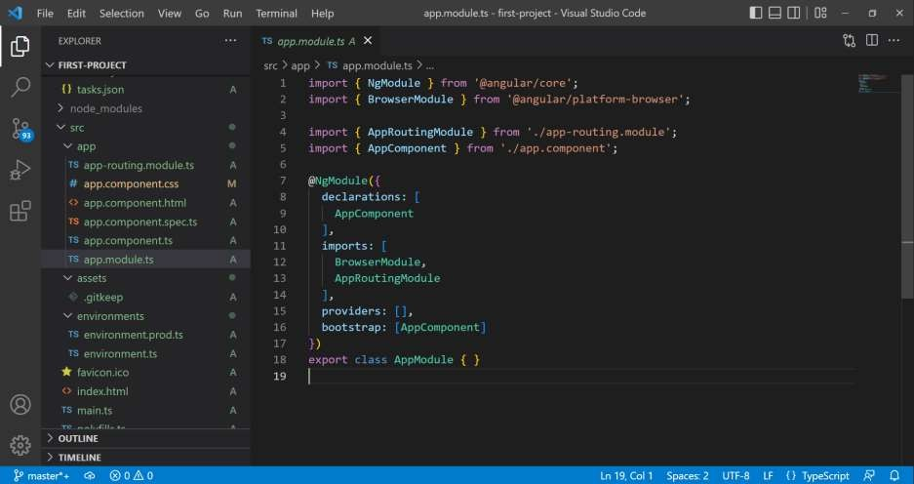

### What are Components in Angular?

In Angular, a **component is a fundamental building block of a user interface (UI) and represents a specific part of the application's user interface**. Components in Angular are responsible for defining the view, handling user interactions, and encapsulating the application's logic related to that particular part of the UI.

The Component is the main building block of an Angular Application. A Component contains the definition of the View and the data that defines how the View looks and behaves.  The Angular Components are plain javascript classes and defined using. @component Decorator. This Decorator provides the component with the View to display & Metadata about the class.

The Component passes the data to the view using a process called Data Binding. This is done by Binding the DOM Elements to component properties. Binding can display component class property values to the user, change element styles, respond to a user event, etc.

A component consists of three main parts:

1. **Component Class**: This is a TypeScript class that contains the data and methods for the component's behavior. It defines the properties and methods that the component uses to interact with the view and manage its state.
2. **Component Template**: This is an HTML markup that defines the component's UI and how the data from the component class is rendered in the view.
3. **Component Metadata**: This is represented using a decorator, **@Component**, which provides metadata for the component, such as its selector (HTML tag to use the component), template URL, style URL, and other configuration options.

**Creating a component in Angular:**

To create a component in Angular, you can use the Angular CLI (Command Line Interface), which provides a command to generate the necessary files and boilerplate code for a new component.

Here are the steps to create a component using the Angular CLI:

1. **Open a Terminal or Command Prompt**.
2. **Navigate to your Angular project directory**.
3. **Use the Angular CLI command to generate the component**. The syntax is as follows:

**ng generate component component-name**

or the shorthand version:

**ng g c component-name**

Replace **component-name** with the desired name of your component. The Angular CLI will automatically create the necessary files for the component, including the component class, template, styles, and add the component to the appropriate module.

For example, if you want to create a component called "my-component," you would use the following command:

ng generate component my-component

After running this command, you will find a new folder named "my-component" in your project's "src/app" directory. Inside that folder, you'll find the component class, template, styles, and other related files.

You can then customize the generated component class and template to implement the desired functionality and user interface for your application.

Once the component is created, you can use it in other parts of your application by adding its selector tag to the templates of other components or in the routing configuration. This way, Angular's component-based architecture allows you to build complex applications by combining and reusing smaller, modular components.

What is a Selector and Template?

A selector is used to identify each component uniquely into the component tree.

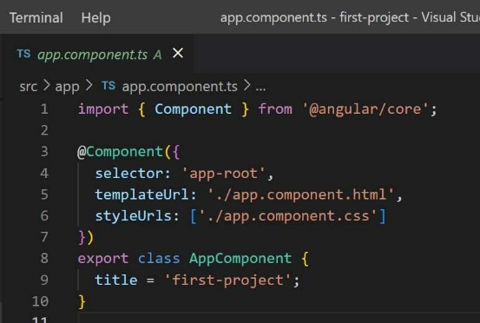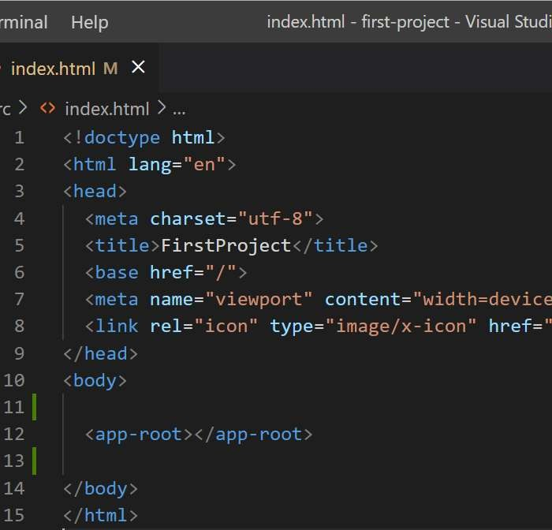

A Template is a HTML view of an Angular component.

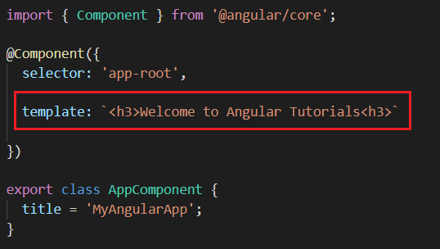

templateUrl is the link of the HTML template file.

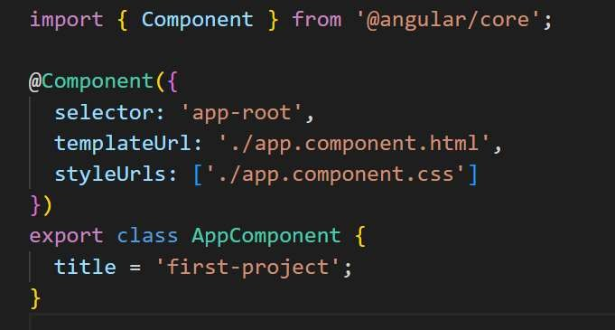

### How an Angular App gets Loaded and Started? What are index.html, app-root, selector and ts?

5 Steps executed when client send request from browser:

1. First, request hit index.html page.

2. Second, Index.html will invoke main.js file(which is the javascript version of main.ts file.)

3. Third, main.ts compiles the web-app and bootstraps the app.module.ts file.

4. Fourth, App-Module file will then bootstrap the app-component.

5. Finally, the App-component html will be displayed.

### What is a Bootstrapped Module & Bootstrapped Component?

The module which is loaded first, when the Angular application start is called Bootstrapped module.

By default, AppModule is the Bootstrapped module in Agular project.

The component which loaded first, after the module is called Bootstrapped component.

By default, AppComponent is the Bootstrapped component in Angular project.

### **Bootstraping in Angular: How Angular Works Internally**

From <<https://www.tektutorialshub.com/angular/angular-bootstrapping-application/>>

Angular takes the following steps to bootstrap the application:

1. Load index.html
2. Load Angular, Other Libraries, and App Code
3. Execute main.ts File
4. Load App-Level Module
5. Load App-Level Component
6. Process Template

From <<https://www.pluralsight.com/guides/bootstrapping-an-application-in-angular>>

### Diff b/w stateless and stateful component

Stateless Component: it doesn't have its internal state, it's driven by the parent which gives it all it needs at the moment.

Stateful Component: it can be guided by the father, but it has its own internal state for convenience

### about Generic component

Generic components in Angular help us implement components with better type safety.

## Data Binding

Data binding in Angular is a powerful feature that establishes a connection between the application's data (Model) and the user interface (View). It allows you to synchronize the data between the component and the HTML template, ensuring that changes to the data in one place are automatically reflected in the other. Angular supports four types of data binding:

1. **Interpolation (One-Way Binding):**
   * Interpolation is a one-way data binding technique that allows you to embed expressions or variables directly into the HTML template using double curly braces **{{ }}**
   * The expression inside the curly braces is evaluated and replaced with the corresponding value from the component's data.
   * Example: **<h1>{{ title }}</h1>**
2. **Property Binding (One-Way Binding):**
   * Property binding is another form of one-way data binding that allows you to bind data from the component's data to an HTML element's property using square brackets **[ ]**.
   * It allows you to set an HTML element's property value based on the component's data.
   * Example: **<input [value]="username">**
3. **Event Binding (One-Way Binding):**
   * Event binding allows you to listen to events, such as clicks or keystrokes, in the HTML template and respond to them by calling methods in the component.
   * It is achieved using parentheses **()** to bind event handlers to component methods.
   * Example: **<button (click)="onButtonClick()">Click Me</button>**
4. **Two-Way Data Binding:**
   * Two-way data binding combines both property binding and event binding, allowing data to flow in both directions between the component and the template.
   * It is achieved using the **[(ngModel)]** directive and is primarily used with form elements, such as input and select.
   * Example: **<input [(ngModel)]="username">**

The process of two-way data binding is a combination of property binding and event binding. When the user enters text into the input field, the property binding **[ngModel]** updates the component's **username** property with the entered value. Simultaneously, the event binding **(ngModelChange)** listens to changes in the input and updates the input field's value with the component's **username** property, ensuring that both the template and the component stay in sync.

Overall, data binding in Angular allows for seamless communication between the component and the template, reducing the need for manual DOM manipulation and simplifying the way data is presented and handled in the application. It is one of the key features that make Angular a powerful and user-friendly framework for building dynamic and interactive web applications.

## Directives

In Angular, directives are a type of component that allow you to extend the behavior of HTML elements. Directives enable you to manipulate the DOM, modify the appearance or behavior of elements, and create reusable components that encapsulate specific functionalities.

There are two main types of directives in Angular:

1. **Attribute Directives**: Attribute directives are used to change the behavior or appearance of an existing DOM element or component. They are applied as attributes of HTML elements and use the **@Directive** decorator in Angular. Attribute directives can modify the element's behavior or style based on the input provided in the directive.

Example of an attribute directive that changes the background color of an element:

**html**

<!-- component template -->

<div appBackgroundColor="red">This div has a red background color.</div>

**typescript**

**// attribute directive**

import { Directive, ElementRef, Input } from '@angular/core';

@Directive({

selector: '[appBackgroundColor]',

})

export class BackgroundColorDirective {

constructor(private el: ElementRef) {}

@Input('appBackgroundColor') backgroundColor: string;

ngOnInit() {

this.el.nativeElement.style.backgroundColor = this.backgroundColor;

}

}

In this example, the **BackgroundColorDirective** is an attribute directive that takes the color as an input and applies the specified background color to the target element.

1. **Structural Directives**: Structural directives are used to change the structure of the DOM by adding or removing elements based on a condition. They use the **\*** (asterisk) symbol in their notation in Angular. Common structural directives are **\*ngIf**, **\*ngFor**, and **\*ngSwitch**.

Example of a structural directive that conditionally renders an element:

**html**

<!-- component template -->

<div *ngIf="isLoggedIn">Welcome, {{ username }}!</div>

**typescript**

// component class

export class MyComponent {

isLoggedIn = true;

username = 'John';

}

In this example, the **\*ngIf** structural directive will render the **<div>** element only if the **isLoggedIn** property is true. If **isLoggedIn** is false, the element will not be included in the DOM.

The key difference between attribute and structural directives lies in their behavior:

* **Attribute Directives** modify the behavior or appearance of an existing element by applying the directive as an attribute to the element.
* **Structural Directives** change the DOM structure by adding or removing elements based on certain conditions, and they use the **\*** notation to indicate that they will be modifying the structure.

Both attribute and structural directives are powerful tools in Angular that allow developers to extend and customize the behavior of HTML elements and create dynamic and interactive user interfaces.

### Templates

In Angular, **templates are a fundamental part of the user interface (UI) development. They define how the application's data and components are rendered and displayed in the browser.** Templates are written in HTML with additional Angular-specific syntax and directives to provide dynamic content and functionality.

There are three main types of templates in Angular:

1. **Inline Templates**: Inline templates are defined directly within the component metadata using the **template** property. The template is written as a string enclosed within backticks (**`**).

Example of an inline template:

import { Component } from '@angular/core';

@Component({

selector: 'app-inline-template',

template: `

<h1>Hello, {{ name }}!</h1>

<p>This is an inline template in Angular.</p>

`,

})

export class InlineTemplateComponent {

name = 'John';

}

1. **External Templates**: External templates are defined in separate files and linked to the component using the **templateUrl** property. The template is written in an external HTML file.

Example of an external template:

import { Component } from '@angular/core';

@Component({

selector: 'app-external-template',

templateUrl: './external-template.component.html',

})

export class ExternalTemplateComponent {

name = 'Jane';

}

External templates are useful for separating the HTML from the component code, making it easier to maintain and manage larger templates.

1. **Inline Templates with <ng-template>**: Angular provides a powerful feature called the **<ng-template>** element, also known as the Angular template tag. It allows you to define reusable templates that are not rendered directly on the page but can be referenced and used elsewhere in the application.

Example of using **<ng-template>**:

import { Component } from '@angular/core';

@Component({

selector: 'app-ng-template-example',

template: `

<ng-template #greetingTemplate>

<h1>Hello, {{ name }}!</h1>

</ng-template>

<div *ngTemplateOutlet="greetingTemplate"></div>

`,

})

export class NgTemplateExampleComponent {

name = 'Alice';

}

In this example, we define an **<ng-template>** with the reference **#greetingTemplate**. Then, we use the **\*ngTemplateOutlet** directive to insert the content of the template into the **<div>** element.

Templates in Angular play a crucial role in defining the UI and displaying data. They are enriched with Angular-specific features like interpolation, property binding, event binding, structural directives, and more, allowing developers to create dynamic and interactive user interfaces. By using templates, developers can easily separate the concerns of the application and build maintainable and modular code.

What are Directives? What are the type of directives?

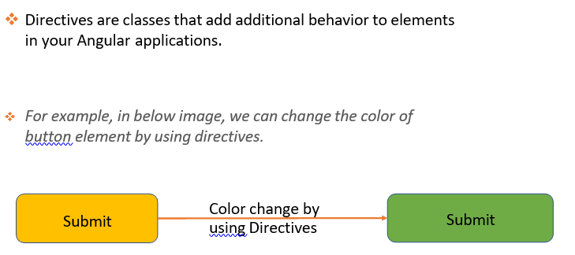

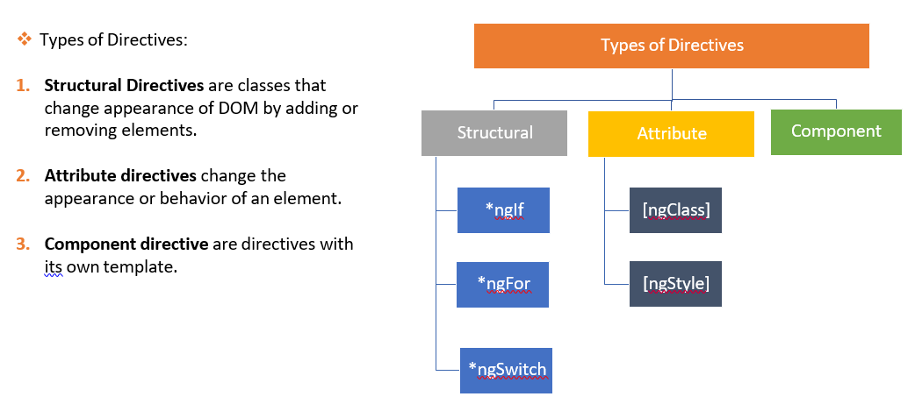

What is *ngIf Structural directive?

*ngIf is a structural directive, which is used to add or remove items based on the if condition.

What is *ngFor Structural directive?

*ngFor is a structural directive, which is used to iterate a list of items and then display them.

What is *ngSwitch Structural directive?

ngSwitch is a structural directive, which is used in combination with *ngSwitchCase and *ngSwitchDefault that are both structural directives.

What is [ngStyle] Attribute directive?

[ngStyle] is an attribute directive, which is used to updates styles of the HTML element.

What is [ngClass] Attribute directive?

[ngClass] is an attribute directive, which is used to add and remove CSS classes on an HTML element.

### What is the difference between Component, Attribute and Structural Directives?

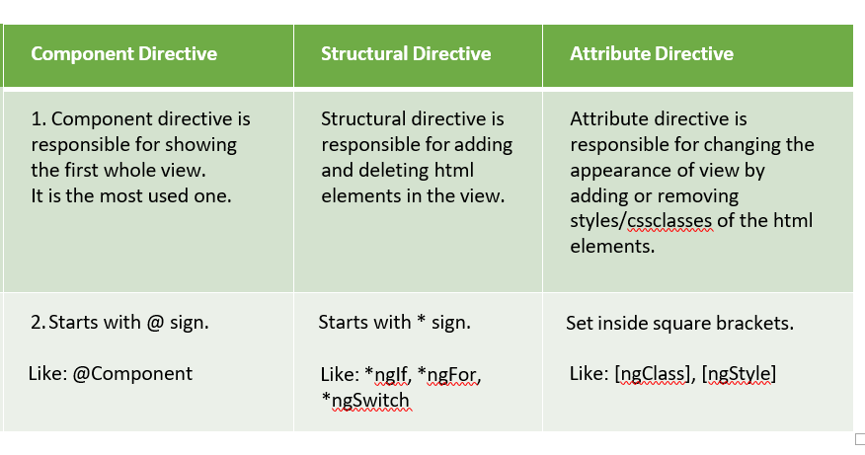

### Diff b/w hostbinding and hostlistener

In Angular, the @HostListener() function decorator allows you to handle events of the host element in the directive class.

In Angular, the @HostBinding() function decorator allows you to set the properties of the host element from the directive class.

<https://dzone.com/articles/what-are-hostbinding-and-hostlistener-in-angular>

<https://www.tektutorialshub.com/angular/hostbinding-and-hostlistener-in-angular/#host-element>

If you are using *ngFor or *ngIf, which angular provider module should we import ?

[CommonModule](https://angular.io/api/common/CommonModule) from @angular/common

From <<https://angular.io/guide/ngmodule-faq>>

How to Create & Use Custom Directive In Angular

From <<https://www.tektutorialshub.com/angular/custom-directive-in-angular/#creating-custom-attribute-directive>>

### Show active customer as green, show inactive customer as blue in table column ?

Directive or ngStyle or ngClass

### What is Decorator?

Angular decorators store metadata about a class, method, or property.

For example, in image @Component decorator store

metadata information about the app-component.

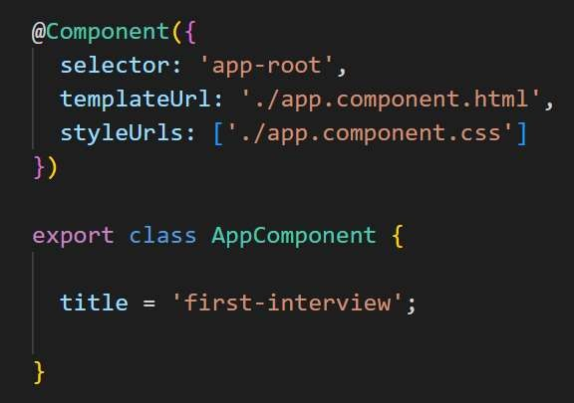

Metadata

All decorators are represented with @ symbol.

### What are the types of Decorator?

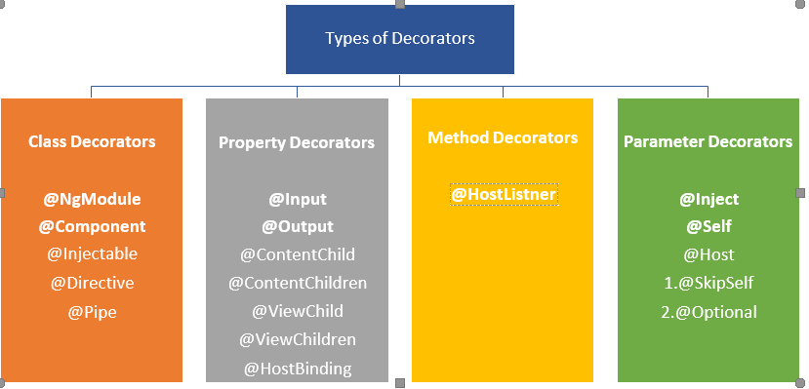

## Pipes

In Angular, pipes are a feature that allows you to transform and format data before displaying it in the user interface. Pipes are like functions that take an input value, perform a specific transformation, and then return the transformed output. They are used within template expressions and are denoted by the **|** symbol followed by the pipe name.

Angular provides several built-in pipes for common transformations, and you can also create custom pipes for specific use cases.

Here's how pipes help in data transformation:

1. **Data Formatting**: Pipes can format data in various ways, such as converting dates to specific formats, formatting numbers with decimal places or currency symbols, and displaying text in uppercase or lowercase.

Example using the **date** and **uppercase** built-in pipes:

<!-- component template -->

<p>Today's date is {{ currentDate | date:'dd/MM/yyyy' }}</p>

<p>{{ message | uppercase }}</p>

// component class

export class MyComponent {

currentDate = new Date();

message = 'hello, world!';

}

In this example, the **date** pipe is used to format the **currentDate** property as "dd/MM/yyyy", and the **uppercase** pipe is used to convert the **message** to uppercase.

1. **Data Filtering**: Pipes can be used to filter data based on specific criteria. For example, the **filter** pipe can be used to filter an array based on a search term or certain conditions.

Example using the **filter** built-in pipe:

<!-- component template -->

<input type="text" [(ngModel)]="searchTerm" placeholder="Search">

<ul>

<li *ngFor="let item of items | filter:searchTerm">{{ item }}</li>

</ul>

// component class

export class MyComponent {

searchTerm = '';

items = ['Apple', 'Banana', 'Orange', 'Mango'];

}

In this example, the **filter** pipe is used to filter the **items** array based on the **searchTerm**, allowing the user to search for specific items in the list.

1. **Data Manipulation**: Pipes can perform various data manipulations, such as sorting arrays, joining strings, extracting parts of strings, and more.

Example using the **sort** and **slice** built-in pipes:

<!-- component template -->

<p>Sorted numbers: {{ numbers | sort }}</p>

<p>First three items: {{ items | slice:0:3 }}</p>

// component class

export class MyComponent {

numbers = [5, 2, 8, 3, 1];

items = ['Apple', 'Banana', 'Orange', 'Mango'];

}

In this example, the **sort** pipe is used to sort the **numbers** array, and the **slice** pipe is used to get the first three items from the **items** array.

Pipes are a powerful feature in Angular that simplify data transformations and formatting in templates. They help keep the component code clean by moving data-related manipulations to the template level, enhancing code readability and maintainability. Additionally, you can create custom pipes for specific business logic, making them reusable across the application.

### ASYNC Pipe in Angular

The [async](https://angular.io/api/common/AsyncPipe) pipe subscribes to an Observable or Promise and returns the latest value it has emitted. When a new value is emitted, the [async](https://angular.io/api/common/AsyncPipe) pipe marks the component to be checked for changes. When the component gets destroyed, the [async](https://angular.io/api/common/AsyncPipe) pipe unsubscribes automatically to avoid potential memory leaks. When the reference of the expression changes, the [async](https://angular.io/api/common/AsyncPipe) pipe automatically unsubscribes from the old Observable or Promise and subscribes to the new one.

### What are Pipes? What are the types of Pipes & Parameterized Pipes?

Pipes are simple functions which accept an input value and return a transformed value.

Types of Pipes:

1. Built-in Pipes are provided by Angular framework. Like lowercase, uppercase, date etc.

2. Custom pipe, we can create and develop ourselves.

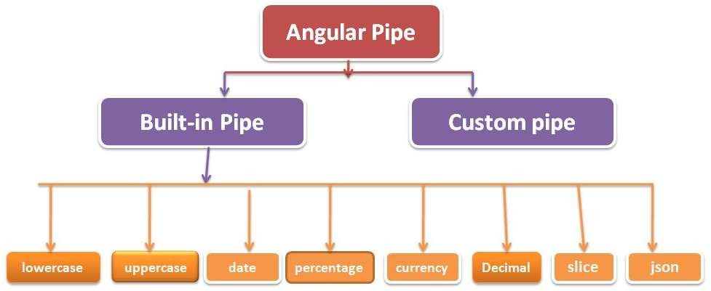

When we pass any parameters to the pipes, it is called parameterized pipes.

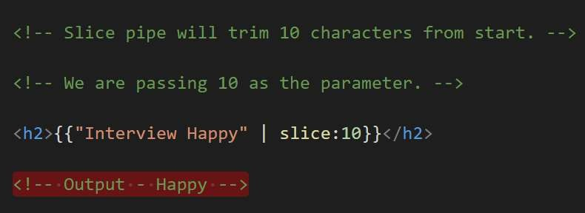

### What is Chaining Pipes?

The chaining pipes use multiple pipes on a data input.

For example, in below image one pipe is for slice and then other

pipe will further transform the result to uppercase

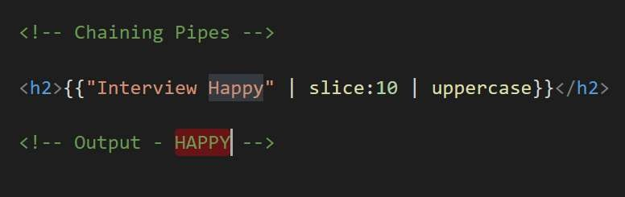

### Have u used custom pipes ? ( Search mechanism )

### How can we add filter, when we type something we should see only typing words in table ?

( approach need to discuss ) ( pipes can we use ) ( pipes with *ngFor )

### How pipe is different from directive?

A pipe is to manipulate data, while a directive is more for DOM manipulation.

A pipe gets data as an input, transforms it and outputs this data in another way.

A directive gets a DOM element its "attached" to and enhances it with some kind of features.

### How directive are different from component?

Other two directives are

1. Structural directives—change the DOM layout by adding and removing DOM elements. Ex:NgFor and NgIf.
2. Attribute directives—change the appearance or behavior of an element, component, or another directive. Ex: NgStyle

## Services and DI

### Dependency injection (DI)

Angular dependency injection (DI) is a design pattern and a core feature of the Angular framework that facilitates the management and injection of dependencies into classes and components. In DI, instead of creating objects and managing dependencies manually, Angular’s DI container is responsible for creating and providing instances of required objects or services to classes that need them.

Key aspects and significance of Angular dependency injection:

1. **Decoupling and Inversion of Control (IoC)**:
   * Dependency injection promotes the principle of Inversion of Control (IoC). Instead of components creating their dependencies, components specify their dependencies as constructor parameters or properties, and the DI container provides these dependencies.
   * This decouples the components from the responsibility of creating or managing their dependencies, making the code more modular and easier to maintain.
2. **Code Reusability and Testability**:
   * DI enhances code reusability since services and other dependencies can be easily shared among different components and modules. This promotes a more modular and maintainable codebase.
   * It also greatly simplifies unit testing, as dependencies can be easily mocked or stubbed during testing, allowing isolated testing of individual components.
3. **Simplified Dependency Management**:
   * Angular’s DI container automatically resolves and injects dependencies based on their registered providers. This eliminates the need for manual instantiation of dependencies and ensures that components receive the correct instances of their dependencies.
   * The DI system handles the creation and disposal of objects, avoiding memory leaks and reducing the risk of resource mismanagement.
4. **Hierarchical Dependency Injection**:
   * Angular's DI follows a hierarchical pattern, with a root injector at the application level and child injectors at component levels. This allows for a hierarchy of injectors, with components inheriting the dependencies provided at higher levels.
   * This hierarchy enables better control over the scope and lifetime of dependencies, making it easier to manage shared services or singleton instances.
5. **Provider Configuration**:
   * Providers are used to configure how dependencies are created and which instances should be provided for a specific token (dependency). Providers can be defined at various levels, such as the module level or the component level, allowing for fine-grained control over dependency injection.
6. **Lazy Loading and Optimization**:
   * Angular’s DI system supports lazy loading, allowing services and components to be loaded only when required. This can significantly improve the initial load time and reduce the size of the application bundle.

Overall, Angular’s dependency injection system is a powerful mechanism that enhances the modularity, testability, and maintainability of Angular applications. It provides a clean and organized way to manage dependencies and helps developers write more scalable and efficient code. By leveraging DI, developers can focus on building business logic and user interfaces while leaving the responsibility of dependency management to the Angular framework.

### Services

In Angular, **services are a way to organize and share code, data, and functionalities across multiple components in a modular and maintainable manner.** Services are typically used to encapsulate business logic, data retrieval from APIs, data manipulation, and other application-wide operations. They play a crucial role in separating concerns and promoting code reusability, making Angular applications more organized and easier to manage.

Key concepts and importance of Angular services:

1. **Dependency Injection (DI)**: Angular’s dependency injection system is a fundamental concept in the framework, and services are a core part of it. Services are registered with Angular’s DI container, making them available for injection into components or other services that require them. This decouples the components from the direct creation of their dependencies, promoting loose coupling and easier testing.
2. **Code Reusability and DRY Principle**: Services enable you to encapsulate functionalities that are commonly used throughout the application. By centralizing these functionalities in services, you avoid duplication of code across components and follow the Don't Repeat Yourself (DRY) principle. Components can then consume these services and access the shared functionality without having to implement it individually.
3. **Single Responsibility Principle (SRP)**: Angular services encourage adherence to the Single Responsibility Principle. By separating business logic and data-related operations into services, you keep your components focused on their primary responsibility – managing the user interface. This leads to cleaner and more maintainable code.
4. **State Management and Data Sharing**: Services can be used as a central hub for managing the application's state and sharing data between components. They can hold data, act as data stores, or use observables to communicate changes across different parts of the application. This enables seamless communication between components that would otherwise be isolated.
5. **Asynchronous Operations**: Services are often used to handle asynchronous operations such as making HTTP requests, handling timers, or performing other time-consuming tasks. By encapsulating these operations within services, you ensure that the components remain focused on their user interface responsibilities.
6. **Testing**: Using services allows for easier unit testing. Components can be tested independently by injecting mock services, making it simpler to isolate and test specific functionalities without the need for the entire application to be running.
7. **Lazy Loading and Optimization**: By separating functionalities into services, you can optimize your application's loading time. Lazy loading modules that include services can reduce the initial bundle size, as the service code will only be loaded when required, not upfront.

To create a service in Angular, you use the **@Injectable()** decorator. This decorator tells Angular that the class can be used as a service and that it might have its own dependencies to be injected.

Example of a simple Angular service:

*import { Injectable } from '@angular/core';*

*@Injectable({*

*providedIn: 'root', // This tells Angular to provide the service at the root level*

*})*

*export class DataService {*

*private data: string[] = ['Apple', 'Banana', 'Orange'];*

*getData(): string[] {*

*return this.data;*

*}*

*}*

Overall, Angular services are essential for structuring an application, promoting reusability, managing dependencies, and enhancing maintainability. They are a crucial part of the Angular architecture and are used extensively in real-world applications to create robust and efficient solutions.

Explain Services with Example?

A service is a typescript class and reusable code which can be used in multiple components.

How to create Service in Angular?

Service can be implemented in components with the help of dependency injection.

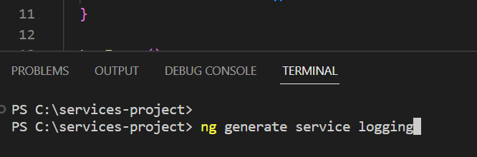

How to use Dependency Injector with Services in Angular?

4 Steps to inject service dependency in the component:

1. First step is, create the service – (LoggingService).

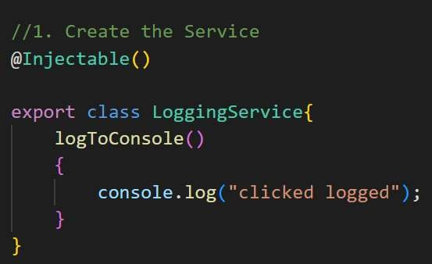

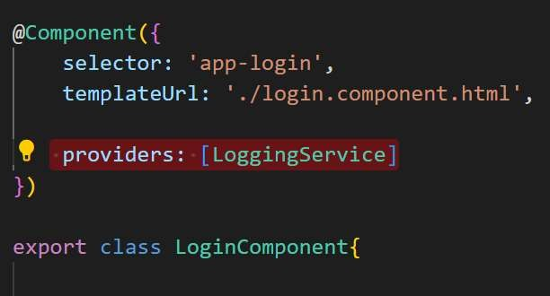2. Second step is, set the providers as the service name(LoggingService), inside the any component decorator as shown below.

3. Third step is, inside the constructor parameter create a new property(loggingService) and then assign the Service type(LoggingService) here.

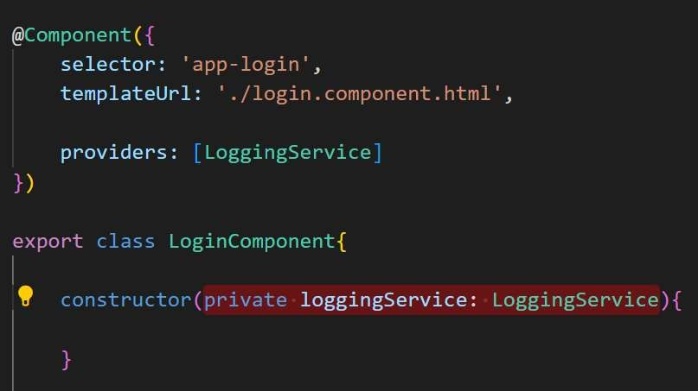

4. Finally use the property(loogingService), to call the method(logToConsole) of the LoggingService.

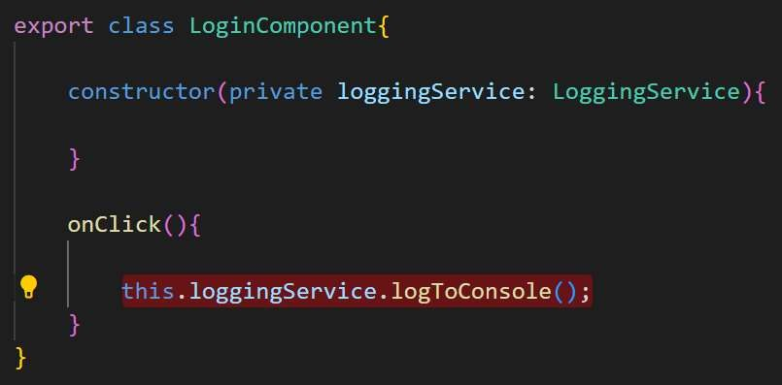

### What is Hierarchical Dependency Injection?

As per Angular, if we will inject the service in parent component, then service will be available to all it’s child components, but if we will inject the service directly in child component then it will not be available for Parent and siblings components.

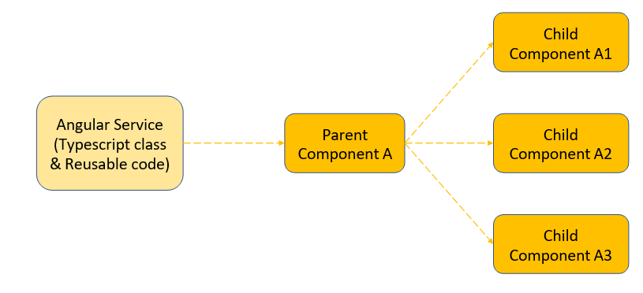

### What is Provider in Angular?

A provider is an object declared inside decorators which inform Angular that a particular service is available for injecting inside the components.

Provider can be set in module or in the component as shown below.

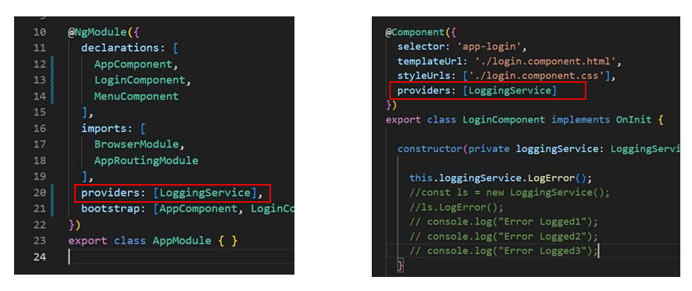

### What is the role of @Injectable Decorator in a Service?

With @Injectable decorator one service can be used by another service.

For example, in image we set the LoggingService as Injectable. That means, now any other service also can use LoggingService methods.

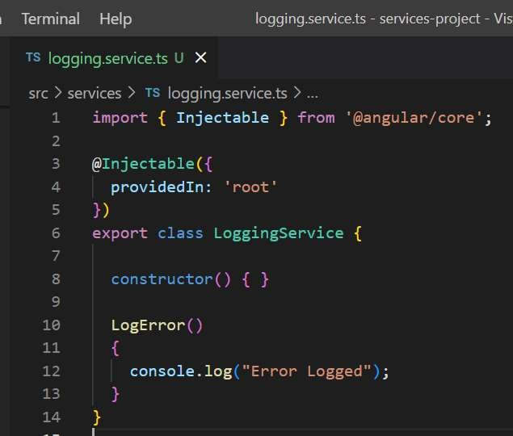

### How Angular Resolves Dependencies

<https://www.tektutorialshub.com/angular/how-dependency-injection-resolution-works-in-angular/>

### Resolution Modifiers in Angular DI

In Angular, resolution modifiers, such as @Self, @SkipSelf, @Optional, and @Host, are used in conjunction with dependency injection to control the scope and behavior of service resolution within the component hierarchy. These modifiers help determine where Angular should look for the required service when it's injected into a component or directive.

### Dependency Providers in Angular DI

<https://www.tektutorialshub.com/angular/angular-providers/>

### Questions about Injection Tokens

<https://www.tektutorialshub.com/angular/injection-token-in-angular/>

### Angular IVY

Ivy is the code name for Angular's [next-generation compilation and rendering pipeline](https://blog.angular.io/a-plan-for-version-8-0-and-ivy-b3318dfc19f7). With the version 9 release of Angular, the new compiler and runtime instructions are used by default instead of the older compiler and runtime, known as View Engine

What are Angular Providers

The **Angular Provider** is an instruction (or recipe) that describes how an object for a certain token is created. The **Angular Providers** is an array of such instructions (Provider). Each provider is uniquely identified by a **token** (or DI  Token ) in the Providers Array.

We register the services participating in the [dependency injections](https://www.tektutorialshub.com/angular/angular-dependency-injection/) in the Providers metadata. There are two ways by which we can do it.

* 1. Register directly in the Providers array of the @NgModule or @Component or in @Directive.
  2. Or use the providedIn property of the @[Injectable](https://www.tektutorialshub.com/angular/angular-injector-injectable-inject/) decorator.

From <<https://www.tektutorialshub.com/angular/angular-providers/#what-are-angular-providers>>

The [Angular Dependency Injection](https://www.tektutorialshub.com/angular/angular-dependency-injection/) provides several types of providers.

* Class Provider : useClass
* Value Provider: useValue
* Factory Provider: useFactory
* Aliased Class Provider: useExisting

From <<https://www.tektutorialshub.com/angular/angular-providers/>>

### How is service getting instantiated ?

Services are instantiated when you provide them.

What you are doing in the constructor is injecting an existing service instance into your class so that it can be used.

There are three ways to instantiate or provide a service:

One is in the app module.

@NgModule ({  
 providers:[myservice1,myservice2],  
})

This instantiates the service and makes it available throughout the application.

You can also provide it in a feature module, or shared module, and it accomplishes the same thing. If you provide it in the app module, then provide the same service in a feature module that is lazy loaded, it instantiates a second one that becomes globally available. The first one disappears into the ether.

If you want to instantiate a service for a specific component, and possibly have multiple instantiations one for each component, then you provide it in the component metadata.

@Component ({  
 providers: [myservice]  
})

Then you would inject it using the constructor.

From <<https://stackoverflow.com/questions/41215226/make-sure-a-service-is-instantiated>>

### Service need to be used only in a particular component not whole application ?

Another way to limit provider scope is by adding the service you want to limit to the component's providers array.

Component providers and NgModule providers are independent of each other.

This method is helpful when you want to eagerly load a module that needs a service all to itself.

Providing a service in the component limits the service only to that component and its descendants. Other components in the same module can't access it.

src/app/app.component.ts

@[Component](https://angular.io/api/core/Component)({  
 */  
 providers:[UserService]  
})

From <<https://angular.io/guide/providers#limiting-provider-scope-with-components>>

The @[Injectable](https://angular.io/api/core/Injectable)() decorator specifies that Angular can use this class in the DI system.

From <<https://angular.io/guide/dependency-injection#whats-next>>

@Inject() is **a manual mechanism for letting Angular know that a parameter must be injected**.

From <https://www.tektutorialshub.com/angular/angular-injector-injectable-inject/>

## COMPONENT COMMUNICATION

### communication between parent and child components

In Angular, communication between parent and child components can be achieved using the following methods:

1. **Input and Output Properties (Two-Way Binding)**:
   * Parent to Child (Input): The parent component can pass data to the child component using input properties. Input properties are decorated with **@Input()** in the child component, and they allow the parent component to bind data to the child component's properties.
   * Child to Parent (Output - Event Emitter): The child component can communicate with the parent component using output properties, which are Event Emitters. The child component emits events using the **EventEmitter** class, and the parent component can listen to these events and respond accordingly.

**Parent Component:**

import { Component } from '@angular/core';

@Component({

selector: 'app-parent',

template: `

<app-child [inputData]="dataFromParent" (outputEvent)="handleChildEvent($event)"></app-child>

`,

})

export class ParentComponent {

dataFromParent = 'Data from parent component';

handleChildEvent(eventData: any) {

console.log('Event received from child:', eventData);

}

}

**Child Component:**

import { Component, Input, Output, EventEmitter } from '@angular/core';

@Component({

selector: 'app-child',

template: `

<p>{{ inputData }}</p>

<button (click)="emitEvent()">Send Event to Parent</button>

`,

})

export class ChildComponent {

@Input() inputData: string = '';

@Output() outputEvent = new EventEmitter<any>();

emitEvent() {

this.outputEvent.emit('Event data from child');

}

}

1. **ViewChild and ViewChildren Decorators**:
   * The **ViewChild** and **ViewChildren** decorators allow the parent component to access child components or elements within the parent's template. This provides a way for the parent component to interact with its child components directly.

**Parent Component:**

import { Component, ViewChild } from '@angular/core';

import { ChildComponent } from './child.component';

@Component({

selector: 'app-parent',

template: `

<app-child></app-child>

<button (click)="callChildMethod()">Call Child Method</button>

`,

})

export class ParentComponent {

@ViewChild(ChildComponent) childComponent!: ChildComponent;

callChildMethod() {

this.childComponent.childMethod();

}

}

**Child Component:**

import { Component } from '@angular/core';

@Component({

selector: 'app-child',

template: `<p>Child Component</p>`,

})

export class ChildComponent {

childMethod() {

console.log('Child method called from parent');

}

}

1. **Service Communication**:
   * You can also use a shared service to facilitate communication between components. The service acts as a mediator, and components can interact with the service to share data or trigger actions.

**Shared Service:**

import { Injectable } from '@angular/core';

import { BehaviorSubject } from 'rxjs';

@Injectable({ providedIn: 'root' })

export class DataService {

private messageSource = new BehaviorSubject<string>('');

currentMessage = this.messageSource.asObservable();

changeMessage(message: string) {

this.messageSource.next(message);

}

}

**Parent Component:**

import { Component } from '@angular/core';

import { DataService } from './data.service';

@Component({

selector: 'app-parent',

template: `

<p>Parent Component</p>

<button (click)="sendMessageToChild()">Send Message to Child</button>

`,

})

export class ParentComponent {

constructor(private dataService: DataService) {}

sendMessageToChild() {

this.dataService.changeMessage('Message from parent');

}

}

**Child Component:**

import { Component, OnDestroy } from '@angular/core';

import { DataService } from './data.service';

import { Subscription } from 'rxjs';

@Component({

selector: 'app-child',

template: `<p>{{ message }}</p>`,

})

export class ChildComponent implements OnDestroy {

message: string = '';

private subscription: Subscription;

constructor(private dataService: DataService) {

this.subscription = this.dataService.currentMessage.subscribe((message) => {

this.message = message;

});

}

ngOnDestroy() {

this.subscription.unsubscribe();

}

}

These methods provide various ways to communicate between parent and child components in Angular. Depending on your specific use case and the level of communication required, you can choose the most appropriate approach.,

### What are Parent-Child Components?

Parent component is the outer component.

Child components are the components inside the parent component.

Most of the time app-component is only the parent component and rest of the components are child components

### What is @Input Decorator? How to transfer data from Parent component to Child component?

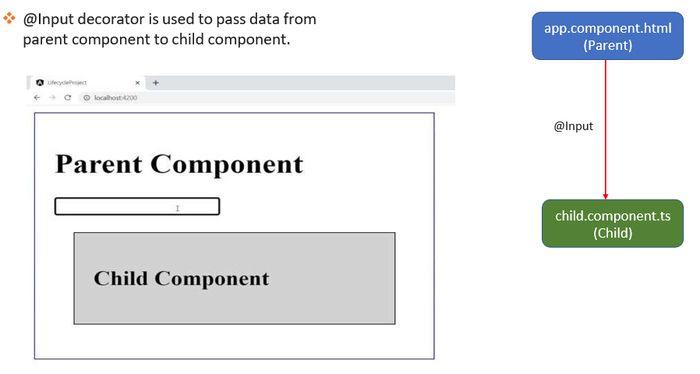

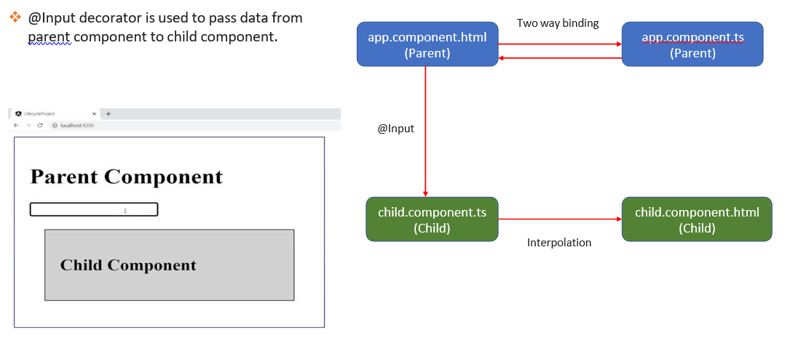

### What is @Output Decorator and Event Emitter?

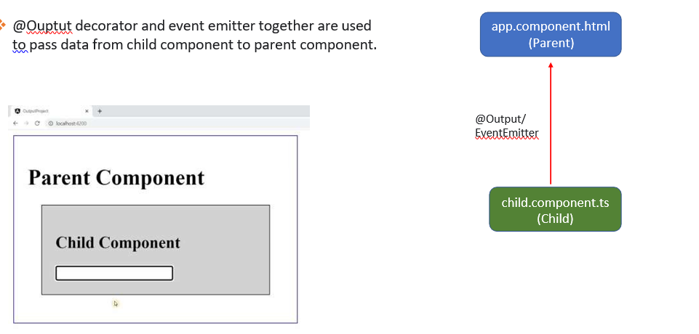

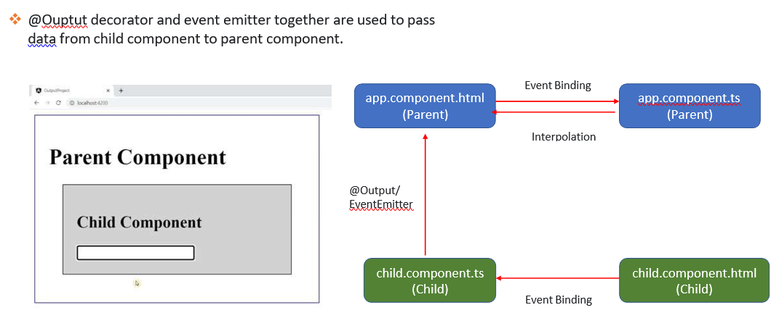

### What are the various ways to communicate between the components?

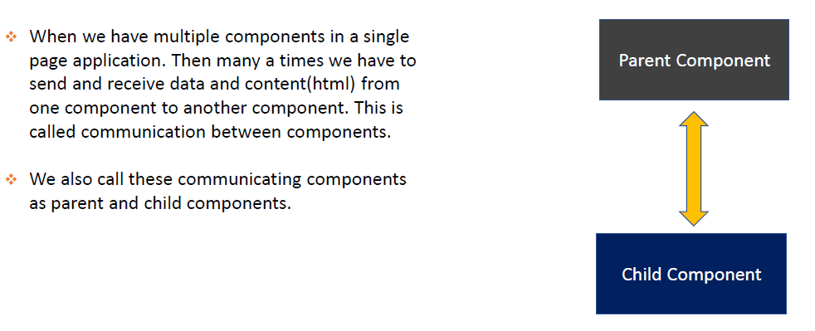

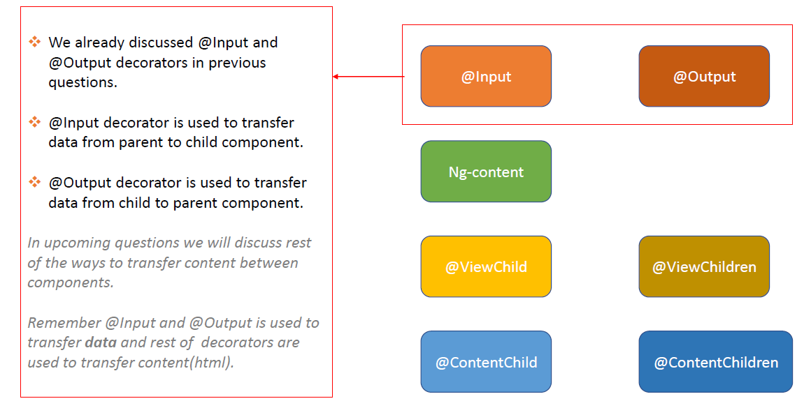

### What is ContentProjection? What is <ng-content>?

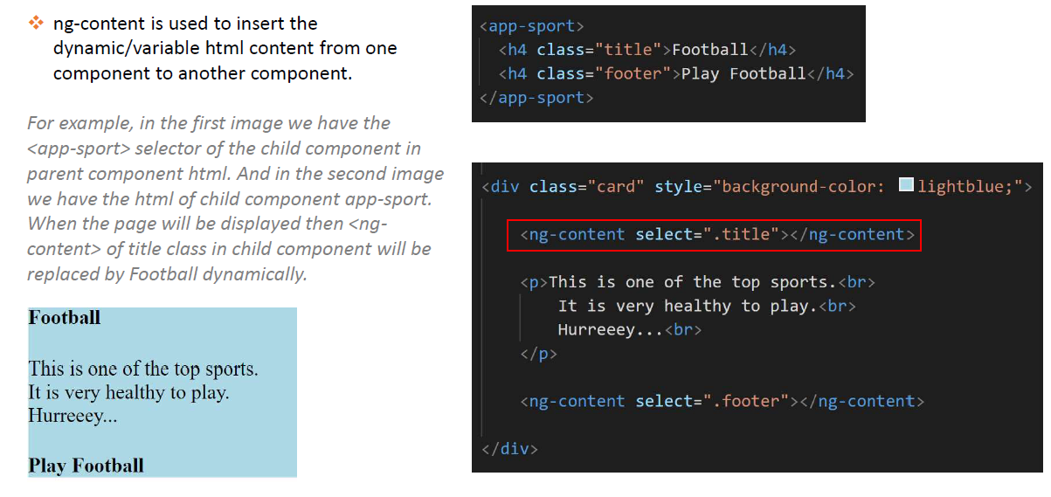

### What is Template Reference Variable in Angular?

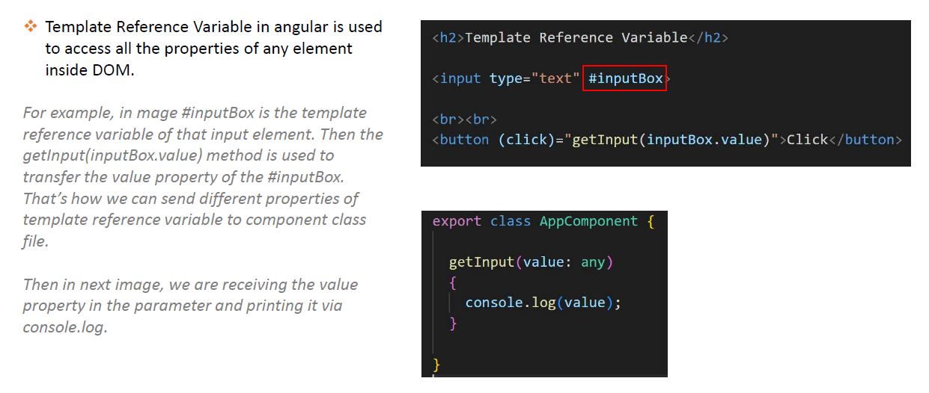

### What is the role of ViewChild in Angular ?

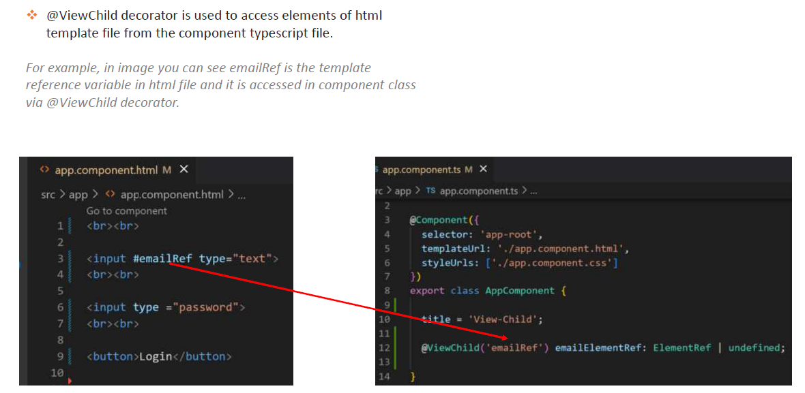

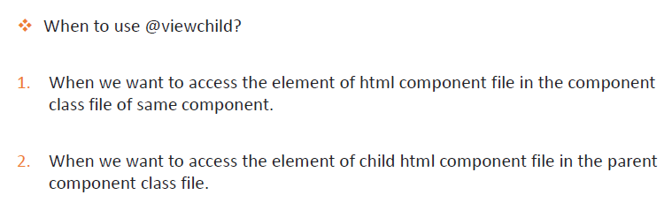

### How to access the child component from parent component with ViewChild ?

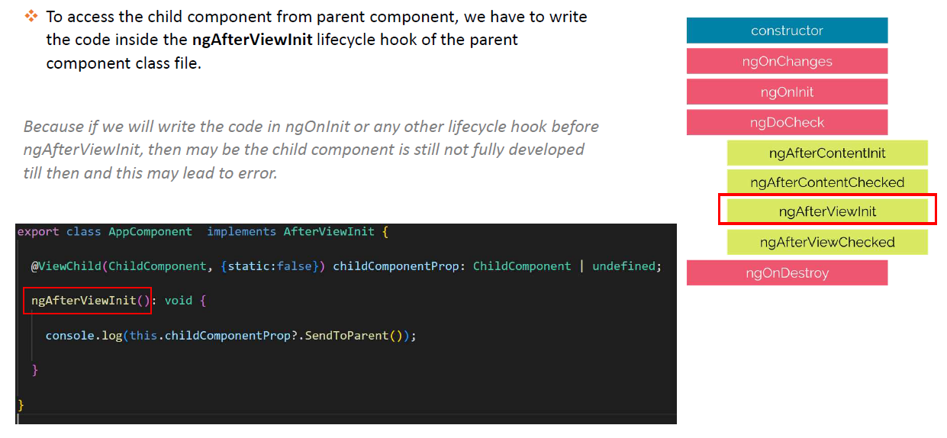

### What is the difference between ViewChild and ViewChildren? What is QueryList?

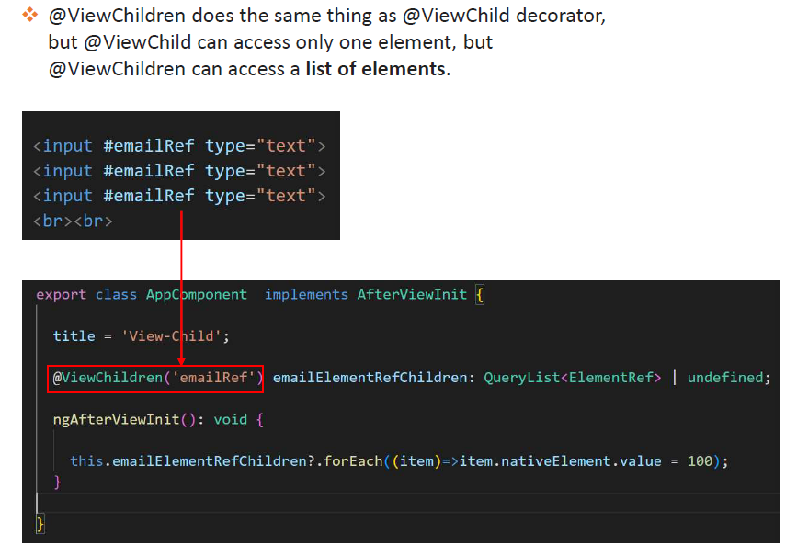

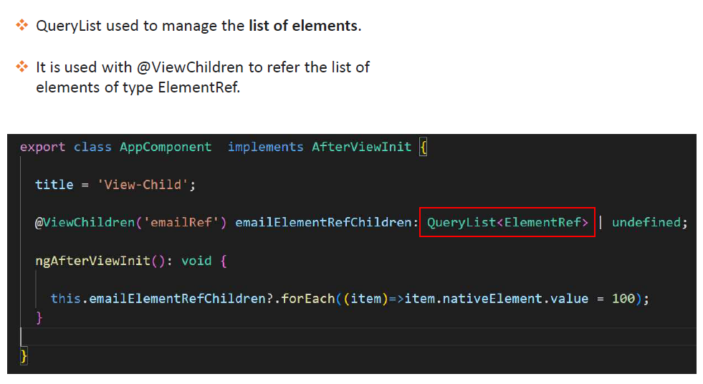

### What is ContentChild?

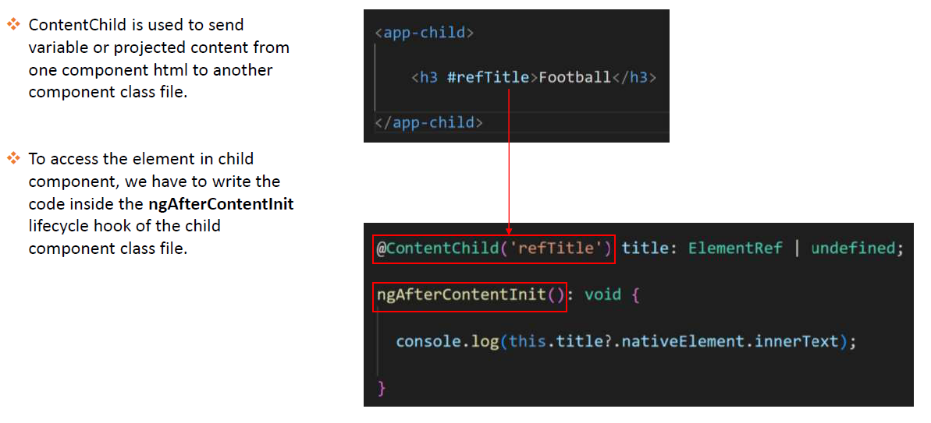

### What is the difference between ContentChild & ContentChildren?

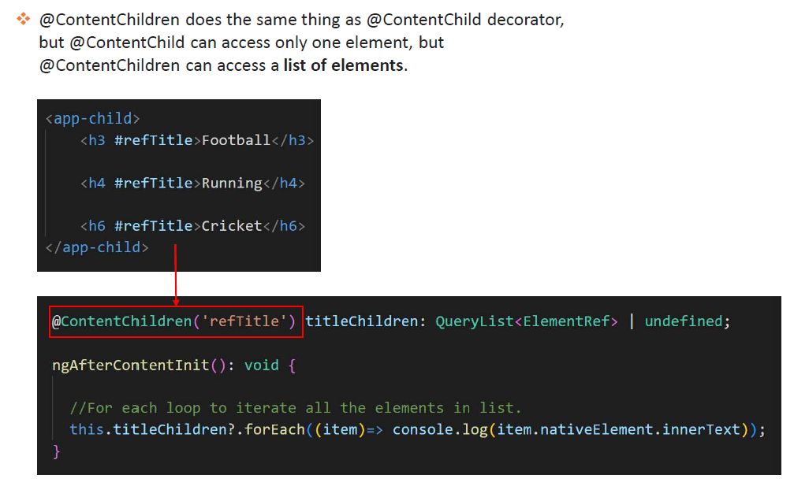

### Compare ng-Content, ViewChild, ViewChildren, ContentChild & ContentrChildren?

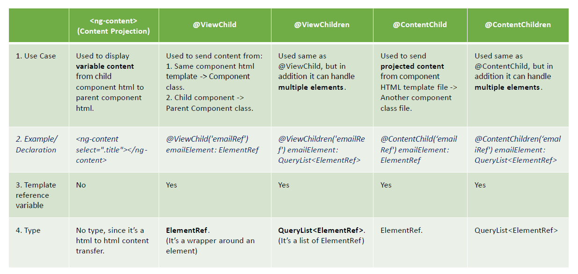

**Ng content vs ng template vs ng container**

<https://stackoverflow.com/questions/65053378/in-angular-what-ng-content-and-ng-template-does>

ng-content is used to project content at a specific place within a component.

Example:

<!-- custom.component.html -->

<h1>

<ng-content></ng-content>

</h1>

<!-- app.component.html -->

<app-custom>test</app-custom>

The code above would produce the following html:

<app-custom>

<h1>

test

</h1>

</app-custom>

ng-template is a block describing a template, a template is not rendered unless explicitly referenced or used.

The following code does not output any HTML:

<ng-template>

<div>Hello</div>

</ng-template>

But this one would display the div:

<ng-container *ngIf="false; else myTemplate"></ng-container>

<ng-template #myTemplate>

<div>Hello</div>

</ng-template>

Both will never be visible in the HTML code, they are only used by Angular.

Bonus:

ng-container is another Angular element used with structural directives (ngFor, ngIf), it does not produce HTML either.

So ng-container is useful when you want to conditionaly append a group of elements (ie using *ngIf="foo") in your application but don't want to wrap them with another element.

<div>

<ng-container *ngIf="true">

<h2>Title</h2>

<div>Content</div>

</ng-container>

</div>

EventEmitter is **a module that helps share data between components using emit() and subscribe() methods**. EventEmitter is in the Observables layer, which observes changes and values and emits the data to the components subscribed to that EventEmitter instance.

<https://www.tektutorialshub.com/angular/angular-input-output-eventemitter/#input-output-eventemitter>

What is Two way data binding

Two way data binding means that changes made to our model in the component are propagated to the view and that any changes made in the view are immediately updated in the underlying component data.

Two way data binding is useful in data entry forms. Whenever a user makes changes to a form field, we would like to update our model. Similarly, when we update the model with new data, we would like to update the view as well

From <<https://www.tektutorialshub.com/angular/ngmodel-two-way-data-binding-in-angular/>>

Data Sharing Between Angular Components

1. Parent to Child: via Input
2. Child to Parent: via Output() and EventEmitter
3. Child to Parent: via ViewChild
4. Unrelated Components: via a Service

From <<https://www.dotnettricks.com/learn/angular/sharing-data-between-angular-components-methods>>

How Input works ?

How Output Decorator works ?

<https://www.tektutorialshub.com/angular/angular-input-output-eventemitter/>

### Call Child Component method from Parent Component

We can use Viewchild to call Child Component method from Parent Component

From <<https://www.c-sharpcorner.com/article/call-parent-method-from-child-component-and-child-method-from-parent-component/>>

### Differences b/w component and directive :

* + A component is always elements (‘E’) where directive can be an attribute, element name, comment or CSS class (‘E’, ‘A’, ‘C’, ‘M’). Templates are the mandatory property and always required in Component, but Directive doesn’t always require them.
  + Component is used to break up the application into smaller components. But Directive is used to design re-usable components, which is more behavior-oriented. That is why components are widely used in later versions of Angular to make things easy and build a total component-based model.
  + As Component has views, viewEncapsulation can be defined. Whereas Directive doesn’t have views. So you can’t use viewEncapsulation in directive.
  + Although Components make it easier to write simple, effective code, it has a simpler configuration than plain directives, it is optimized for component-based architecture. But when not to use a component? The answer is – a component does not support “compile” and “pre-link” functions. So for manipulating DOM objects, we should use the directives.
  + Components should never modify any data or DOM that is out of their own scope. Directives have isolated scopes, by default the child inherits the scope from its parent.
  + Only one component can be present per DOM element. There can be more than one directive in a DOM element
  + To register component we use @Component meta-data annotation. For directive, we use @Directive meta-data annotation.

From <<https://www.geeksforgeeks.org/difference-between-directive-and-component-in-angularjs/>>

### What is the use of Template?

A template is a form of HTML that tells Angular how to render the component.

Views are typically arranged hierarchically, allowing you to modify or show and hide entire UI sections or pages as a unit. The template immediately associated with a component defines that component's *host view*.

From <<https://angular.io/guide/architecture-components#templates-and-views>>

### Which type of binding to pass data between view to component ?

Two way data binding

Angular provides various ways to share the data between component

* Using @Input decorator (Parent to Child)
* Using @Output decorator and EventEmitter (Child to Parent)
* Using @ViewChild decorator (Child to Parent)
* Using a Service (Unrelated Components)

From <<https://www.c-sharpcorner.com/article/sharing-the-data-between-components-in-angular/>>

**Content projection** is a pattern in which you insert, or *project*, the content you want to use inside another component. For example, you could have a Card component that accepts content provided by another component.

From <<https://angular.io/guide/content-projection>>

The **ng-content tag** is used for content projection. It is basically a placeholder to hold the dynamic content until it is parsed. Once the template is parsed, Angular replaces the tag with content.

From <<https://www.educative.io/edpresso/what-is-ng-content-in-angular>>

ViewChild Vs ContentChild

[ViewChild or ViewChildren](https://www.tektutorialshub.com/angular/understanding-viewchild-viewchildren-querylist-in-angular/) can access any DOM element, component, or directive. But it cannot be used to access the projected content.

While ContentChild or ContentChildren can access only the projected content, but cannot be used to access any other content.

From <<https://www.tektutorialshub.com/angular/contentchild-and-contentchildren-in-angular/#viewchild-vs-contentchild>>

### ViewContainerRef

Represents a container where one or more Views can be attached.

I’ll focus in the use of the ViewContainerRef to attach a component. This object is basically a $(<selector>) for Angular (DOM manipulation). Injecting this object into a Component’s constructor will give us that Component’s container and, with it, we can append a sibling Component to that container.

Diff b/w template and ngTemplate

ng-content is used to project content at a specific place within a component.

Example:

<!-- custom.component.html -->

<h1>

<ng-content></ng-content>

</h1>

<!-- app.component.html -->

<app-custom>test</app-custom>

The code above would produce the following html:

<app-custom>

<h1>

test  
 </h1>

</app-custom>

ng-template is a block describing a template, a template is not rendered unless explicitly referenced or used.

The following code does not output any HTML:

<ng-template>

<div>Hello</div>

</ng-template>

But this one would display the div:

<ng-container*ngIf="false; else myTemplate"></ng-container>

<ng-template #myTemplate>

<div>Hello</div>

</ng-template>

Both will never be visible in the HTML code, they are only used by Angular.

Bonus:

ng-container is another Angular element used with structural directives (ngFor, ngIf), it does not produce HTML either.

From <<https://stackoverflow.com/questions/65053378/ng-content-vs-ng-template>>

## Lifecycle Hooks

### Angular lifecycle hooks :

Angular lifecycle hooks are methods that provide developers with a way to tap into various stages of a component's lifecycle. These hooks allow you to perform actions at specific points during the creation, update, and destruction of Angular components. Understanding and using these hooks effectively can help you manage component behaviour, state, and interactions more efficiently. Angular lifecycle hooks can be categorized into two groups: Component lifecycle hooks and Directive lifecycle hooks.

**Component Lifecycle Hooks:**

1. **ngOnChanges():**
   * This hook is called when one or more data-bound input properties of the component change.
   * Use this hook to respond to changes in input properties and update the component state accordingly.
2. **ngOnInit():**
   * This hook is called once after the component has been initialized and its inputs have been set.
   * Use this hook to perform any setup tasks or initialization logic for the component.
3. **ngDoCheck():**
   * This hook is called during every change detection cycle, whenever Angular detects changes to a component.
   * Use this hook to implement **custom change detection logic**, but be cautious as it can impact performance if overused.
4. **ngAfterContentInit():**
   * This hook is called once after Angular projects external content (e.g., content inside **<ng-content>**).
   * Use this hook to perform initialization tasks that rely on the content projected into the component.
5. **ngAfterContentChecked():**
   * This hook is called after Angular checks the content that the component projects.
   * Use this hook for logic that needs to be executed whenever the content changes.
6. **ngAfterViewInit():**
   * This hook is called once after Angular initializes the component's views and child views.
   * Use this hook to perform setup tasks that require access to the component's view.
7. **ngAfterViewChecked():**
   * This hook is called after Angular checks the component's views and child views.
   * Use this hook for logic that needs to be executed whenever the view changes.
8. **ngOnDestroy():**
   * This hook is called just before the component is destroyed and removed from the DOM.
   * Use this hook to perform cleanup tasks, unsubscribe from observables, or release resources.

**Directive Lifecycle Hooks:**

1. **ngOnInit():**
   * Similar to the component's **ngOnInit()**, this hook is called once after the directive has been initialized and its inputs have been set.
   * Use this hook to perform setup tasks or initialization logic for the directive.
2. **ngOnChanges():**
   * Similar to the component's **ngOnChanges()**, this hook is called when one or more data-bound input properties of the directive change.
   * Use this hook to respond to changes in input properties and update the directive behavior accordingly.
3. **ngDoCheck():**
   * Similar to the component's **ngDoCheck()**, this hook is called during every change detection cycle, whenever Angular detects changes to the directive.
   * Use this hook to implement custom change detection logic for the directive.
4. **ngAfterContentInit():**
   * Similar to the component's **ngAfterContentInit()**, this hook is called once after Angular projects external content (e.g., content inside **<ng-content>**) that the directive affects.
   * Use this hook to perform initialization tasks that rely on the content projected into the directive.
5. **ngAfterContentChecked():**
   * Similar to the component's **ngAfterContentChecked()**, this hook is called after Angular checks the content that the directive affects.
   * Use this hook for logic that needs to be executed whenever the content changes.
6. **ngAfterViewInit():**
   * Similar to the component's **ngAfterViewInit()**, this hook is called once after Angular initializes the views affected by the directive.
   * Use this hook to perform setup tasks that require access to the views affected by the directive.
7. **ngAfterViewChecked():**
   * Similar to the component's **ngAfterViewChecked()**, this hook is called after Angular checks the views affected by the directive.
   * Use this hook for logic that needs to be executed whenever the view changes.
8. **ngOnDestroy():**
   * Similar to the component's **ngOnDestroy()**, this hook is called just before the directive is destroyed.
   * Use this hook to perform cleanup tasks, unsubscribe from observables, or release resources used by the directive.

**Use Cases:**

* **Initialization and Setup:** Use **ngOnInit()** and **ngAfterViewInit()** hooks to perform initialization and setup tasks for components or directives.
* **Data Binding and State Management:** Use **ngOnChanges()** to respond to changes in input properties and update component or directive state accordingly.
* **External Content Handling :**  Use **ngAfterContentInit()** and **ngAfterContentChecked()** hooks to handle projected content in components and directives.
* **Custom Change Detection:** Use **ngDoCheck()** to implement custom change detection logic if needed, although it should be used judiciously due to performance considerations.
* **Resource Cleanup:** Use **ngOnDestroy()** to perform cleanup tasks, such as unsubscribing from observables or releasing resources, to avoid memory leaks.
* **Dynamic View Changes:** Use **ngAfterViewChecked()** to react to changes in the view or apply changes to the view.

By understanding and leveraging Angular lifecycle hooks appropriately, you can manage the behavior and state of your components and directives effectively throughout their lifecycle, leading to better performance and maintainability in your Angular applications.

### Difference between constructor and onInit.

Constructor is predefined default method of the typescript class. There is no relation between Angular and constructor. Normally we use constructor to define/initialize some variables, but when we have tasks related to Angular's bindings we move to Angular's ngOnInit life cycle hook. ngOnInit is called just after the constructor call. We can also do the same work in the constructor but its preferable to use ngOnInit to start Angular's binding.

in order to use ngOnInit we have to import this hook from the core library:

import {Component, OnInit} from '@angular/core'

Then we implement this interface with exported class (this is not compulsory to implement this interface but generally we did).

Example of using both:

export class App implements OnInit{ constructor(){ //called first time before the ngOnInit() } ngOnInit(){ //called after the constructor and called after the first ngOnChanges() } }

Mostly we use ngOnInit for all the initialization/declaration and avoid stuff to work in the constructor. The constructor should only be used to initialize class members but shouldn't do actual "work".

So you should use constructor() to setup Dependency Injection and not much else. ngOnInit() is better place to "start" - it's where/when components' bindings are resolved

### Difference between constructor and ngOnInit

Constructor initializes class members.

ngOnInit() is a place to put the code that we need to execute at very first as soon as the class is instantiated.

From <<https://www.geeksforgeeks.org/what-is-the-difference-between-constructor-and-ngoninit-in-angularjs/>>

### What is Change Detection Strategy? ( Did u use CDS / custom CDS)



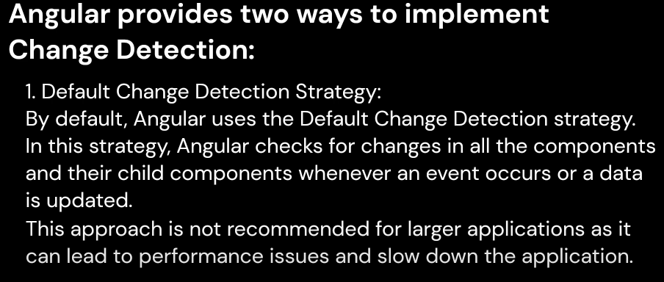

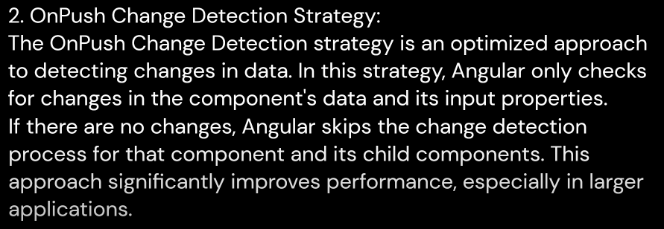

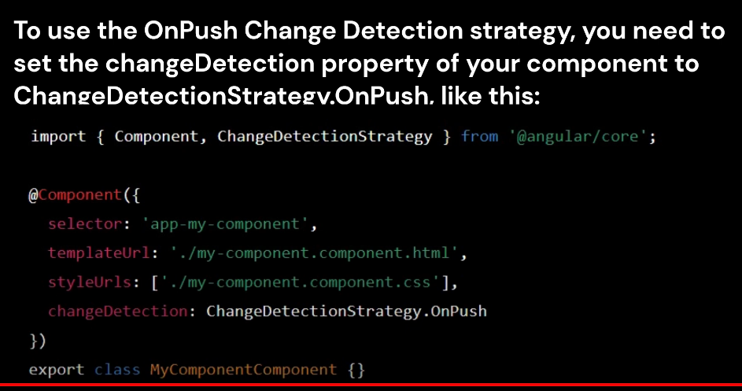

What are Lifecycle Hooks in Angular?

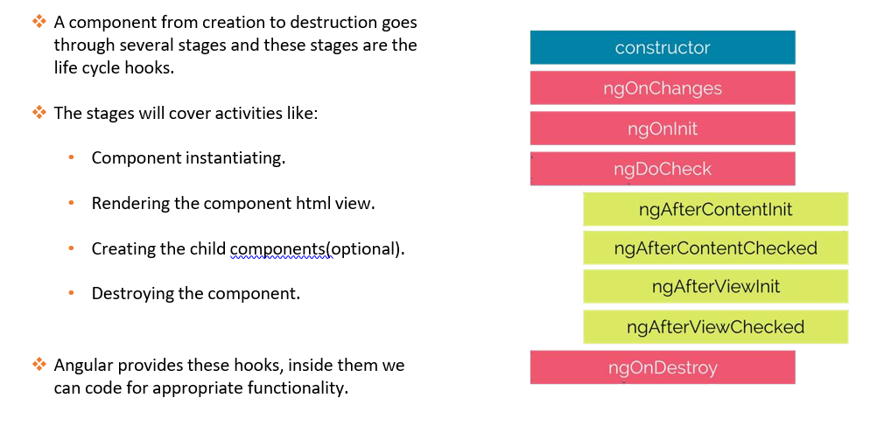

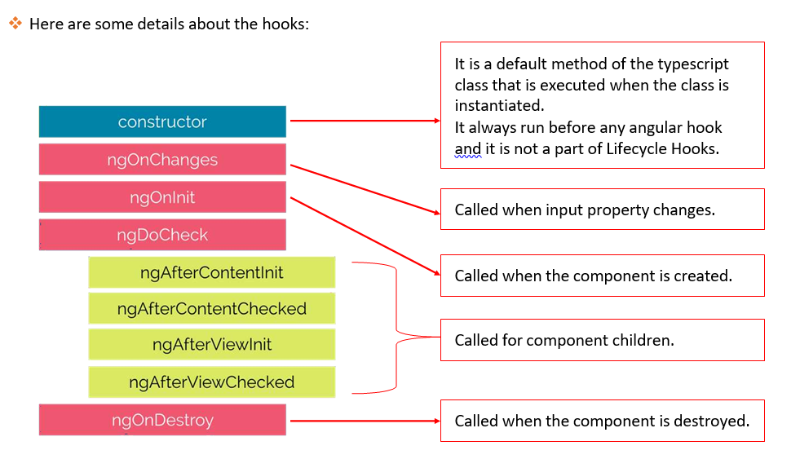

### What is a Constructor in Angular?

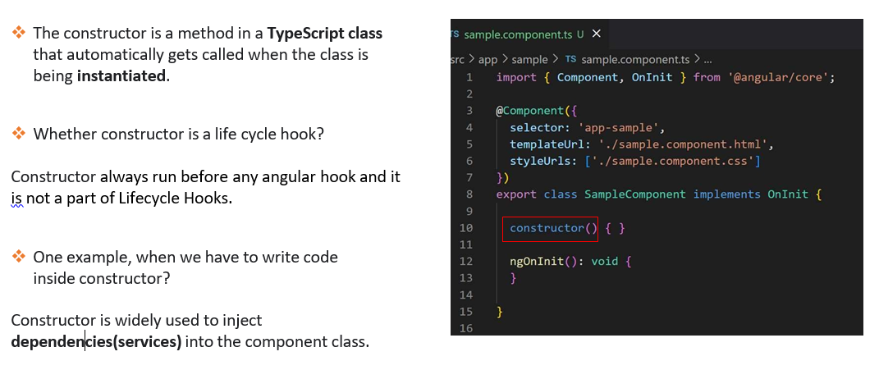

### What is ngOnChanges life cycle hook in Angular?

The ngOnChnages is the first life cycle hook, which angular fires when it detects any changes to the input property.

### What is ngOnInit life cycle hook in Angular?

1. NgOnInit signals the activation of the created component.

2. This is the second hook and called after ngOnChanges.

3. NgOnInit called only once during lifecycle.

4. By default, present in the component.

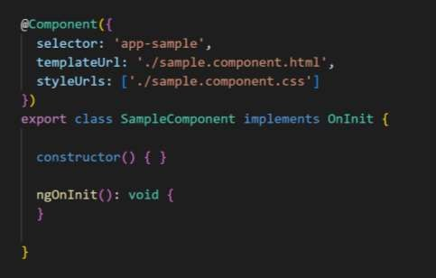

### What is the difference between constructor and ngOnInit?

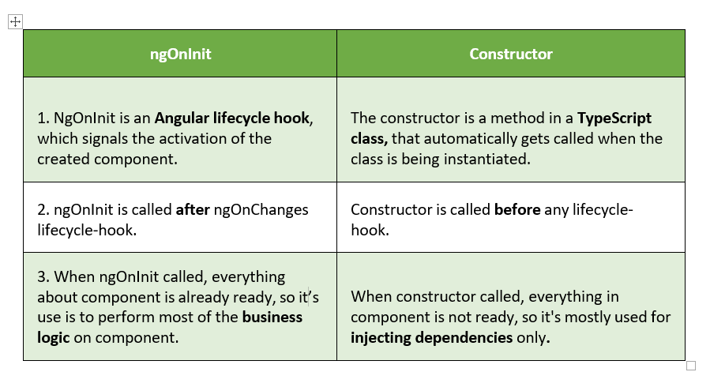

## Routing

### routing

Angular provides a powerful client-side routing system that allows developers to implement Single Page Applications (SPAs) with multiple views. **Angular's routing mechanism uses the Angular Router module to manage navigation between different components and views without requiring a full page reload.** Here's how Angular handles routing and navigation:

1. **Router Configuration**: To set up routing in an Angular application, you need to define the routes and their associated components in the application's main module (usually the AppModule) or in feature modules. Each route is defined by a path and the corresponding component that should be loaded when the user navigates to that path.

Example router configuration in **app.module.ts**:

import { NgModule } from '@angular/core';

import { RouterModule, Routes } from '@angular/router';

import { HomeComponent } from './home.component';

import { AboutComponent } from './about.component';

const routes: Routes = [

{ path: '', component: HomeComponent }, // Default route

{ path: 'about', component: AboutComponent },

];

@NgModule({

imports: [RouterModule.forRoot(routes)],

exports: [RouterModule],

})

export class AppModule {}

1. **Router Outlet**: To display the content of the routed components, you need a placeholder in the main template where the content will be rendered. This placeholder is called the **router-outlet**. It acts as a viewport for the currently active component as the user navigates through the application.

Example of using **router-outlet** in **app.component.html**:

<!-- app.component.html -->

<header>

<!-- Your app header here -->

</header>

<main>

<router-outlet></router-outlet>

</main>

<footer>

<!-- Your app footer here -->

</footer>

1. **Navigation Links**: Angular provides the **routerLink** directive to create navigation links in the templates. The **routerLink** directive generates appropriate links for navigation based on the defined routes.

Example of using **routerLink** for navigation in a component template:

<!-- home.component.html -->

<h2>Welcome to the Home page</h2>

<a routerLink="/about">Go to About page</a>

1. **Programmatic Navigation**: In addition to using navigation links, you can programmatically navigate to different routes using the Angular Router service. The **Router** class provides methods like **navigate()**, **navigateByUrl()**, and others for programmatic navigation.

Example of programmatic navigation in a component:

import { Component } from '@angular/core';

import { Router } from '@angular/router';

@Component({

selector: 'app-example',

templateUrl: './example.component.html',

})

export class ExampleComponent {

constructor(private router: Router) {}

goToAboutPage() {

this.router.navigate(['/about']);

}

}

1. **Route Parameters**: Routes can have parameters to pass data dynamically to the components. Parameters are defined in the route's path using a colon (**:**) followed by the parameter name.

Example of route parameter in the router configuration:

const routes: Routes = [

{ path: '', component: HomeComponent },

{ path: 'user/:id', component: UserDetailComponent },

];

In the above example, the **UserDetailComponent** can access the value of the **id** parameter through the **ActivatedRoute** service.

1. **Lazy Loading**: Angular supports lazy loading, where feature modules can be loaded on-demand as the user navigates to specific routes. Lazy loading helps reduce the initial application load time by loading only the required modules when needed.

Lazy loading example in router configuration:

const routes: Routes = [

{ path: '', component: HomeComponent },

{

path: 'lazy',

loadChildren: () => import('./lazy-module/lazy-module.module').then((m) => m.LazyModule),

},

];

In this example, the **LazyModule** will be loaded only when the user navigates to the **/lazy** route.

With the Angular Router, developers can build complex SPAs with multiple views and handle navigation seamlessly without requiring full page reloads. It enables the creation of a smooth and responsive user experience by dynamically updating the content in the **router-outlet** as users navigate through the application.

### **HttpClient** module

In Angular, HTTP requests are handled using the **HttpClient** module, which provides a simple and powerful way to interact with backend servers and APIs over HTTP or HTTPS. The **HttpClient** module is part of the **@angular/common/http** package and offers various methods for making different types of HTTP requests like GET, POST, PUT, DELETE, etc.

Here's how you handle HTTP requests in Angular using **HttpClient**:

1. **Import the HttpClientModule**: First, you need to import the **HttpClientModule** in your application's main module (usually the **AppModule**) to make **HttpClient** available throughout the application.

// app.module.ts

import { NgModule } from '@angular/core';

import { BrowserModule } from '@angular/platform-browser';

import { HttpClientModule } from '@angular/common/http';

@NgModule({

imports: [BrowserModule, HttpClientModule],

declarations: [/* Your components */],

bootstrap: [/* Your root component */],

})

export class AppModule {}

1. **Inject HttpClient into a Service or Component**: To use **HttpClient**, you need to inject it into a service or a component where you want to make HTTP requests. You can do this by adding it to the constructor of the service or component.

import { HttpClient } from '@angular/common/http';

@Injectable()

export class DataService {

constructor(private http: HttpClient) {}

}

1. **Making HTTP Requests**: After injecting **HttpClient**, you can use its methods to make HTTP requests. The most commonly used methods are:

* **get(url: string)**: To perform a GET request.
* **post(url: string, data: any)**: To perform a POST request.
* **put(url: string, data: any)**: To perform a PUT request.
* **delete(url: string)**: To perform a DELETE request.

Each method returns an **Observable** that represents the asynchronous result of the request. You need to subscribe to the Observable to trigger the actual HTTP request.

Example of a GET request:

import { Injectable } from '@angular/core';

import { HttpClient } from '@angular/common/http';

import { Observable } from 'rxjs';

@Injectable()

export class DataService {

constructor(private http: HttpClient) {}

getData(): Observable<any> {

return this.http.get<any>('https://api.example.com/data');

}

}

1. **Handling Response**: After making the request, you can handle the response using the **.subscribe()** method on the **Observable**. The response can be processed or used to update the component's state or perform other operations.

import { Component, OnInit } from '@angular/core';

import { DataService } from './data.service';

@Component({

selector: 'app-my-component',

template: '<div>{{ data }}</div>',

})

export class MyComponent implements OnInit {

data: any;

constructor(private dataService: DataService) {}

ngOnInit() {

this.dataService.getData().subscribe((response) => {

this.data = response;

});

}

}

1. **Error Handling**: You should also handle errors using the **.subscribe()** method's error callback or the **.catch()** operator if the Observable is piped with RxJS operators.

The **HttpClient** module takes care of important details like setting request headers, handling CORS, and providing mechanisms for interceptors to modify requests and responses globally.

By using **HttpClient**, you can efficiently interact with APIs, retrieve data from servers, and perform CRUD operations in Angular applications. Its simplicity, flexibility, and integration with RxJS make it a powerful tool for handling HTTP requests in Angular projects.

### guards

**Angular guards are a set of mechanisms provided by the Angular framework to control access to routes and secure different parts of an application based on certain conditions.** They are used to prevent unauthorized users from accessing certain routes or to execute certain logic before allowing navigation to specific routes.

Angular provides the following types of guards:

1. **CanActivate**: This guard is used to determine whether a user can activate a particular route. It checks if a user is allowed to navigate to a specific route and returns a boolean value indicating whether the navigation should be allowed or not.
2. **CanActivateChild**: Similar to **CanActivate**, but it applies to child routes. It checks whether a user can activate any child route within a parent route.
3. **CanDeactivate**: This guard is used to determine whether a user can deactivate a particular route. It checks if it is safe to navigate away from the current route and returns a boolean value indicating whether the navigation should be allowed or not.
4. **CanLoad**: This guard is used to determine whether a user can load a lazy-loaded module. It checks if a user is allowed to load a module lazily and returns a boolean value indicating whether the module should be loaded or not.
5. **Resolve**: The resolve guard is used to fetch some data or perform an action before activating a route. It ensures that the necessary data is available before rendering the component associated with the route.

To use guards, you need to define them and attach them to specific routes in the route configuration of your Angular application. Guards can be defined as individual services and should implement the corresponding guard interface (e.g., **CanActivate**, **CanActivateChild**, etc.).

Here's an example of using **CanActivate** guard to secure a route:

import { Injectable } from '@angular/core';

import { CanActivate, ActivatedRouteSnapshot, RouterStateSnapshot, Router } from '@angular/router';

@Injectable({ providedIn: 'root' })

export class AuthGuard implements CanActivate {

constructor(private router: Router) {}

canActivate(route: ActivatedRouteSnapshot, state: RouterStateSnapshot): boolean {

// Check if the user is logged in or has the necessary permissions

const isLoggedIn = /* Check if user is logged in */;

if (isLoggedIn) {

return true; // Allow navigation to the route

} else {

this.router.navigate(['/login']); // Redirect to the login page if not logged in

return false; // Block navigation to the route

}

}

}

In the route configuration, you can attach the **AuthGuard** to a specific route using the **canActivate** property:

import { NgModule } from '@angular/core';

import { RouterModule, Routes } from '@angular/router';

import { AuthGuard } from './auth.guard';

import { MyComponent } from './my.component';

const routes: Routes = [

{

path: 'protected-route',

component: MyComponent,

canActivate: [AuthGuard], // Attach the AuthGuard to secure this route

},

];

@NgModule({

imports: [RouterModule.forRoot(routes)],

exports: [RouterModule],

})

export class AppRoutingModule {}

In this example, the **AuthGuard** is used to check if the user is logged in before allowing access to the **'protected-route'**. If the user is not logged in, they will be redirected to the login page.

Angular guards play a critical role in securing routes and controlling access to various parts of an application. They help enforce authentication, authorization, and data loading logic before navigation, making Angular applications more secure and user-friendly.

What is Routing? How to setup Routing?

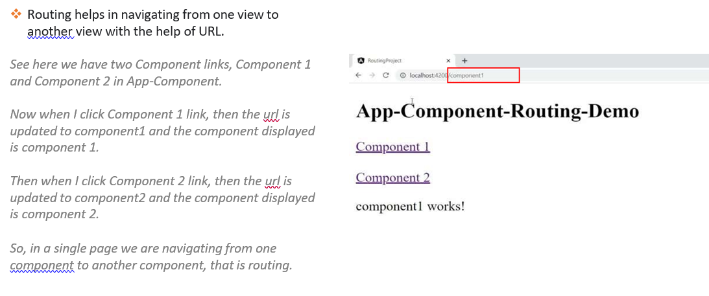

What is router outlet?

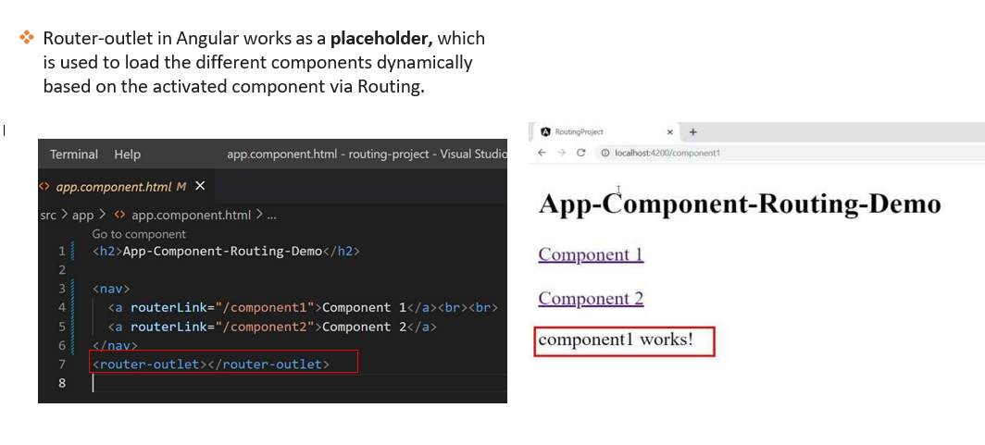

What are router links?

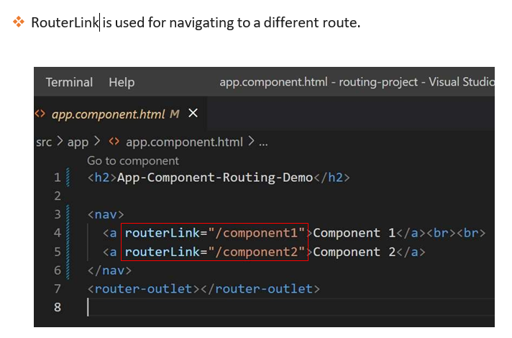

**Route Params :**

<https://www.tektutorialshub.com/angular/angular-passing-parameters-to-route/>

this._Activatedroute.paramMap.subscribe(params => {

this.id = **params.get('id')**;

});

**Query params:**

<https://www.digitalocean.com/community/tutorials/angular-query-parameters>

this._Activatedroute.queryParams

.subscribe(params => {

console.log(params); // { order: "popular" }

this.order = **params.order;**

console.log(this.order); // popular

}

);

}

{ queryParams: { order: 'popular' }

{ queryParamsHandling: 'preserve' } //preserve/merge

this.router.navigate(['/'], { queryParamsHandling: 'preserve' })

<a [routerLink]="['/page-2']" [routerLinkActive]="['is-active']" queryParamsHandling="merge">

**What is the use of base href?**

The <base> HTML element specifies **the base URL to use for all relative URLs in a document**. There can be only one <base> element in a document. A document's used base URL can be accessed by scripts with Node/baseURI . If the document has no <base> elements, then baseURI defaults to location.href

**Auth Guard**

<https://medium.com/@ryanchenkie_40935/angular-authentication-using-route-guards-bf7a4ca13ae3>

* CanActivate
* CanActivateChild
* CanDeactivate
* CanLoad
* Resolve

**canActivate** is used to prevent unauthorized users from accessing certain routes. [See docs](https://angular.io/guide/router#canactivate-requiring-authentication) for more info.

**canLoad** is used to prevent the application from loading entire modules lazily if the user is not authorized to do so

Consider we have a API URL, how we will consume the API URL to retrieve the data ?

<https://www.geeksforgeeks.org/angularjs-fetch-data-from-api-using-httpclient/>

What is the exact Angular class that we will use under method to retrieve the data from the URL ?

Steps to get query parameters from URL route in Angular

1. import ActivatedRoute from ‘@angular/router’.

2. Inject ActivatedRoute class in constructor.

3. Access queryParams property of ActivatedRoute class which returns an observable of the query parameters that are available in the current URL route.

<https://www.angularjswiki.com/angular/get-query-parameters-in-angular/>

What is method we use for HTTPClient to get data ?

HttpClient.**get**()

HTTP Interceptors in Angular

From <<https://www.tektutorialshub.com/angular/angular-httpclient-http-interceptor/>>

**What's the Router Outlet in Angular?**

The router-outlet is a directive that's available from the @angular/router package and is used by the router to mark where in a template, a matched component should be inserted.

Thanks to the router outlet, your app will have multiple views/pages and the app template acts like a shell of your application.

From <<https://www.techiediaries.com/angular-9-8-router-outlet/>>

### What is the diffrence between RouterModule.forRoot() vs RouterModule.forChild()? Why is it important?

* forRoot creates a module that contains all the directives, the given routes, and the router service itself.
* forChild creates a module that contains all the directives and the given routes, but does not include the router service. It registers the routers and uses the router service created at the root level.
* This is important because location is a mutable global property. Having more than one object manipulating the location is not a good idea.

From <<https://github.com/Yonet/Angular-Interview-Questions/blob/main/router.md>>

|  |  |
| --- | --- |
| pathMatch?: string | The path-matching strategy, one of 'prefix' or 'full'. Default is 'prefix'.  By default, the router checks URL elements from the left to see if the URL matches a given path and stops when there is a config match. Importantly there must still be a config match for each segment of the URL. For example, '/team/11/user' matches the prefix 'team/:id' if one of the route's children matches the segment 'user'. That is, the URL '/team/11/user' matches the config {path: 'team/:id', children: [{path: ':user', component: User}]} but does not match when there are no children as in {path: 'team/:id', component: Team}.  The path-match strategy 'full' matches against the entire URL. It is important to do this when redirecting empty-path routes. Otherwise, because an empty path is a prefix of any URL, the router would apply the redirect even when navigating to the redirect destination, creating an endless loop. |

From <<https://angular.io/api/router/Route#properties>>

Child Routes / Nested Routes

From <<https://www.tektutorialshub.com/angular/angular-child-routes-nested-routes/>>

Route Guards

From <<https://www.tektutorialshub.com/angular/angular-route-guards/#angular-route-guards>>

What are Route Parameters

The Route parameters are a dynamic part of the Route and essential in determining the route.

From <<https://www.tektutorialshub.com/angular/angular-passing-parameters-to-route/#what-are-route-parameters>>

What are query parameters

Query parameters are optional parameters that you pass to a route. The query parameters are added to the end of the URL Separated by Question Mark

From <<https://www.tektutorialshub.com/angular/angular-passing-optional-query-parameters-to-route/#what-are-query-parameters>>

**How to Create Multiple Router-Outlets?**

You can have multiple outlets in the same template:

<router-outlet></router-outlet><router-outletname="sidebar"></router-outlet>

* The unnamed outlet is the primary outlet.
* Except for the primary outlet, all other outlets must have a name.

From <<https://www.techiediaries.com/angular-router-multiple-outlets/#Create_Multiple_Router_Outlets>>

How do you make routing using anchor tag

<https://www.cloudhadoop.com/angular-anchor-click-event/>

RouterLink, Navigate and NavigateByUrl

From <<https://www.techiediaries.com/angular-router-routerlink-navigate-navigatebyurl/>>

Passing Parameters to Route

From <<https://www.tektutorialshub.com/angular/angular-passing-parameters-to-route/>>

**What Is HttpClient?**

HttpClient is a built-in service class available in the @angular/common/http package. It has multiple signature and return types for each request. It uses the RxJS observable-based APIs, which means it returns the observable and what we need to subscribe it. This API was developed based on XMLHttpRequest interface exposed by browsers.

From <<https://www.telerik.com/blogs/angular-basics-how-to-use-httpclient>>

The routerLink directive replaces the href attribute of anchor(<a>) tags to create links and routerLinkActive is used for making the active link.

For example.

<a [routerLink]="/products" [routerLinkActive]="/products">Products</a>

From <<https://www.c-sharpcorner.com/article/angular-routing-tutorial/>>

How do u make routing in ts file ?

<https://www.itsolutionstuff.com/post/how-to-create-routing-module-in-angular-11example.html>

How to authenticate user ?

Using token, store session

Restrictions based on user roles ?

Routing Guards

What is the difference between HttpClient and HttpClientModule?

Answer: They both support HTTP calls but HTTP is the older API and will eventually be deprecated. The new HttpClient service is included in the HttpClientModule that used to initiate HTTP request and responses in angular apps. **The HttpClientModule is a replacement of HttpModule**.

How will u create a Route ? ( explain starting from app.route ts)

How will u use the customer id from url to load the details in new ui ? ( Routing Navigation, QueryParam.id )

How current application is loaded (In respect to Routing ) ?

How do we invoked backend services using angular

How we can authenticate while navigating to child component ? AuthGuard

### Lazy loading

**Lazy loading** is a technique used in Angular to load modules on-demand or lazily when they are needed instead of loading all modules upfront when the application starts. This can significantly improve the initial loading time of the application, as only the essential modules are loaded initially, and other modules are fetched when the user navigates to specific routes or features that require them.

To implement lazy loading in Angular, follow these steps:

1. **Create Separate Modules:** Organize your application into separate feature modules. Each module should encapsulate related components, services, and other resources.
2. **Routing Configuration:** In your main **app-routing.module.ts**, configure the routes for your application. For modules that you want to load lazily, use the **loadChildren** property instead of the **component** property in the route configuration.

const routes: Routes = [

{ path: '', redirectTo: 'home', pathMatch: 'full' },

{ path: 'home', component: HomeComponent },

{ path: 'lazy', loadChildren: () => import('./lazy/lazy.module').then(m => m.LazyModule) },

// Other routes...

];

1. **Module Imports:** Ensure that the lazy-loaded module is imported in the **app.module.ts**, but not in any other module. Importing it only in the **app.module.ts** allows Angular's build optimizer to generate separate chunks for lazy-loaded modules.

// app.module.ts

import { NgModule } from '@angular/core';

import { BrowserModule } from '@angular/platform-browser';

import { RouterModule } from '@angular/router';

import { AppComponent } from './app.component';

import { routes } from './app-routing.module';

@NgModule({

declarations: [AppComponent],

imports: [

BrowserModule,

RouterModule.forRoot(routes),

],

bootstrap: [AppComponent],

})

export class AppModule { }

1. **Build and Serve:** Now, build your Angular application. When you serve the application, you will notice that the lazy-loaded module's code is not included in the initial main bundle. Instead, it generates a separate chunk (JavaScript file) for the lazy-loaded module.
2. **Lazy Loading in Action:** When the user navigates to a route that loads the lazy-loaded module, Angular will fetch the separate chunk containing the module's code on-demand. The user will experience a slight delay when accessing that route for the first time as the module is fetched, but subsequent navigation to the same route will be faster as the chunk is cached by the browser.

By implementing lazy loading in your Angular application, you can optimize its loading time, especially for larger applications with many feature modules. This allows users to get to the essential parts of the application quickly, and non-essential parts are fetched only when needed, resulting in a smoother user experience.

## Asynchronous operations

### What are Asynchronous operations?

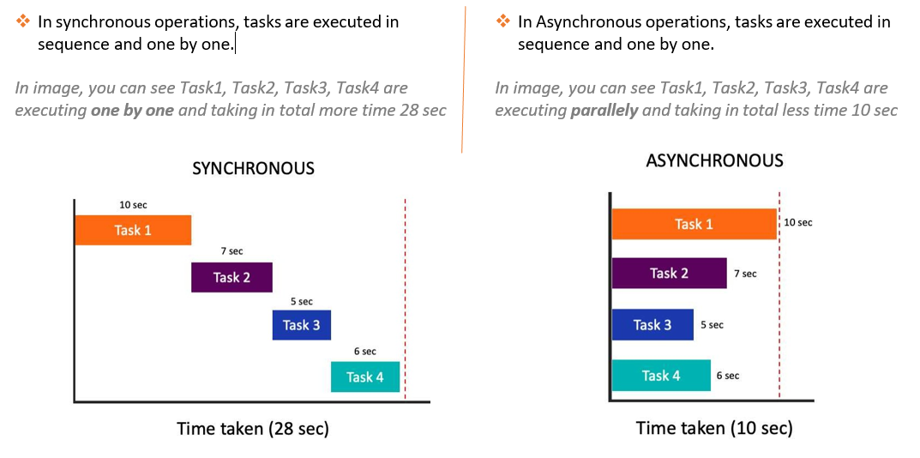

### How to do asynchronous operations in Angular?

Observables are used to perform asynchronous operations and handle asynchronous data

### What is the difference between Promise and Observables ?

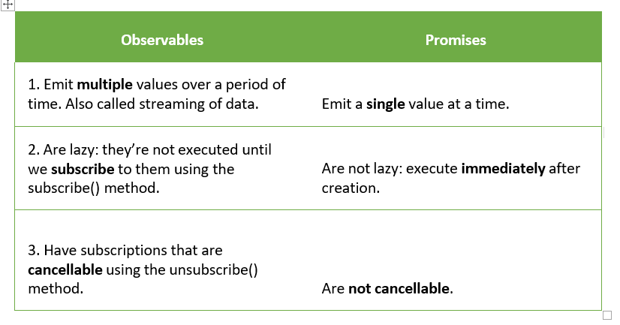

### What is the advantage of Observable over Promises?

1. In Observable, streaming of data will display continuous data to end user. So, the user has not to wait.

In Promises, end user have to wait until the whole data is not

available, which is not good.

2. Observables are lazy, means they will not execute until someone subscribe them, which is a good thing.

Promises are not lazy, means they will immediately execute even if there is no subscriber, which is not good.

What is RxJS?

RxJS is a javascript library, that allow us to work with asynchronous data stream with the help of observables.

Observables are introduced by RxJS library.

RxJS stands for Reactive Extensions for JavaScript.

What is Observable? How to implement Observable

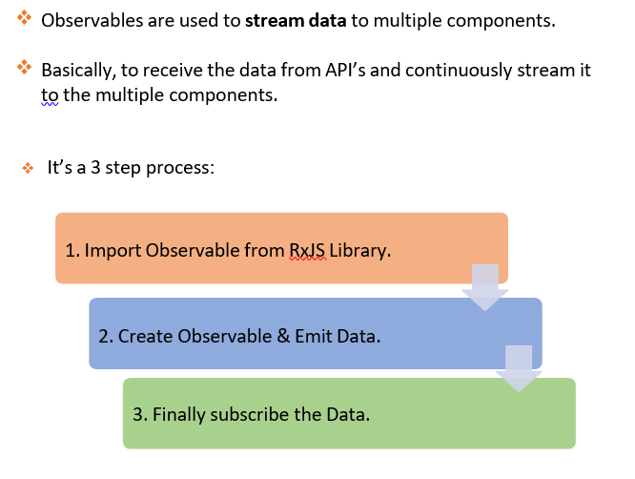

### What is the role of HttpClient in Angular?

HttpClient is a built-in service class provided by Angular, which is used to perform HTTP requests(GET/POST/PUT/DELETE) to send and receive data from API or Servers.

Package name is - @angular/common/http package

### What are the steps for fetching the data with HttpClient & Observable?

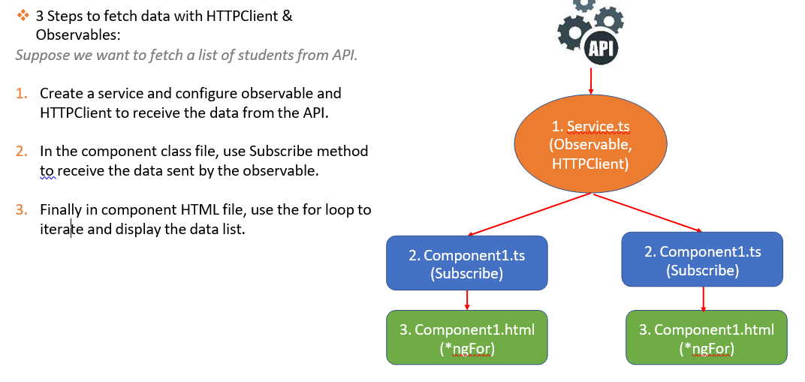

1. Create a service and configure observable and HTTPClient to receive the data from the API.

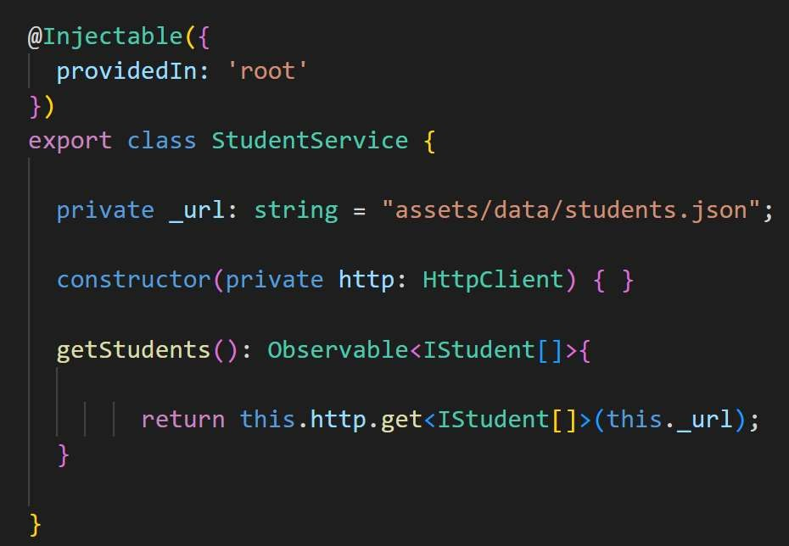

2. In the component class file, use Subscribe method to receive the data sent by the observable.

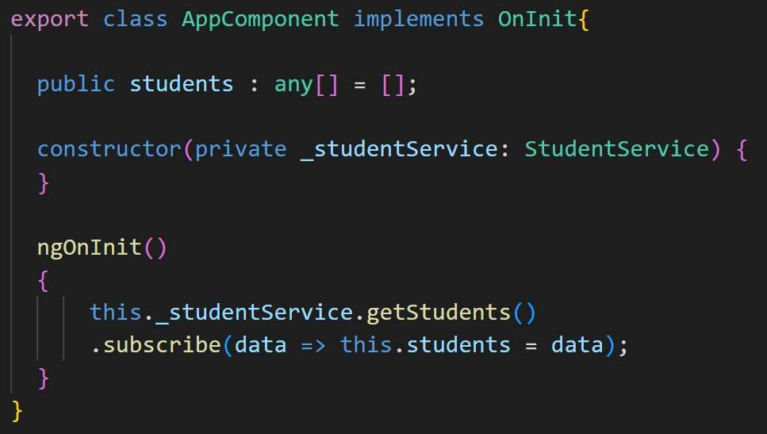

3. Finally in component HTML file, use the for loop to iterate and display the data list.

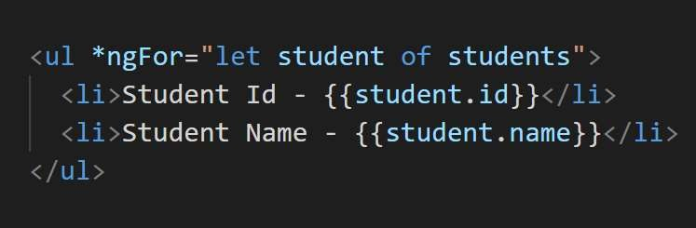

How to do HTTP Error Handling in Angular?

HTTP Error Handling can be done by using catchError and throwError functions from rxjs.

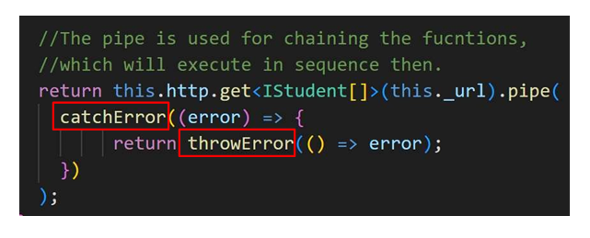

**Promise vs Observable**

**Promise**

A Promise handles a **single event** when an async operation completes or fails.

Note: There are Promise libraries out there that support cancellation, but ES6 Promise doesn't so far.

**Observable**

[**https://medium.com/@mpodlasin/promises-vs-observables-4c123c51fe**](https://medium.com/@mpodlasin/promises-vs-observables-4c123c51fe13)

[**https://itnext.io/javascript-promises-vs-rxjs-observables-de5309583ca2#f41a**](https://itnext.io/javascript-promises-vs-rxjs-observables-de5309583ca2#f41a)

An Observable is like a **Stream** (in many languages) and allows to pass zero or more events where the callback is called for each event.

Often Observable is preferred over Promise because it provides the features of Promise and more. With Observable it doesn't matter if you want to handle 0, 1, or multiple events. You can utilize the same API in each case.

Observable also has the advantage over Promise to be **cancelable**. If the result of an HTTP request to a server or some other expensive async operation isn't needed anymore, the Subscription of an Observable allows to cancel the subscription, while a Promise will eventually call the success or failed callback even when you don't need the notification or the result it provides anymore.

Observable provides **operators** like map, forEach, reduce, ... similar to an array

There are also powerful operators like retry(), or replay(), ... that are often quite handy.

## Forms

Angular Form Validation is a mechanism used to ensure that data entered by users in forms meets specific criteria or constraints before it is submitted to the server. It helps in maintaining data integrity and providing a better user experience by preventing invalid or inconsistent data from being submitted.

Angular provides both template-driven and reactive forms for implementing form validation.

### Template-Driven Forms:

Template-driven forms rely on directives in the template to handle form validation. Angular automatically tracks and validates the form state based on the provided directives.

To implement template-driven form validation, you need to:

1. Import the **FormsModule** in the app module.

import { NgModule } from '@angular/core';

import { FormsModule } from '@angular/forms';

@NgModule({

imports: [FormsModule],

declarations: [/* Your components */],

bootstrap: [/* Your root component */],

})

export class AppModule {}

1. Use the **ngForm**, **ngModel**, and other validation directives in the template.

<form #myForm="ngForm" (ngSubmit)="onSubmit()">

<label for="name">Name:</label>

<input type="text" name="name" [(ngModel)]="formData.name" required>

<label for="email">Email:</label>

<input type="email" name="email" [(ngModel)]="formData.email" required email>

<button type="submit">Submit</button>

</form>

1. Handle form submission and validation in the component.

import { Component } from '@angular/core';

@Component({

selector: 'app-my-component',

templateUrl: './my-component.component.html',

})

export class MyComponent {

formData = {

name: '',

email: '',

};

onSubmit() {

if (this.myForm.valid) {

// Form is valid, submit the data

console.log(this.formData);

} else {

// Form is invalid, handle error or show validation messages

}

}

}

### Reactive Forms:

Reactive forms are built programmatically using the **FormControl**, **FormGroup**, and **FormBuilder** classes. They offer more control and flexibility in managing form validation and data.

To implement reactive form validation, you need to:

1. Import the **ReactiveFormsModule** in the app module.

import { NgModule } from '@angular/core';

import { ReactiveFormsModule } from '@angular/forms';

@NgModule({

imports: [ReactiveFormsModule],

declarations: [/* Your components */],

bootstrap: [/* Your root component */],

})

export class AppModule {}

1. Create a form group and form controls in the component.

import { Component, FormBuilder, Validators } from '@angular/core';

@Component({

selector: 'app-my-component',

templateUrl: './my-component.component.html',

})

export class MyComponent {

myForm = this.formBuilder.group({

name: ['', Validators.required],

email: ['', [Validators.required, Validators.email]],

});

constructor(private formBuilder: FormBuilder) {}

onSubmit() {

if (this.myForm.valid) {

// Form is valid, submit the data

console.log(this.myForm.value);

} else {

// Form is invalid, handle error or show validation messages

}

}

}

1. Bind form controls to form elements in the template.

<form [formGroup]="myForm" (ngSubmit)="onSubmit()">

<label for="name">Name:</label>

<input type="text" formControlName="name">

<label for="email">Email:</label>

<input type="email" formControlName="email">

<button type="submit">Submit</button>

</form>

With both template-driven and reactive forms, Angular will handle validation based on the provided directives or form control validators. If the form is invalid, you can show error messages to users or disable the submit button until the form is valid.

Form validation in Angular is crucial for ensuring data integrity, providing a better user experience, and reducing errors during data submission. It helps in maintaining data consistency and improves the overall usability of Angular applications.

### What are Angular Forms? What are the type of Angular Forms?

Angular forms are used to handle user's input.

For example, login form, registration form, feedback form, update profile form etc etc.

All these are forms, in which user will input and then submit the information

4 steps data flow process in Angular forms-

1. The user will input the data in the HTML template file. .

2. Then data will be bind in the component typescript class file.

3. Then it will be sent to the Angular service.

4. Angular service will then finally send it to the Server which will receive the data and process the data. (In most cases this server will be an API only.)

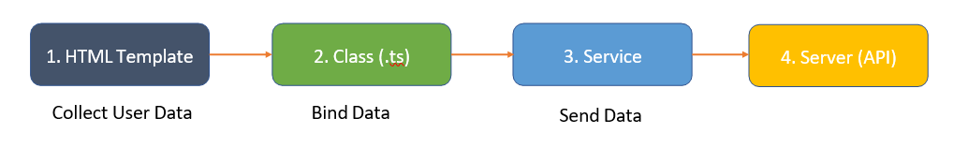

There are 2 types of forms in Angular:

1. Template driven forms - In template driven forms, most of the code will be written and handled in HTML templates only.

2. Reactive forms - in reactive forms most of the code will be written in component typescript class file.

### What is the difference between Template Driven Forms & Reactive Forms?

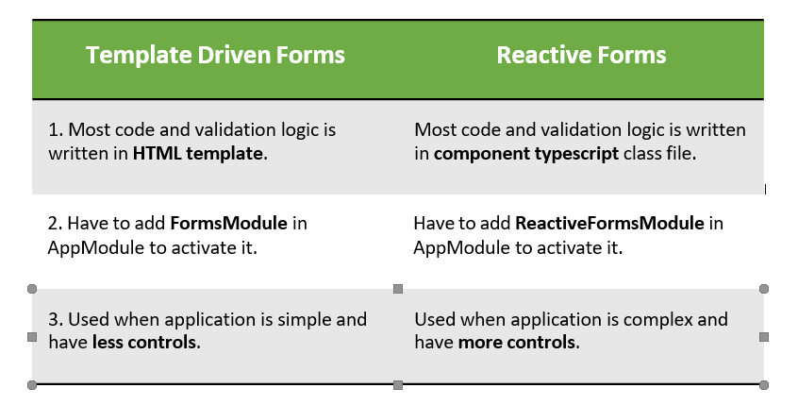

### How to setup Template Driven Forms?

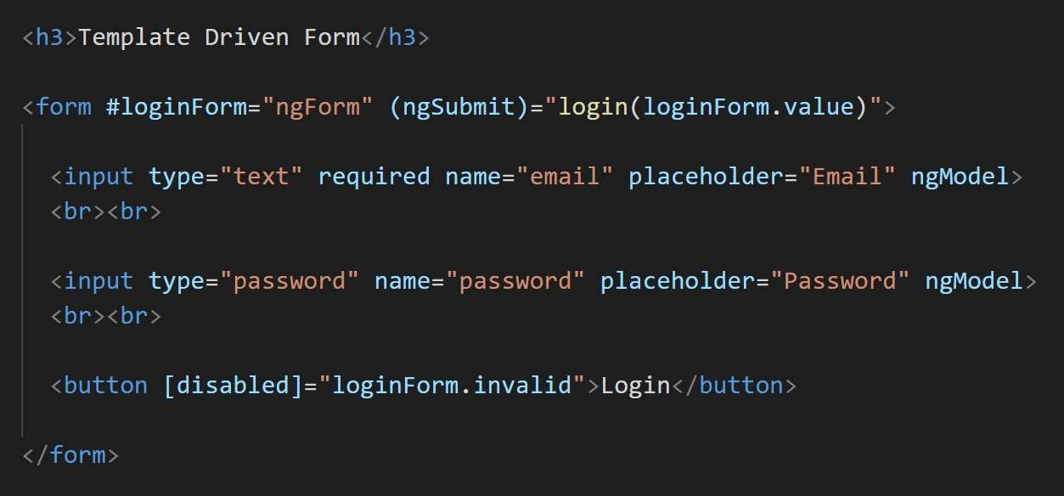Below is the sample code to setup login form using template driven form approach in html template file. Here we have used template reference variable (#loginForm).

### How to apply Required field validation in template driven forms?

For example, if you want to put required field validation in email field, then put the required keyword there, which will make the form invalid until the email is empty. Also, you can disable the button if the form is invalid.

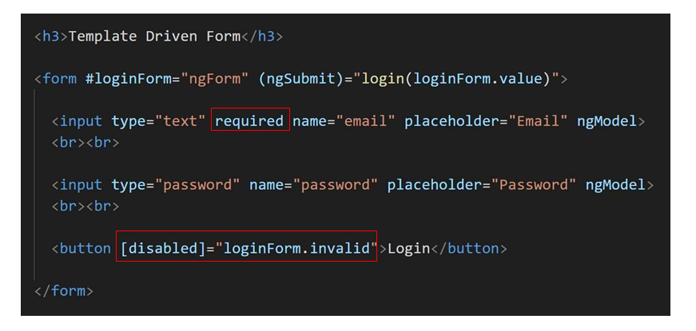

### What is Form Group and Form Control in Angular?

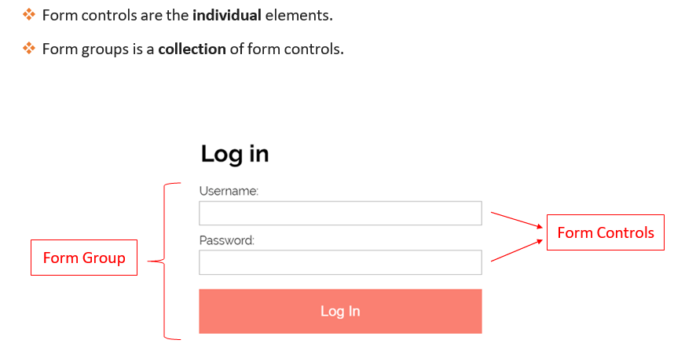

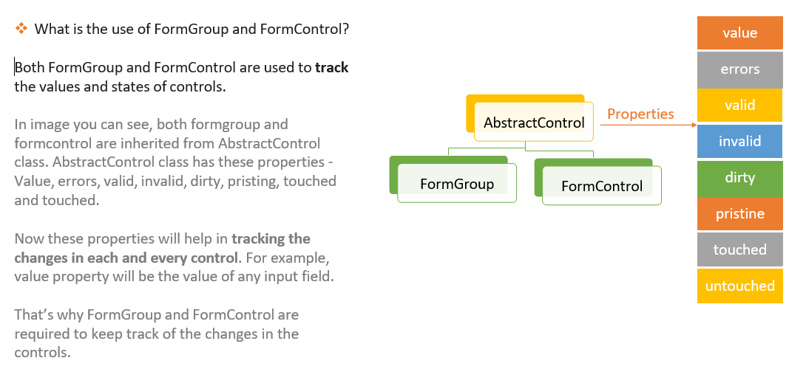

### How to setup Reactive Forms?

Below are some important points about Reactive Forms:

1. In reactive forms most code and validation logic is written in component typescript file.

2. Reactive Forms can be activated by adding ReactiveFormsModule in AppModule.

### When to use Reactive forms and when to use template driven forms?

Reactive Forms are used when application is complex and have more number of controls.

Template driven forms is used when number of controls are very less in the form.

Normally we prefer reactive forms in general.

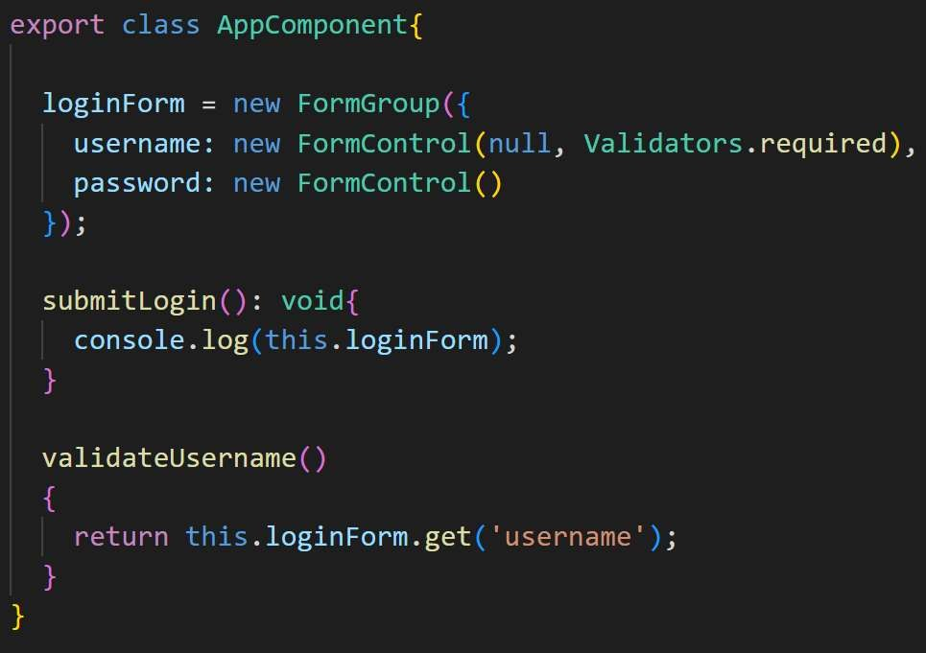

### How to do validations in reactive forms?



**Validators:** <https://www.digitalocean.com/community/tutorials/angular-reactive-forms-custom-validator>

<https://www.digitalocean.com/community/tutorials/angular-custom-validation>

<https://www.digitalocean.com/community/tutorials/angular-formly>

### FormControl in Angular

FormControl sets and tracks the individual HTML form element. it is one of the building blocks of the angular forms.

From <<https://www.tektutorialshub.com/angular/formcontrol-in-angular/>>

**How To Use Custom Form Validation in Angular**

From <<https://www.digitalocean.com/community/tutorials/angular-custom-validation>>

**Validators:**

<https://www.digitalocean.com/community/tutorials/angular-reactive-forms-custom-validator>

<https://www.digitalocean.com/community/tutorials/angular-custom-validation>

<https://www.digitalocean.com/community/tutorials/angular-formly>

### Template Driven Forms Features

* Easy to use
* Suitable for simple scenarios and fails for complex scenarios
* Similar to AngularJS
* Two way data binding(using [(NgModel)] syntax)
* Minimal component code
* Automatic track of the form and its data(handled by Angular)
* Unit testing is another challenge

### Reactive Forms Features

* More flexible, but needs a lot of practice
* Handles any complex scenarios
* No data binding is done (immutable data model preferred by most developers)
* More component code and less HTML markup
* Reactive transformations can be made possible such as
  + Handling a event based on a debounce time
  + Handling events when the components are distinct until changed
  + Adding elements dynamically
* Easier unit testing

From <<https://stackoverflow.com/questions/39142616/what-are-the-practical-differences-between-template-driven-and-reactive-forms>>

<https://zoaibkhan.com/blog/how-to-add-async-validation-to-angular-reactive-forms/>

Different events in Angular

All JS events like click, mouseover, mouse up.....

## Authentication & Authorization

### What is Authentication & Authorization in Angular?

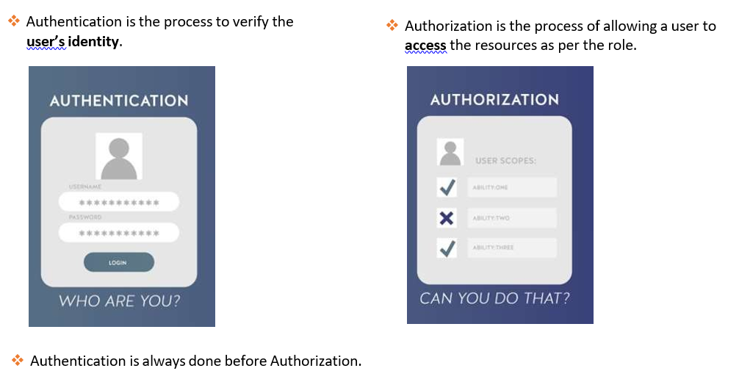

### What is JWT Token Authentication in Angular?

JWT authentication is a process to authenticate Angular user credentials to get or post data from API’s.

Upcoming is the image, where we will see, how the request will start from Angular and what are the steps to authenticate the request and get the data back from the API.

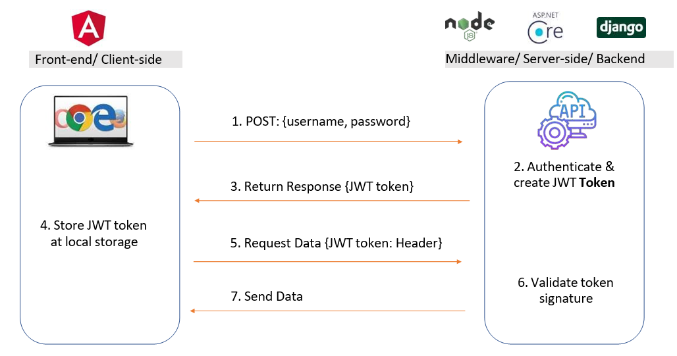

How to Mock or Fake an API for JWT Authentication?

### How to implement the Authentication with JWT in Angular?

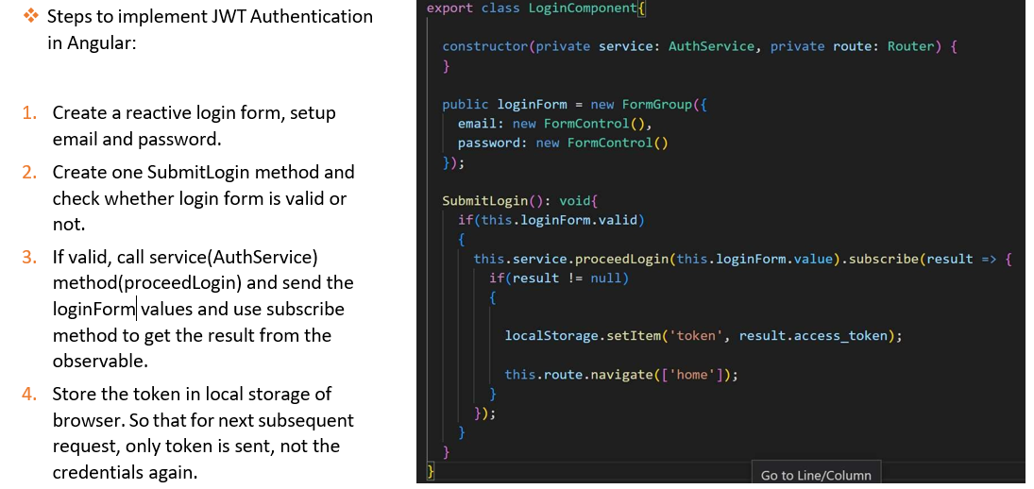

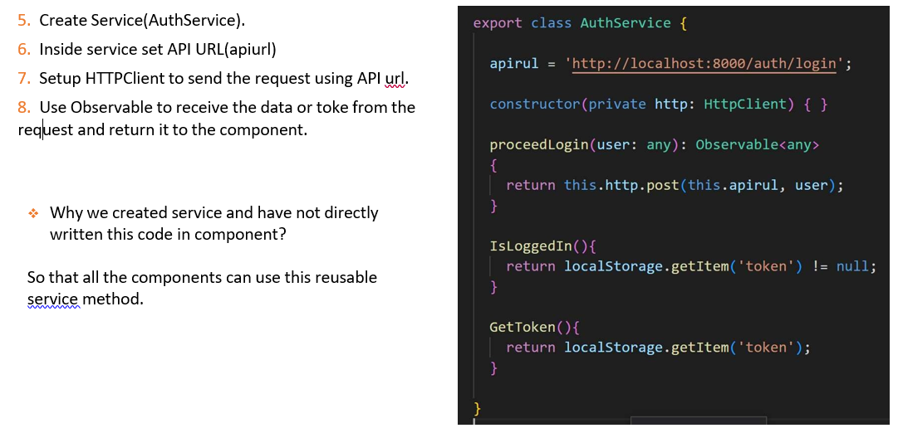

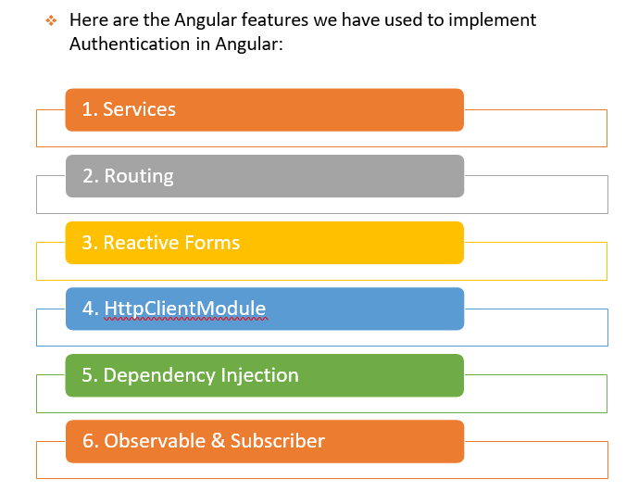

### What is Auth Guard?

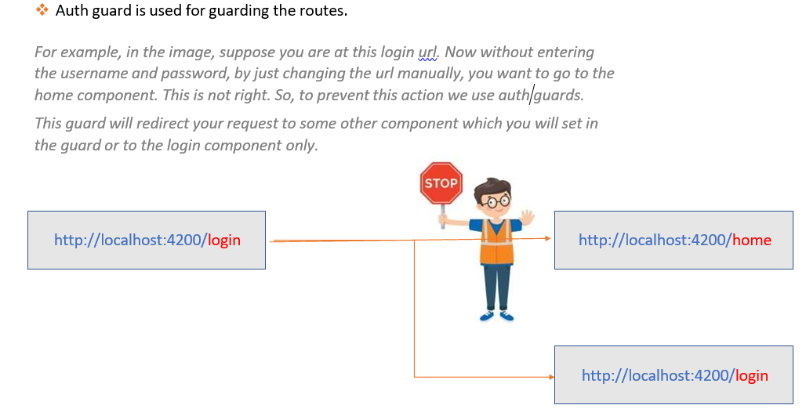

### What is HTTP Interceptor?

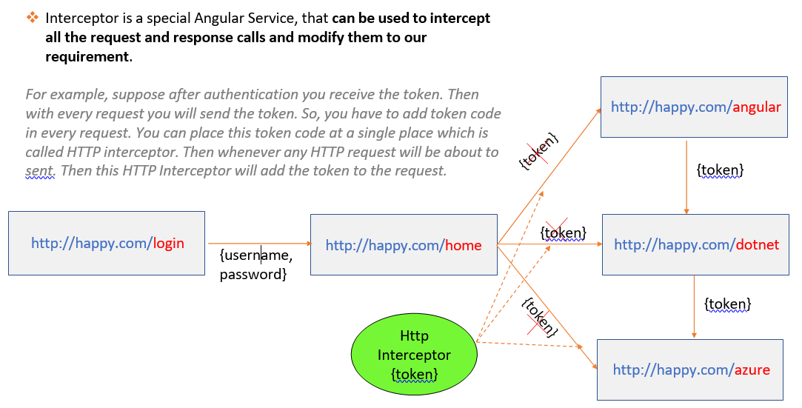

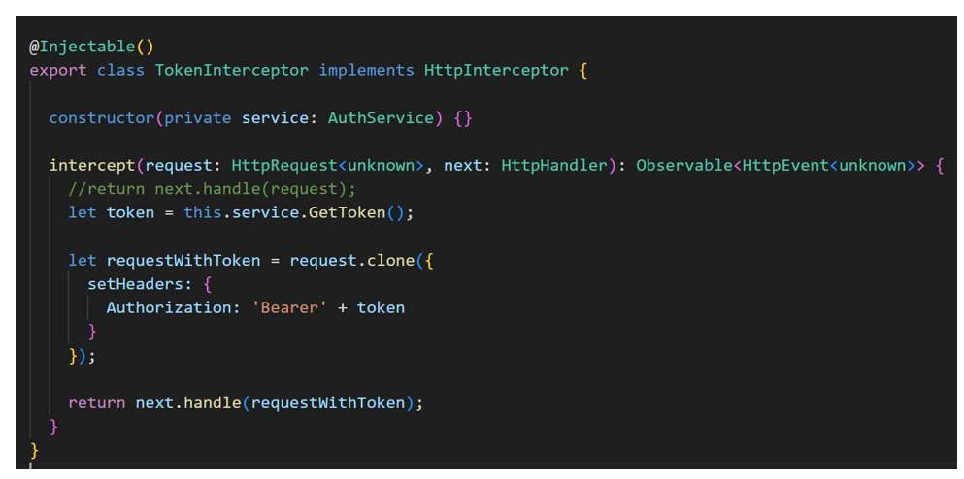

### How to Retry automatically if there is an error response from API?

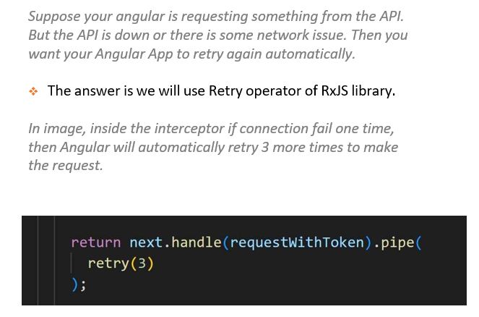

### What are the parts of JWT Token?

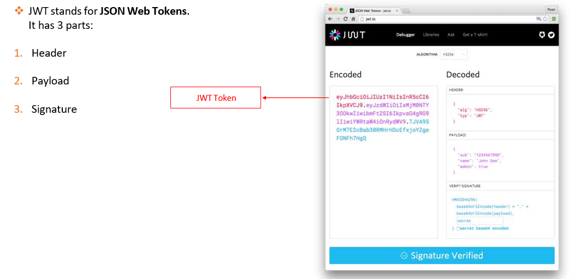

### What is Postman?

Postman is a tool for testing API’s.

### Which part of the request has the token stored when sending to API?

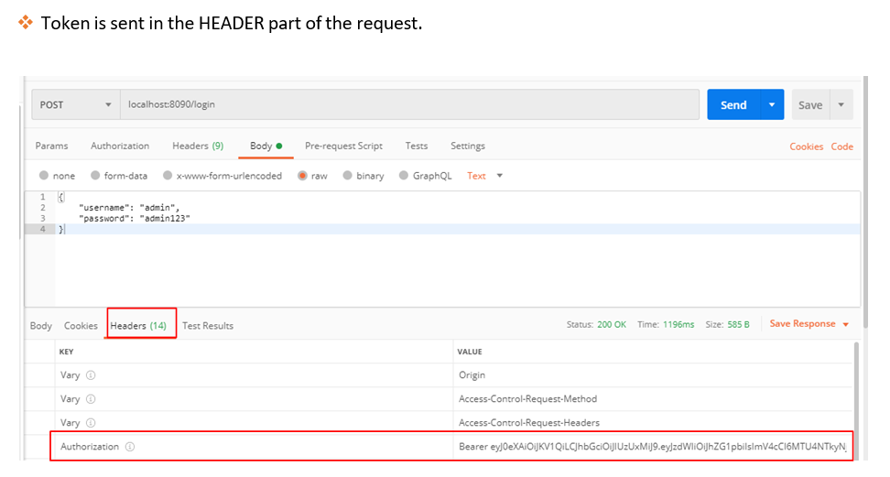

### JWT:

A **JWT** token is simply a compact and self contained JSON object that contains information like email and password. You can use **JWT** to add authentication in your **Angular** 8 application without resorting to make use of the traditional mechanisms for implementing authentication in web apps like sessions and cookies.

**JWT** stands for JSON Web Token. Essentially its a token that represents a claim between 2 parties; client and server in our case. These tokens typically have a id (user id) and expiration attached to them.

<https://blog.angular-university.io/angular-jwt-authentication/>

https://auth0.com/blog/complete-guide-to-angular-user-authentication/

## What is RxJS

**RxJS** (Reactive Extensions for JavaScript) is a library for reactive programming using observables that makes it easier to compose asynchronous or callback-based code.

What are pros and cons of RxJS?

### Advantages of using RxJS

The following are the advantages of using RxJS −

* RxJS can be used with other Javascript libraries and frameworks. It is supported by javascript and also with typescript. Few examples are Angular, ReactJS, Vuejs, nodejs etc.
* RxJS is an awesome library when it comes to the handling of async tasks.RxJS uses observables to work with reactive programming that deals with asynchronous data calls, callbacks and event-based programs.
* RxJS offers a huge collection of operators in mathematical, transformation, filtering, utility, conditional, error handling, join categories that makes life easy when used with reactive programming.

### Disadvantages of using RxJS

The following are the disadvantages of using RxJS −

* Debugging the code with observables is little difficult.
* As you start to use Observables, you can end up your full code wrapped under the observables.

### Why RxJS is important for Angular ?

RxJS is important in Angular because it allows us to compose our asynchronous or callback-based code into a sequence of operations executed on a data stream that releases values from a publisher to a subscriber.

### How to transform data in RxJS?

Using map, pluck, and mapTo

### How rxjs map differs from javascript map ?

RxJS is for working with Observables and native map is for Arrays.

### How filter works in RxJS and how it differs from JS filter?

RxJS is for working with Observables and native map is for Arrays.

### How to implement error handling in RxJS?

Angular CatchError is an RxJs Operator. We can use it to handle the errors thrown by the [Angular Observable](https://www.tektutorialshub.com/angular/angular-observable-tutorial-using-rxjs/). Like all other RxJs operators, the CatchError also takes an observable as input and returns an observable (or throws an error).

Create a Observable and add error handling to it

How will you write subscribe to be ready for error handling

### RxJs subscribe and error callbacks

To see the RxJs error handling behavior in action, let's create a stream and subscribe to it. Let's remember that the subscribe call takes three optional arguments:

* a success handler function, which is called each time that the stream emits a value
* an error handler function, that gets called only if an error occurs. This handler receives the error itself
* a completion handler function, that gets called only if the stream completes

|  |
| --- |
| @Component({ |
| selector: 'home', |
| templateUrl: './home.component.html' |
| }) |
| export class HomeComponent implements OnInit { |
| constructor(private http: HttpClient) {} |
| ngOnInit() { |
| const http$ = this.http.get<Course[]>('/api/courses'); |
|  |
| http$.subscribe( |
| res => console.log('HTTP response', res), |
| err => console.log('HTTP Error', err), |
| () => console.log('HTTP request completed.') |
| ); |
| } |
| } |

### What does combineLatest operator work in RxJS?

Combines multiple Observables to create an Observable whose values are calculated from the latest values of each of its input Observables.

### What is Behaviorsubject ?

BehaviorSubject is a type of subject, a special type of observable in RxJS, that keeps track of the current value and emits it to new subscribers. It is similar to a regular subject, but it also stores the latest value that has been passed to it. This is useful when you want to provide a default value for a subject or when you need to access the latest value of the subject.

What is most common use case of behaviour subject in angular ?

“BehaviourSubject” is used when you want all the subscribers to receive the last emitted value. The major difference here is that BehaviorSubject remembers the last emitted value and gives it to whoever subscribes to it.

### How Subject and Behaviorsubject differ in RxJS?

**Subject**is a special observable that acts as both observer & observable. It'll allow to emit new value using **next()** method. It allows value to be **multicasted**to many observers. Which means, all the subscribers, who subscribe to the subject will receive the same instance of the subject and the same value emitted. It is also called as hot observable which does not wait for subscriber to emit value. It can start emitting value right after the use of **next()** method.

It plays a vital role in communication between two components and transferring data. But there is a problem, when you subscribe to an event that is already emitted then you'll not get any data. The emitted data will be lost. Let's see it in detail:

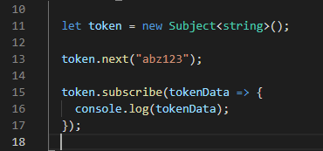

Subject is emitted and subscribed as depicted in the image above. But, what will happen here is nothing. Yes, when we subscribe a subject which has already emitted a value then no value will be received as it is already emitted and is lost.

So, **what can be the solution for this?**

Well, this can be handled using BehaviorSubject or ReplaySubject. BehaviourSubject and ReplaySubject works mostly in a similar way with slight differences.

* BehaviorSubject can hold only last data emitted in the memory whereas ReplaySubject can hold in memory as much as we define in the bufferSize. By default the bufferSize is infinite.

In the image below, we have instantiated ReplaySubject with default bufferSize which is Infinite.

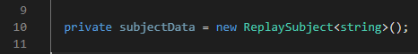

But we can also limit the bufferSize by passing a constructor parameter as depicted in the image below.

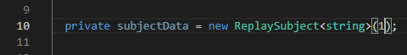

* BehaviourSubject needs an initial value but ReplaySubject does not need any initial value.

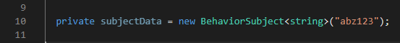

If you do not provide an argument value then it prompt an error. It is mandatory to provide an argument value for **BehaviorSubject**.

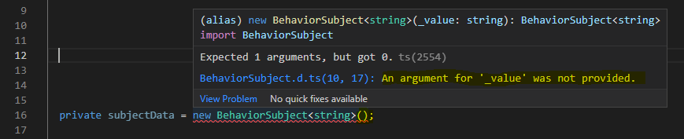

So, **which one to use between BehaviorSubject and ReplaySubject if there is no initial value?**

We can use **ReplaySubject**if we have got no initial value and by passing a constructor parameter 1.

<https://www.c-sharpcorner.com/article/understanding-subject-behaviorsubject-replaysubject/>

Observables vs Promises - what is the difference and what should be used in Angular ?

### Synchronous Vs. Asynchronous

* In the Synchronous process, multiple tasks are executed one after another, which means the second task is waiting to complete the first task. In that case, the thread needs to wait before moving to another task.
* Another side, in the asynchronous process, there are multiple processes executed simultaneously. It will not wait for the complete previous task. It will just move to the next task and start the execution.

### Observable Vs. Promise

|  |  |
| --- | --- |
| **Observable** | **Promise** |
| Observable can emit multiple values. | A promise can emit only a single value at a time. |
| Observables are lazy when we subscribe then only that will execute. | Promises are not lazy; they will execute immediately on creation. |
| Observable can be synchronous or asynchronous. | Promises are asynchronous. |
| Observable can be unsubscribed. | There is no facility to unsubscribe promises. |
| Observable has different RxJS functions like Filter, Map, Reduce, and many more. | Promises don't have any function. |

<https://www.c-sharpcorner.com/article/observable-and-promise-in-angular/#:~:text=Observable%20can%20emit%20multiple%20values,will%20execute%20immediately%20on%20creation>.

### Cold vs hot observables - what is the difference?

**Cold Observables** start emitting or creating values only when the subscription starts, like a typical YouTube video. Each subscriber will see the same sequence (or pattern) of events from start to finish.

**Hot Observables** are always being updated with new values, like a live stream on YouTube. When you subscribe you start with the most recent value and only see future changes.

<https://github.com/rohan-paul/Awesome-JavaScript-Interviews/blob/master/Angular-Topics-Interview/Observables/cold-vs-hot-observable.md>

### Flat vs ConcatMap vs SwitchMap vs MergeMap vs Map vs ExhaustMap in RxJS

* **flatMap/mergeMap** - creates an Observable immediately for any source item, all previous Observables are kept alive. Note flatMap is an alias for mergeMap and flatMap will be removed in RxJS 8.
* **concatMap** - waits for the previous Observable to complete before creating the next one
* **switchMap** - for any source item, completes the previous Observable and immediately creates the next one
* **exhaustMap** - source items are ignored while the previous Observable is not completed

### Operators in RxJS

An operator is a pure function that takes in observable as input and the output is also an observable. To work with operators we need a pipe() method.

### RxJs - Memory leaks

In the world of RxJS, memory leaks happen when Observables linger around in memory, long after they've finished their tasks. They're no longer needed, but they stick around anyway, taking up precious space. So we need to unsubscribe it.

Flattening Operators - mergeMap vs switchMap vs concatMap vs exhaustMap

### Unsubscribing :

Use the unsubscribe method

Use Async | Pipe

<https://blog.bitsrc.io/6-ways-to-unsubscribe-from-observables-in-angular-ab912819a78f>

After retrieving the data from API, provide only "HR" data in service ?

( RXJS need to be used to filter )

Consider we have 3 API URLs, we have send response of first to second , second to third and give final response ?

( RXJS need to be used to filter )

## What is Typescript?

TypeScript is a typed super set of JavaScript which has been built and maintained by Microsoft and chosen by the AngularJS team for development.

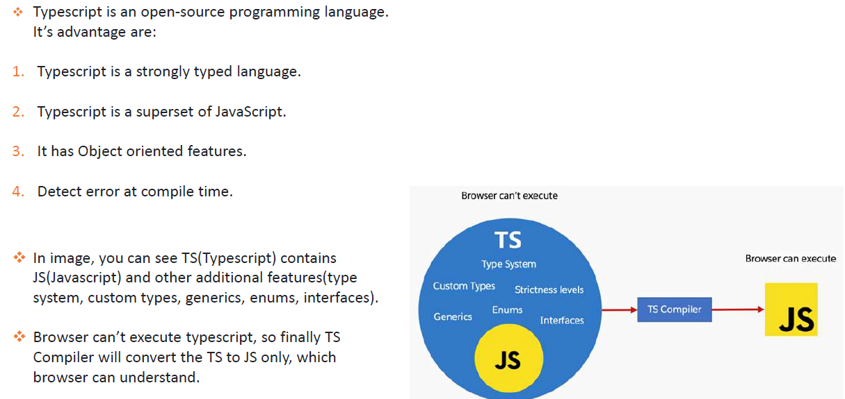

How to install Typescript and check version?

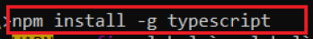

### What is the difference between let and var keyword?

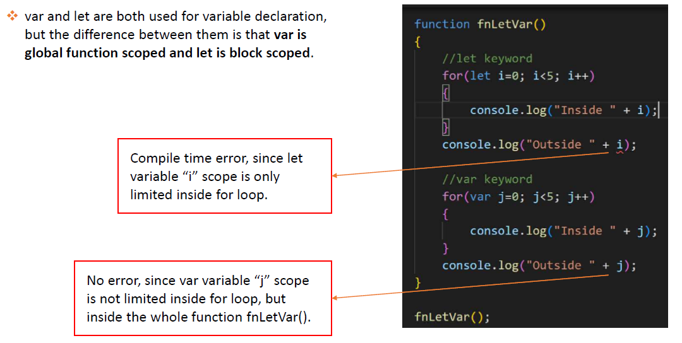

### What is Type annotation?

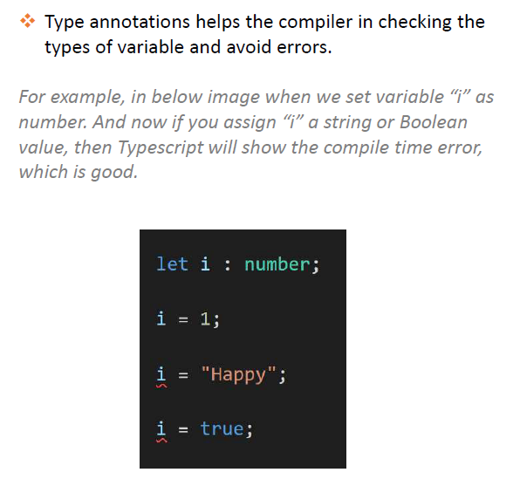

What are Built in/ Primitive and User-Defined/Non-primitive Types in Typescript?

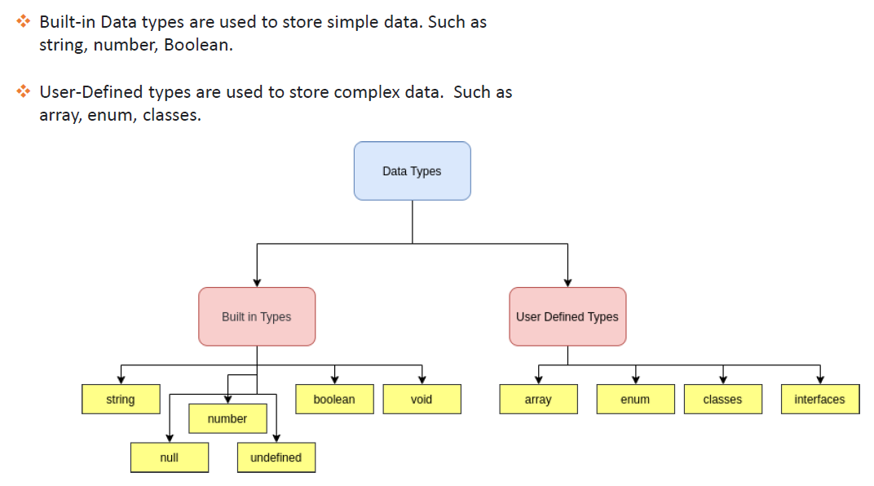

### What is “any” type in Typescript?

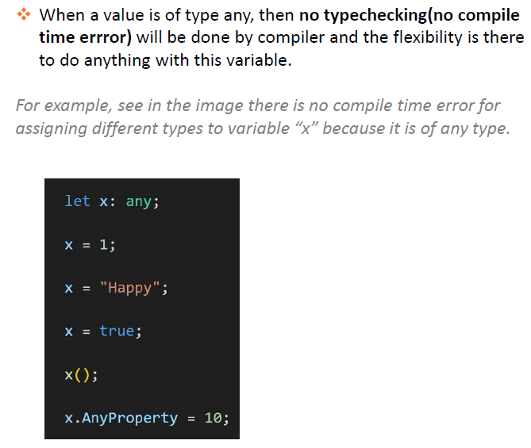

### What is Enum type in Typescript?

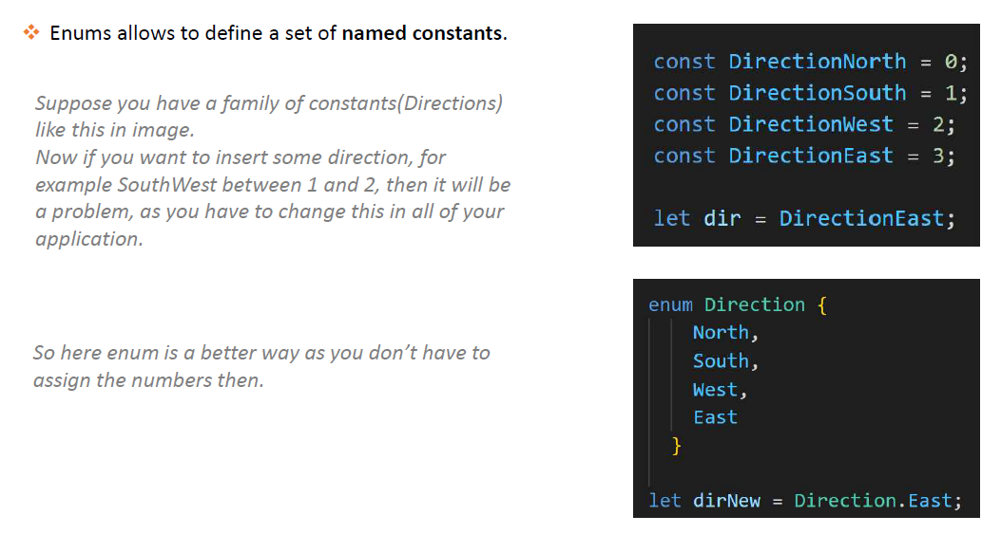

### What is the difference between void and never types in Typescript?

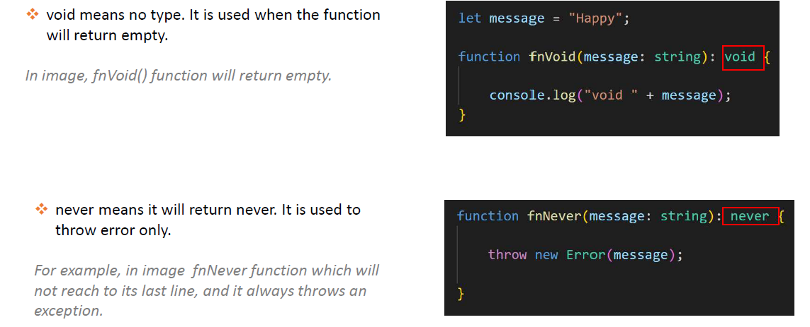

### What is Type Assertion in Typescript?

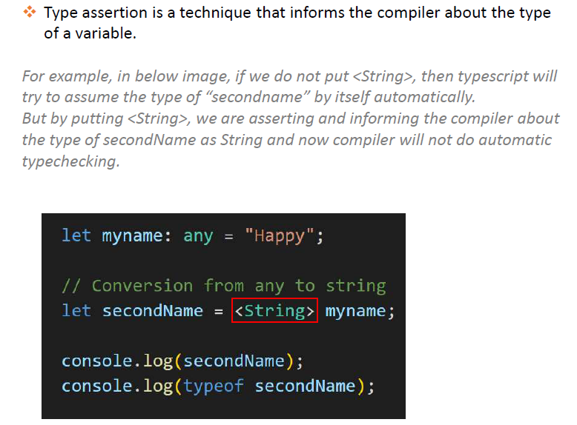

### What are Arrow Functions in Typescript?

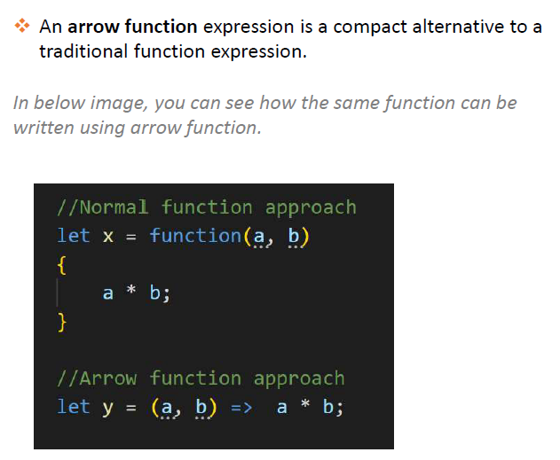

### What is Object Oriented Programming in Typescript?

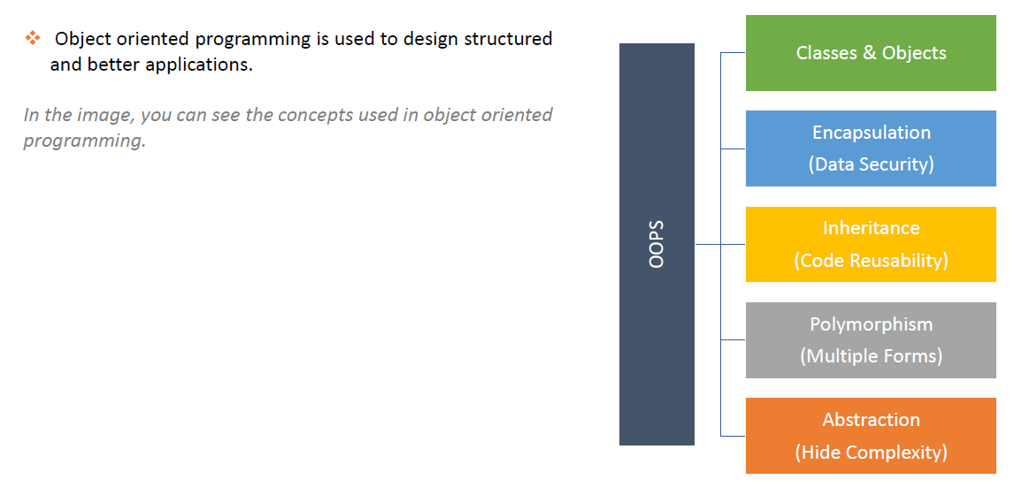

### What are Classes and Objects in Typescript?

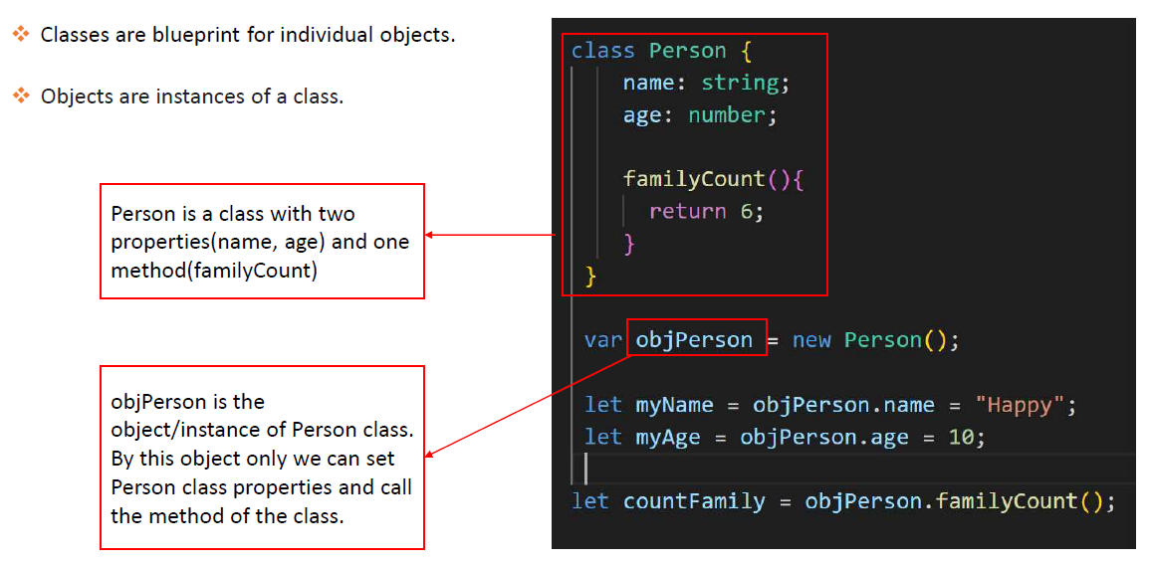

### What is Constructor?

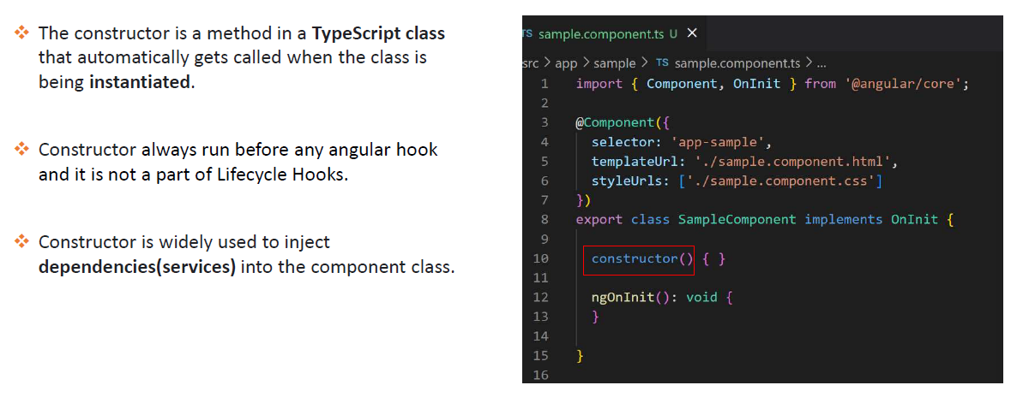

### What are Access Modifiers in Typescript?

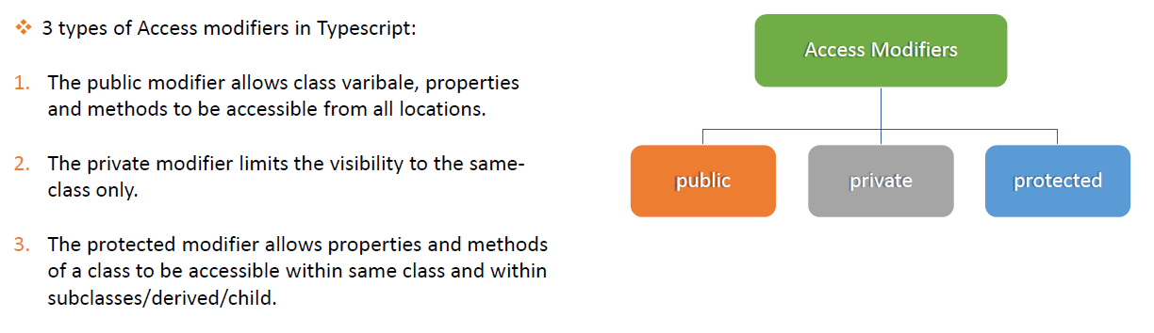

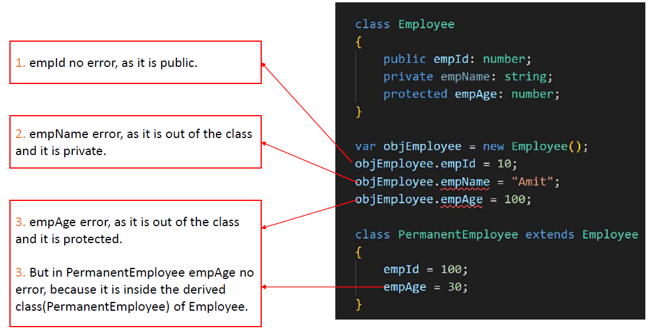

### What is Encapsulation in Typescript?

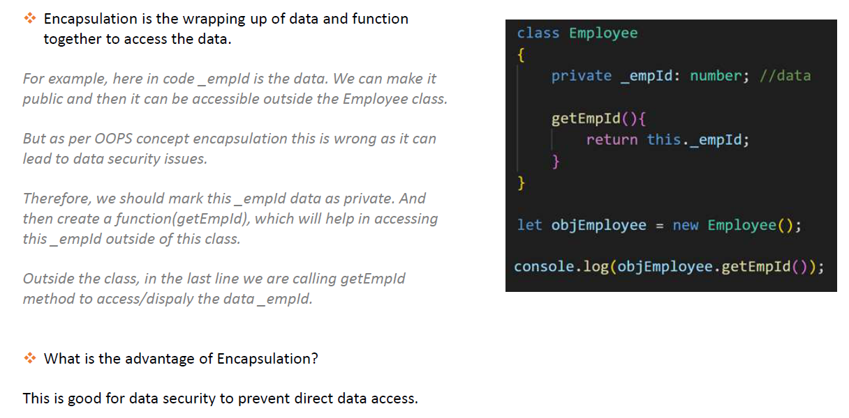

### What is Inheritance in Typescript?

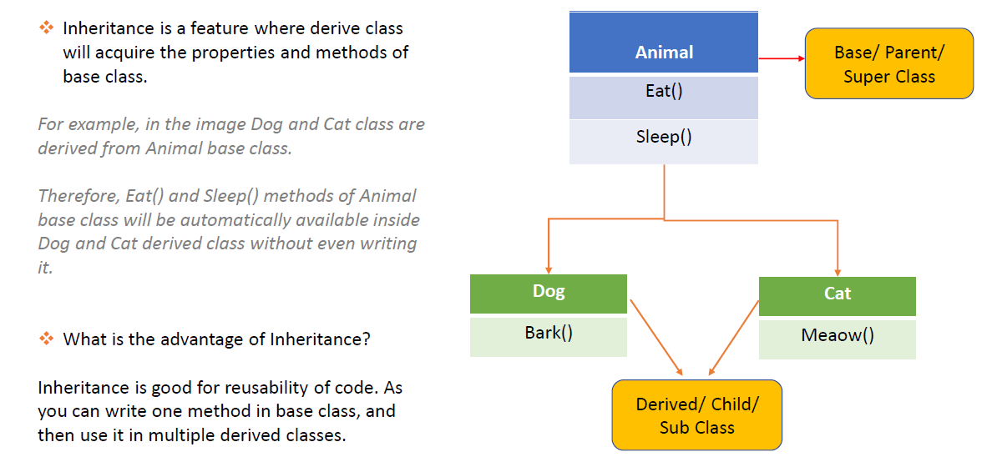

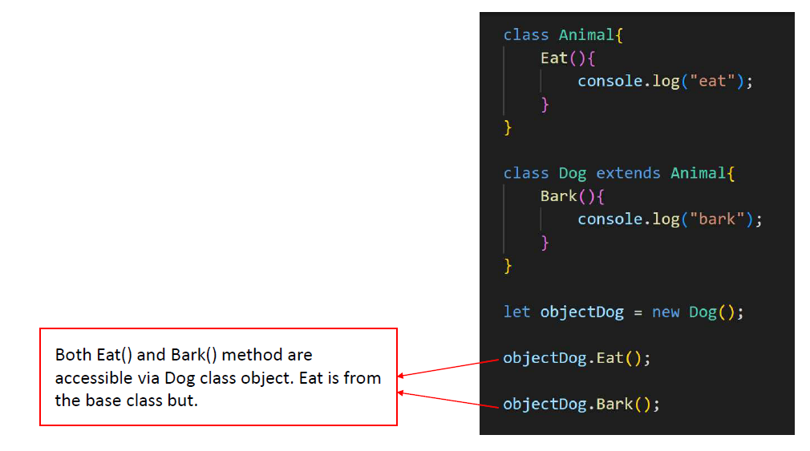

### What is Polymorphism in Typescript?

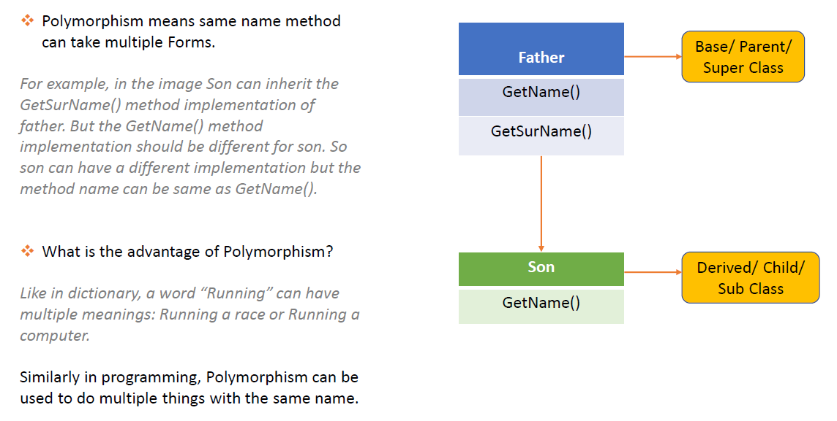

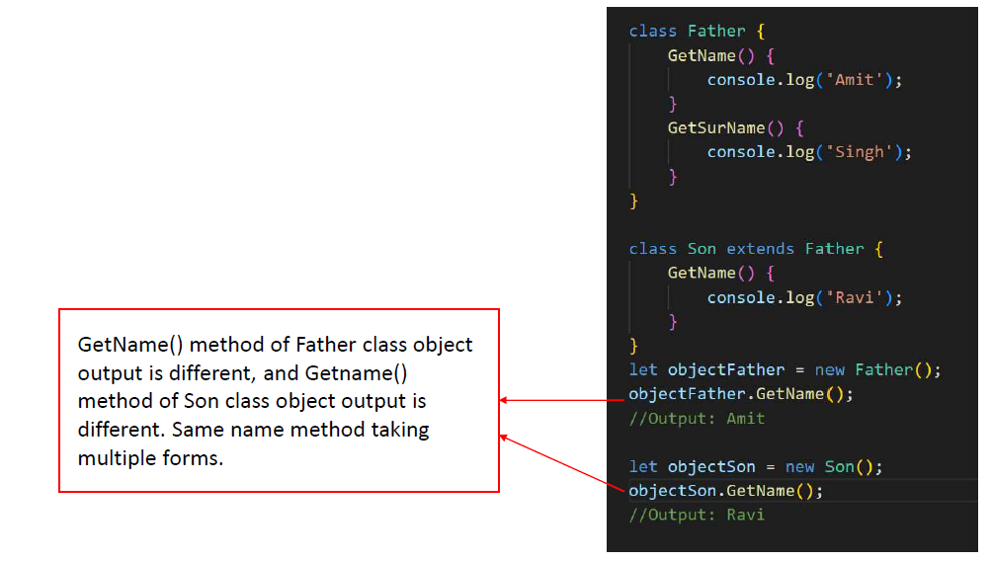

### What is Interface in Typescript?

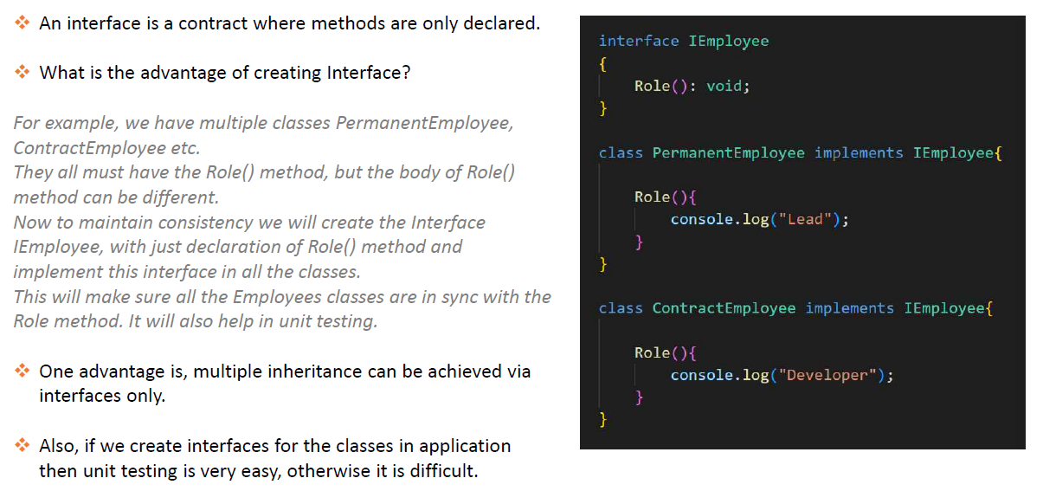

### What's the difference between extends and implements in TypeScript

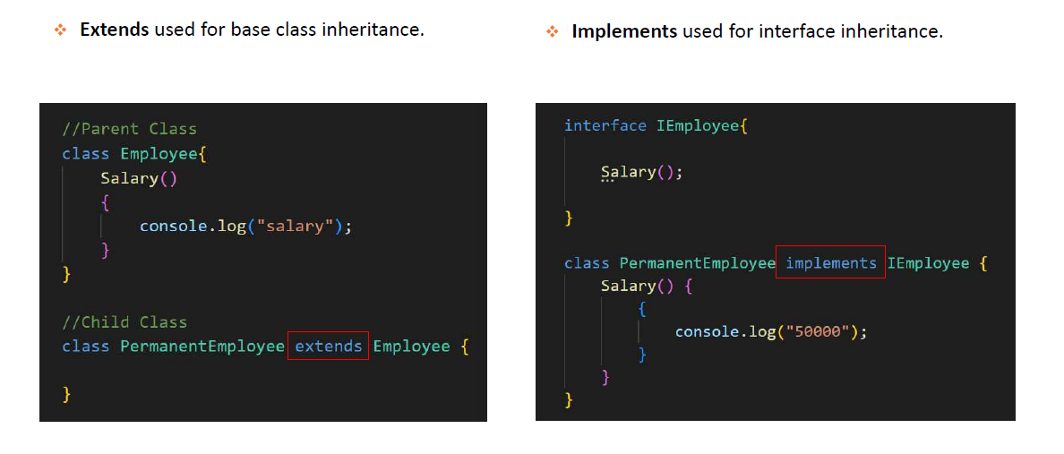

### Is Multiple Inheritance possible in Typescript?

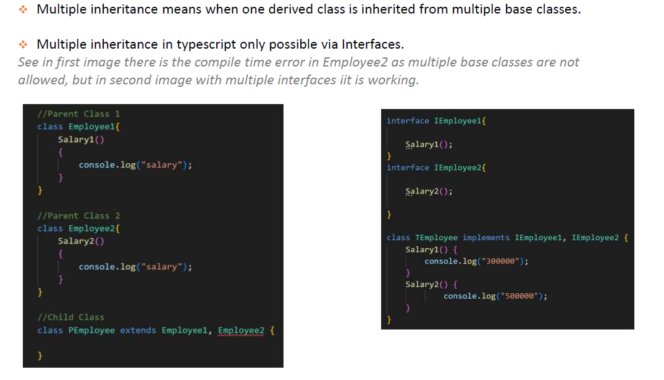

### What is the difference between explicit vs implicit types?

Implicit types come from TypeScript inferring the type based on a variable's initial value and look just like regular JavaScript. Explicit types are when we intentionally provide the type using a special TypeScript syntax.

### What is type in Typescript?

In TypeScript, a type is a convenient way to refer to the different properties and functions that a value has.

### What is the difference between an interface and a type?

| **Type** | **Interface** |
| --- | --- |
| In typescript type is defined for a variable’s data type which means type declaration in typescript is used for declaring names of different types such as user-defined, built-in, or any other data types. | Interfaces are defined as the syntax for the class which provides a way to define entities. |
| It uses the type keyword for defining new types. | It uses the interface keyword for declaring an interface. |
| Types can be used for others like built-in types, tuples, etc. | The interface cannot be used with other types of declaration. |
| Types cannot be extended and hence it does not support classes. | Interfaces can be extended and it supports classes. |
| In Typescript, union types can contain one or more types. | In typescript this feature of union types is not supported as we cannot create a union interface by combining two types. |

### What is union in Typescript?

TypeScript allows us to use more than one data type for a variable or a function parameter. This is called union type.

Syntax:

(type1 | type2 | type3 | .. | typeN)

Consider the following example of union type.

Example: Union

 Copy

let code: (string | number);

code = 123; // OK

code = "ABC"; // OK

code = false; // Compiler Error

let empId: string | number;

empId = 111; // OK

empId = "E111"; // OK

empId = true; // Compiler Error

### How to narrow the union in Typescript?

To narrow a variable to a specific type, implement a type guard. Use the typeof operator with the variable name and compare it with the type you expect for the variable.

const choices: [string, string] = ['NO', 'YES'];

const processAnswer = (answer: number | boolean) => {

if (typeof answer === 'number') {

console.log(choices[answer]);

} else if (typeof answer === 'boolean') {

if (answer) {

console.log(choices[1]);

} else {

console.log(choices[0]);

}

}

}

processAnswer(true); // Prints "YES"

processAnswer(0); // Prints "NO"

### What is unknown in Typescript?

unknown is the type-safe counterpart of any. Anything is assignable to unknown, but unknown isn’t assignable to anything but itself and any without a type assertion or a control flow based narrowing. Likewise, no operations are permitted on an unknown without first asserting or narrowing to a more specific type.

<https://www.typescriptlang.org/docs/handbook/release-notes/typescript-3-0.html#new-unknown-top-type>

### How to work with DOM in Typescript?

<https://www.typescriptlang.org/docs/handbook/dom-manipulation.html>

### How to work with classes in Typescript?

<https://www.tutorialsteacher.com/typescript/typescript-class>

### What are generics in Typescript?

<https://www.tutorialsteacher.com/typescript/typescript-generic>

### What is a tuple in Typescript?

A **tuple** is a typed [array](https://www.w3schools.com/js/js_arrays.asp) with a pre-defined length and types for each index.

<https://www.tutorialsteacher.com/typescript/typescript-tuple>

### What is optional property in Typescript?

Optional Properties are those properties that are not mandatory.

type Person=  {

  name: string;

  age?:number;

}

<https://www.tektutorialshub.com/typescript/optional-properties-in-typescript/>

### What is index signature in Typescript?

A type in TypeScript usually describes an exact set of fields to match on an object. An index signature is a way to define the [Shape](https://www.typescriptlang.org/glossary#shape) of fields which are not known ahead of time.

type MathConstants = {

pi: 3.14159;

phi: 1.61803;

[key: string]: number;

};

interface ModernConstants {

taniguchi: 0.6782344919;

raabe: 0.9189385332;

[key: string]: number;

}

[Try](https://www.typescriptlang.org/play/#code/C4TwDgpgBAsghsAFgYQPYDsDOw7uJqAXigG8AoKKMASwC4oBmAOgEYAWFgVgE4BuCqojpQWTAGwsAHAAYG-AQG0A1hBD1sAJ2roA5gF166AK4BbAEYQN-AL7ztwSwDM4AY2gxUAE0vo0WHHgE5JQB1DpGLkL00uIA7JIATAxsbNwsfAIacHAW0UxpktwMkpwMDAnylMqq6sBaugZQxuaWNkA)

The [key: string]: number; is the index signature, which indicates to TypeScript that any fields on the object which are not mentioned will be a particular types.

<https://www.typescriptlang.org/glossary#index-signatures>

### What is a record type in Typescript?

In TypeScript, the Record type simply allows us to define dictionaries, also referred to as key-value pairs, with a fixed type for the keys and a fixed type for the values. In other words, the Record type lets us define the type of a dictionary; that is, the names and types of its keys.

<https://blog.logrocket.com/level-up-typescript-record-types/#:~:text=In%20TypeScript%2C%20the%20Record%20type,and%20types%20of%20its%20keys>.

### What is omit and pick in Typescript?

Pick allows us to select properties, Partial allows us to make properties optional and Omit allows us to exclude properties

### What is readonly in Typescript?

The read-only is a keyword in the typescript that make the property read-only itself. The read-only keyword allows us to mark the properties as immutable. The Read-only properties cannot be changed outside the class they need to be initialized at declaration.

### What is partial in Typescript?

<https://www.educative.io/answers/how-to-use-the-typescript-partial-type>

### What is required in Typescript?

One of the features of Typescript is Required<Type> which is a built-in utility type that allows you to create a new type that makes all properties of the original type required. It means that any property of the original type that was previously optional becomes mandatory in the new type.

### What is type inference in Typescript?

We know that typescript is a typed language. By the word type inference, we mean when the type is not explicitly declared by the user, and the typescript itself has to infer the type on its own. Type inference is very helpful in type checking when there are is no explicit type annotation available in typescript.

### What is literal type in Typescript?

There are three sets of literal types available in TypeScript today: strings, numbers, and booleans; by using literal types you can allow an exact value which a string, number, or boolean must have.

### What is tsconfig.json file?

The `tsconfig. json` file in an Angular project plays a crucial role in the TypeScript compilation process. It's a configuration file that provides instructions to the TypeScript compiler on how to compile the TypeScript code into JavaScript.

What is function overloading in Typescript?

**TypeScript** provides the concept of **function overloading**. You can have multiple functions with the same name but different parameter types and return type.

What is extends in Typescript?

In TypeScript, you can extend interfaces using the extends keyword. When one interface extends another, it inherits all the members (properties and methods) from the parent interface and can also add its own members or override the ones inherited.

What is infer in Typescript?

The TypeScript compiler can infer the type of x based on the expressions that are used to initialize it. For example, if x is initialized to the string "hello" , the compiler will infer that the type of x is string . If x is initialized to the number 10, the compiler will infer that the type of x is number .

What is annotation in Typescript ?

Type Annotations are annotations which can be placed anywhere when we use a type. The use of Type annotation is not mandatory in TypeScript. It helps the compiler in checking the types of variable and avoid errors when dealing with the data types.

We can specify the type by using a **colon(: Type)** after a variable name, parameter, or property. There can be a space between the colon and variable name, parameter, or property. TypeScript includes all the primitive data types of JavaScript such as number, string, Boolean, etc.

### **Syntax**

var variableName: TypeAnnotation = value;

### Declaration Merging

declaration merging” means that the compiler merges two separate declarations declared with the same name into a single definition. This merged definition has the features of both of the original declarations. Any number of declarations can be merged; it’s not limited to just two declarations.

<https://www.typescriptlang.org/docs/handbook/declaration-merging.html>

Union Types in Typescript

union type describes a value that can be one of several types. We use the vertical bar ( | ) to separate each type, so number | string | boolean is the type of a value that can be a number , a string , or a boolean .

Ambient Declarations

In Typescript, Ambient in refers to the **declarations used to inform a compiler that the actual piece of code exists in a** different place.

**Typings:**

**Typings** describes contract of libraries you use. This allows the TypeScript compiler that what you use exist (classes, properties, ...). You can install **typings** from a repository using the **typings** command or let the compiler find out them leveraging the strategy specified in the tsconfig.  
<https://www.bennadel.com/blog/3169-adding-custom-typings-files-d-ts-in-an-angular-2-typescript-application.htm>

|  |  |
| --- | --- |
| { |  |
|  | "compilerOptions": { |
|  | "target": "es5", |
|  | "module": "commonjs", |
|  | "moduleResolution": "node", |
|  | "sourceMap": true, |
|  | "typeCheck": true, |
|  | "emitDecoratorMetadata": true, |
|  | "experimentalDecorators": true, |
|  | "removeComments": false, |
|  | "noImplicitAny": true, |
|  | "suppressImplicitAnyIndexErrors": true |
|  | }, |
|  | "files": [ |
|  | "typings/index.d.ts" |
|  | ] |
|  | } |

**ES6-Shim:**TypeScript does not come with built-in polyfills. There are certain features it doesn't transpile, this is where polyfills like es-shim come in.

The TypeScript definition file will provide you with typing support within your chosen editor and the es-shim will provide the implementation for the functionality that TypeScript doesn't transpile to ES5 code.

A few of such features TypeScript doesn't transpile are:

* Promises
* Functions hanging off of prototype objects (Array.from(),Array.of(),Number.isInteger(), etc)
* Module loading  
  es6-shim.min.js is a code that emulates ES6 features for ES5 browsers. Some of those features are Promise, Array.from()...